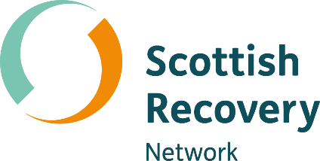

Balancing power in peer support

Peer2Peer: module three, session four
Facilitator session plan



Module three: Peer concepts and practice
Welcome to module three of the Peer2Peer group training course!
This module builds on the foundations developed in modules one and two, focusing on applying peer support concepts and skills in practice. It is designed for people who already have a solid understanding of peer support or experience delivering it and can also be used as continuing professional development for existing peer workers. This module supports participants to deepen their practice and strengthen their confidence in supporting the recovery journey of others.

Before starting this module
We recommend participants complete Preparing for Peer2Peer: participant readiness workbook.
Before facilitating take time to get familiar with this module three, session four plan and the associated participant workbook. Make sure everyone has their own copy of the participant workbook for this session and encourage them to look over the reflection activities beforehand. Ask them to bring their participant workbook along on the day and keep a few spares handy just in case.

After the session
- Complete the facilitator reflections template
- Remind participants to review and finish the reflection activities in their participant workbook before the next session
- Update the group learning agreement slide after the session, ready for future sessions

Session four: Balancing power in peer support
Learning intentions
- Understand the power peer workers have and the influencing factors
- Explore how the peer values can be practiced to balance power in peer relationships
- Explore the roles that may arise in peer relationships and the impact of power, choice and control

Understanding power dynamics
Power dynamics can affect how people communicate, relate, and trust each other, and they can have positive or negative impacts on the outcomes of peer support. Lived experience is shaped by many parts of who we are; our privilege, trauma, culture, and identity all influence what we went through and how it affects us now. For peer workers, understanding these layers helps us see the power we hold and show up with more authenticity in our peer relationships. It also helps us notice where power sits in the moment, how to use it responsibly, and how to rebalance it when needed. Power can show up in peer support in several different ways through structural power (systems and roles), relational power (how we interact), and internal power (our experience).
Even in relationships built on mutuality, peer workers inherently hold more power. Acknowledging this openly and being transparent and authentic about how it shapes the dynamic, is essential to maintaining trust. In peer support, authenticity and mutuality are core values, and putting these values into practice helps rebalance power.
Understanding the different ways power shows up in the peer relationship helps us notice how power shifts and is shared. The “Power framework” over page offers a way to explore how power can limit or strengthen the peer relationship.

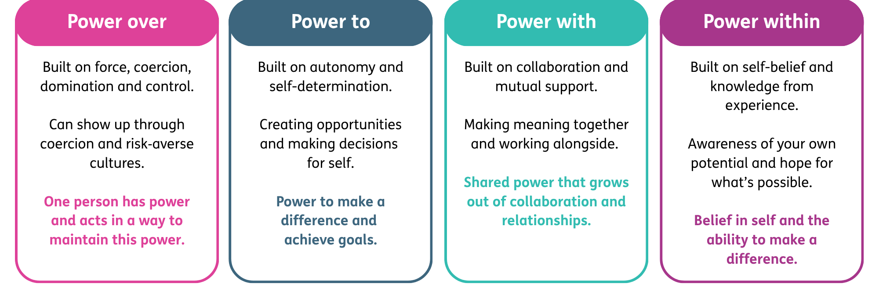
- Word version of the power diagram.
Empowerment
Empowerment is the process whereby people take control of their lives. It is central to recovery and can be understood as having a sense of personal strength and by having control over one’s life. The process of empowerment may also produce hope, another key aspect of recovery. Power as a commodity is something which is rarely given away and generally has to be taken in some form. This means you cannot necessarily empower another person. However, peer support can create an environment that encourages people to take a greater degree of power and control in their own recovery.
It is also possible for empowerment to happen in negative circumstances. For example, where the anger felt by people who have been marginalised or oppressed is used as a motivator for social change. In these moments, holding power is about having the ability to shape change. This reflects the social justice roots of peer support, which emerged from activist movements led by people with lived experience who challenged oppressive systems and built communities of mutual aid.
The opposite of empowerment is disempowerment. Having an understanding of how power may be taken away and how that feels may help develop our learning on how to take it back. Peer workers can also unintentionally disempower others. For example, by making assumptions about what a person needs, or stepping into a “fixing” role.
Power, choice and control in the peer relationship
Peer workers can sometimes fall into some of the helping behaviours that they have experienced during their own recovery, especially roles that involve taking charge, fixing things, or stepping in as the “rescuer”. These patterns are understandable, because many people have learned to navigate support systems where power wasn’t shared. But by remembering the role of mutuality peer workers can put the focus back on being with a person, rather than doing for them. As mutuality builds in the peer relationship, we can explore what our respective experiences have been in relation to accessing help and support. This conversation can help in identifying patterns and ways of being in supportive relationships, like stepping into a “rescuer” role, taking over decisions, or assuming we know what someone needs. These patterns often involve what we call power dynamics.
We all need some power in order to make choices, express our needs, and access what matters to us for recovery. It’s how peer workers use this power in relationships that can potentially cause problems. The way we use our power is dependent on how we’ve learned to influence or control things in our own lives, such as how we’ve learned to cope, protect ourselves, or get things done. It’s natural that power struggles or imbalances can show up.
Employed peer workers should be particularly aware of these power dynamics as being paid for the role can amplify the sense of authority or expertise in the relationship. Staying aware of this and drawing on peer values helps peer workers avoid slipping into roles that take power away from the other person.
Session plan
Two-hours and 30 minutes session. Deliver in person or online. Recommend no more than 15 participants for 2 facilitators. Participants should review and complete the reflective activities in their workbook before the session and bring this along on the day.

Activities  & timing | Resources needed | Guidance
Welcome and introductions  10 minutes | Slide one  Sticky label name badges | Welcome participants when they arrive, make everyone feel comfortable, use people’s names, and thank them for coming.  - 5 minutes: Cover any housekeeping and break times  - 5 minutes: Facilitators and participants all invited to share their names and pronouns. This can be done verbally or, if online, using the chat as an introduction.  A reminder to keep this introduction brief to one or two sentences to keep to time. Invite but do not force people to share their pronouns.
Learning intentions  5 minutes | Slide two | Share the learning intentions from the slide helps participants to know the purpose of the session and what to expect. Facilitators can read them out or invite a participant to read each one.  Check in to see if everyone understands them. Answer any questions people may have at this point.
Group learning agreement  15 minutes | Slide three | To ensure this space remains positive, safe, and empowering for everyone, we will co-create and/or review our group learning agreement.  - If this is the first session: dedicate time to creating the learning agreement together, using CHIME as a guiding framework  - If this is a subsequent session: begin by reviewing the existing agreement, inviting participants to check in and suggest additions or changes
Checking in  10 minutes | Slide four | At the start and end of each session, we’ll use a simple check in and check out question. Everyone gets a couple of minutes to think about it and jot down notes if they wish.  Checking in question: What’s a small way you have used your power recently that had a positive impact on someone else?  After two minutes, model your response then invite people to share their thoughts. Thank each person as they speak, but don’t add your own commentary. Once everyone’s had a turn, reflect back some of the common themes you heard. Wrap it up by saying this is a great way to get everyone’s voice in the room and set the tone together.
Introduction to the topic  20 minutes | Slide five – seven  Slide five  Slide six  Slide seven  Participant workbook | Purpose: To understand the power peer supporters have and the factors that influence this.  - 5 minutes: Facilitators should read out, or invite a few participants to volunteer to read out, the slides on the power framework.  - Then read out slide 6 on the “Power framework” which offers a way to explore how power can limit or strengthen the peer relationship.  Activity one: Understanding power dynamics  - 5 minutes: Individual reflection: Participants will complete the self-reflection activity in the workbook to reflect on what power they hold and what is outside of their power.  - 10 minutes: Group discussions: Break the participants into groups of 3-4. Invite the groups to discuss the following questions:  - What kinds of power might a peer supporter have, even in a relationship that aims to be equal?  - What influences how much power a peer supporter holds?  Key points: Participants will recognise that everyone holds some form of power in relationships even when the intention is equality. Encourage participants to see power as something that can be used positively to create safety and shared decision‑making, while also acknowledging the limits of their role and what sits outside their control.  Sample script: “Power dynamics can affect how people communicate, relate, and trust each other, and they can have positive or negative impacts on the outcomes of peer support. As peer workers, having an awareness of the power we hold can enable us to show up with more authenticity in our peer relationships. Even in relationships built on mutuality, peer workers inherently hold more power. Acknowledging this openly and being transparent and authentic about how it shapes the dynamic, is essential to maintaining trust.”
10 minutes | Slide eight | Comfort break  (suggest setting a timer to alert participants when to return)
Mutuality and empowerment  30 minutes | Slide nine – 12  Slide nine - 10  Slide 11  Participant workbook  Slide 12 | Purpose: To explore how the peer values of empowerment and mutuality can be practiced to balance power in peer relationships.  Sample script: “Empowerment is the process whereby people take control of their lives. Power as a commodity is something which is rarely given away and generally has to be taken in some form. This means you cannot necessarily empower another person. However, peer support can create an environment that encourages people to take a greater degree of power and control in their own recovery. We will explore how our peer values can guide our practice to create the conditions for this in the peer relationship”  - 5 minutes: Facilitators should read out, or invite a few participants to volunteer to read out, the slides on empowerment and disempowerment.  Activity two: Mutuality and empowerment role play  - Pairs discussion: In pairs, participants will take turns role playing. They may wish to use a scenario starter in the workbook, or create their own scenario. As a facilitator, you may wish to role model a scenario with one of the participants before starting.  - 10 minutes: For the first round, the peer worker role should respond to the scenario in a negative way, which would disempower and be non-mutual. After the role play, the pair will reflect on:  - In what ways did the peer supporter disempower and not practice mutuality?  - How might this response impact the relationship?  - 10 minutes: For the second round, the peer worker role should respond to the same scenario in a positive way, which would practice empowerment and mutuality. After the role play, the pair will reflect on:  - In what ways did the peer worker practice empowerment and mutuality?  - How might this response impact the relationship?  - 5 minutes: Bring the participants back as a whole room and ask:  - What will you take forward from this activity about practicing mutuality and empowerment in your peer relationships?  Key points: Participants will explore how mutuality involves shared decision‑making and curiosity, and how empowerment is not about “fixing” or “rescuing” but instead is about supporting the other person’s agency. Encourage participants to notice the emotional impact of each approach and the impact each approach could have on the outcomes of the support. Reinforce that peer workers always hold some power, practising mutuality is a way of using that power positively.
Power and roles in the peer relationship  35 minutes | Slide 13 – 14  Slide 13  Slide 14  Slide 15  Participant workbook  Slide 16 | Purpose: To explore the roles that may arise in peer support relationships, and the impact of power, choice, and control.  Sample script: “Peer workers can sometimes slip into familiar helping roles; like taking charge, fixing things, or stepping in as the ‘rescuer.’ These patterns make sense, especially when many people have come through systems where power wasn’t shared. Through role play scenarios we will explore how these different roles can influence power and outcomes in the peer relationship.”  - 5 minutes: Facilitators should read out or invite a few participants to volunteer to read out the slide on power, choice and control.  Activity three: Power and roles in the peer relationship  - Read out the below scenario to the room:  You have been in a peer support relationship with Sue for a couple of months and things seem to be progressing well. She has told you how much she enjoys working with you and you’re feeling pretty confident. Today she tells you that she is afraid of talking to her doctor about decreasing her medication. Sue knows that you successfully reduced your medication in the past and asks you to talk to her doctor on her behalf.  - 10 minutes: Group discussion: Split the participants into 3 groups. Assign each group one way to respond from the list below. Encourage the groups to work through how each response may play out in reality.  - Persuading Sue that she can do it herself…”If I managed it so can you.”  - Offering to speak to the doctor for Sue as requested.  - Refusing point blank to get involved in the discussion…”I’m not supposed to talk about people’s treatments, I’m here to work on recovery with you”  - Participants should use the prompts in the workbook to guide their discussion which encourages them to think about:  - The role and impact of power  - The possible impact on the relationship  - 5 minutes: Bring the groups back and ask each group to feedback their key points.  - 10 minutes: Group discussion: In the same groups, participants will now respond to the scenario in a way that maintains mutuality and empowerment. They can capture how they would respond in their workbook.  - 5 minutes: Bring the group back as a whole room as invite each group to share how they would respond in a way that maintains mutuality and empowerment. Capture key themes on flipchart.  Key points: Participants will unpack the subtle but significant power dynamics that arise when someone asks a peer supporter to act on their behalf. The role play scenarios will help participants understand how easily peer workers can slip into persuading, rescuing, or distancing, and how each response can either increase or decrease power imbalances. When groups move to designing an empowering, mutual response, highlight how Sue sees the peer supporter as having more power and more capability. Encourage participants to focus their responses around making a connection and being curious.
Learning intentions  5 minutes | Slide 17 | This slide lists the learning intentions we set out to cover at the beginning of the session. Review these again and ask the group if they feel we have covered the topics.
Checking out  10 minutes | Slide 18 | Note: This is a closing activity. If you are running two of these sessions together then save this until the end of the second session.  Closing question: What’s one thing you are taking away from today’s session?  After two minutes, invite people to share their thoughts. Thank each person as they speak, but don’t add your own commentary. Once everyone’s had a turn, reflect back some of the common themes you heard.  Thank everyone, remind them about the next session and the prep for this session outlines in their participant workbook.  As a facilitator if it is helpful, you can complete the facilitator reflections template.

