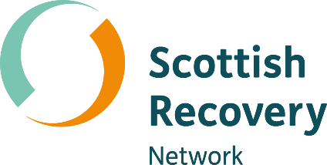

Balancing power in peer support

Peer2Peer: module three, session four
Participant workbook



Module three: Peer concepts and practice
Welcome to module three of the Peer2Peer group training course!
This module builds on the foundations developed in modules one and two, focusing on applying peer support concepts and skills in practice. It is designed for people who already have a solid understanding of peer support or experience delivering it and can also be used as continuing professional development for existing peer workers. This module supports you to deepen your practice and strengthen your confidence in supporting the recovery journey of others.

Purpose of the participant workbook
The workbook is designed to support your learning journey. It gives you space to prepare for each session, reflect on your experiences, and capture your own thoughts. There are no right or wrong answers and facilitators won’t be reading what you write.
Peer2Peer is a learning experience where you will be encouraged to draw on your lived experience to facilitate learning and skills development. It’s important you only share what you are comfortable with and that we recommend making time for self-care after the sessions.

Doing the pre-work before each session helps you arrive with clear thinking and makes it easier to contribute to conversations. It’s a good habit to build for your peer role, or for a future one.

Session four: Balancing power in peer support
Learning intentions
- Understand the power peer workers have and the influencing factors
- Explore how the peer values can be practiced to balance power in peer relationships
- Explore the roles that may arise in peer relationships and the impact of power, choice and control

Checking in question
What’s a small way you have used your power recently that had a positive impact on someone else?
(examples may include sharing knowledge or kind words, setting a boundary, or practical support)
Understanding power dynamics
Power dynamics can affect how people communicate, relate, and trust each other, and they can have positive or negative impacts on the outcomes of peer support. Lived experience is shaped by many parts of who we are; our privilege, trauma, culture, and identity all influence what we went through and how it affects us now. For peer workers, understanding these layers helps us see the power we hold and show up with more authenticity in our peer relationships. It also helps us notice where power sits in the moment, how to use it responsibly, and how to rebalance it when needed. Power can show up in peer support in several different ways through structural power (systems and roles), relational power (how we interact), and internal power (our experience).
Even in relationships built on mutuality, peer workers inherently hold more power. Acknowledging this openly and being transparent and authentic about how it shapes the dynamic, is essential to maintaining trust. In peer support, authenticity and mutuality are core values, and putting these values into practice helps rebalance power.
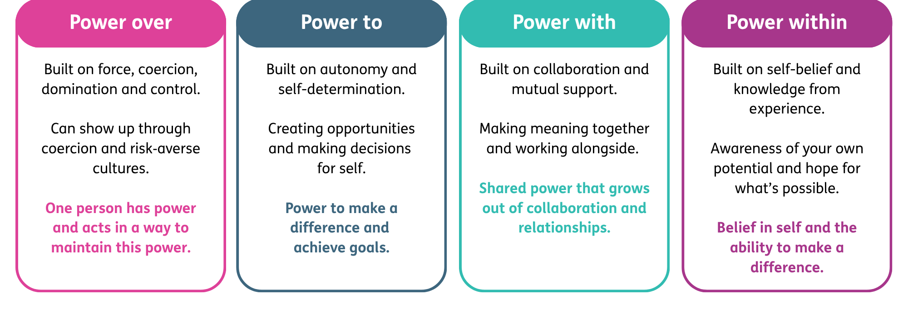
Understanding the different ways power shows up in the peer relationship helps us notice how power shifts and is shared. The “Power framework” below offers a way to explore how power can limit or strengthen the peer relationship.
- Word version of the power diagram.

Activity one: Understanding power dynamics
Individual reflection
As humans we all hold some form of power, even if we aren’t aware of it. Use the self-reflection circle over page to think about the following:
- Within my power: things you can influence, choose or shape
- Outside my power: things I cannot control
Outside my power

Within my power
Group discussion
- What kinds of power might a peer worker have, even in a relationship that aims to be equal?
- What influences how much power a peer worker holds?
Empowerment
Empowerment is the process whereby people take control of their lives. It is central to recovery and can be understood as having a sense of personal strength and by having control over one’s life. The process of empowerment may also produce hope, another key aspect of recovery. Power as a commodity is something which is rarely given away and generally has to be taken in some form. This means you cannot necessarily empower another person. However, peer support can create an environment that encourages people to take a greater degree of power and control in their own recovery.
It is also possible for empowerment to happen in negative circumstances. For example, where the anger felt by people who have been marginalised or oppressed is used as a motivator for social change. In these moments, holding power is about having the ability to shape change. This reflects the social justice roots of peer support, which emerged from activist movements led by people with lived experience who challenged oppressive systems and built communities of mutual aid.
The opposite of empowerment is disempowerment. Having an understanding of how power may be taken away and how that feels may help develop our learning on how to take it back. Peer workers can also unintentionally disempower others. For example, by making assumptions about what a person needs, or stepping into a “fixing” role.

Activity two: Mutuality and empowerment role play
In pairs, you will take turns role playing. One person will be the peer worker, and the other will be the person being supported. You may wish to use one of the scenario starters below or create your own.
Examples
- Callum arrives looking exhausted and says “I’m failing at being a parent. My daughter hasn’t slept properly in days and I don’t know what else to do.”
- Aisha feels uncertain about the future and says “My support worker thinks I should apply for this arts programme, but I’m not sure it’s right for me."
- Mark attends a weekly peer support group. He sends you a message which says “I tried speaking up in the group yesterday, but nobody listened. Maybe I should just stop going.”

- Riley recently started a new job. When catching up about her first week she says “I keep messing things up. I don’t think I’m capable of this right now.”

Role play round one
The person playing the peer worker should respond to the scenario in a negative way which would disempower and be non-mutual. This may look like:
- Non-mutual: the conversation is one-way and both sides don’t gain anything from it
- Not empathetic: there is a lack of genuine understanding founded on shared experience
- Disempowering: someone feels less powerful as a result of the exchange, they may feel less able to find their own way forward or feel dependant on the other person
- Falling into the ‘expert trap’: the peer supporter advising or guiding based on their own experience rather than supporting the person to find their own way forward

After the role play reflect together on the following:
In what ways did the peer worker disempower and not practice mutuality?

How might this response impact the relationship?
Role play round two
Swap roles. The person playing the peer worker should now respond to the same scenario in a positive way which would practice empowerment and mutuality. This may look like:
- Mutual: the exchange is two way, both parties benefit, and there is a sense of interdependence
- Empathic: there is real and genuine understanding of the other person’s situation based on a shared experience which does not involve pity or sympathy
- Empowering: there is a greater sense of self direction and control as a result of the exchange
After the role play reflect together on the following:
In what ways did the peer worker practice empowerment and mutuality?

How might this response impact the relationship?
One thing I will take forward in my peer relationships to practice empowerment and mutuality is…

Power, choice and control in the peer relationship
Peer workers can sometimes fall into some of the helping behaviours that they have experienced during their own recovery, especially roles that involve taking charge, fixing things, or stepping in as the “rescuer”. These patterns are understandable, because many people have learned to navigate support systems where power wasn’t shared. But by remembering the role of mutuality peer workers can put the focus back on being with a person, rather than doing for them. As mutuality builds in the peer relationship, we can explore what our respective experiences have been in relation to accessing help and support. This conversation can help in identifying patterns and ways of being in supportive relationships, like stepping into a “rescuer” role, taking over decisions, or assuming we know what someone needs. These patterns often involve what we call power dynamics.
We all need some power in order to make choices, express our needs, and access what matters to us for recovery. It’s how peer workers use this power in relationships that can potentially cause problems. The way we use our power is dependent on how we’ve learned to influence or control things in our own lives, such as how we’ve learned to cope, protect ourselves, or get things done. It’s natural that power struggles or imbalances can show up.
Employed peer workers should be particularly aware of these power dynamics as being paid for the role can amplify the sense of authority or expertise in the relationship. Staying aware of this and drawing on peer values helps peer workers avoid slipping into roles that take power away from the other person.

Activity three: Power and roles in the peer relationship
Scenario
You have been in a peer support relationship with Sue for a couple of months and things seem to be progressing well. She has told you how much she enjoys working with you and you’re feeling pretty confident. Today she tells you that she is afraid of talking to her doctor about decreasing her medication. Sue knows that you successfully reduced your medication in the past and asks you to talk to her doctor on her behalf.

Group discussion
The facilitator will assign your group one of the following approaches to respond to Sue:
- Persuading Sue that she can do it herself…”If I managed it so can you.”
- Offering to speak to the doctor for Sue as requested.
- Refusing point blank to get involved in the discussion…”I’m not supposed to talk about people’s treatments, I’m here to work on recovery with you”
In your groups, work through how each response may play out in reality. Afterwards, discuss the questions over page. Space for notes:

Who holds the power in this approach? (refer back to the power framework if helpful)

What impact may this approach have on the peer worker’s relationship with Sue?
How would you respond to Sue in a way that maintains empowerment and mutuality?

Closing reflection: What’s one thing you are taking away from today’s session?

Resource list
- Putting the Pieces Together: A Framework for Mental Health Peer Support in Scotland – Scottish Recovery Network
- Peer2Peer manual Sessions 4 and 5 (pages 51 and 62) - Peer2Peer project partners: Scottish Recovery Network (Scotland), Fundación INTRAS (Spain), EASP (Spain), Martín Tellez (Spain). Pro mente Oberöstereich (Austria). LRPSM (Romania)
- A relationship of shared power – Colorada Mental Wellness Network
- Four types of power – Sustaining Communities

