

Navigating discomfort
in the peer relationship

Peer2Peer: module three, session three
Participant workbook


Module three: peer concepts and practice
Welcome to module three of the Peer2Peer group training course!
This module builds on the foundations developed in Modules one and two, focusing on applying peer support concepts and skills in practice. It is designed for people who already have a solid understanding of peer support or experience delivering it and can also be used as continuing professional development for existing peer workers. This module supports you to deepen your practice and strengthen your confidence in supporting the recovery journey of others.

Purpose of the workbook
The workbook is designed to support your learning journey. It gives you space to prepare for each session, reflect on your experiences, and capture your own thoughts. There are no right or wrong answers and facilitators won’t be reading what you write.
Peer2Peer is a learning experience where you will be encouraged to draw on your lived experience to facilitate learning and skills development. It’s important you only share what you are comfortable with and that we recommend making time for self-care after the sessions.

Doing the pre-work before each session helps you arrive with clear thinking and makes it easier to contribute to conversations. It’s a good habit to build for your peer role, or for a future one.

Session three: Navigating discomfort in the peer relationship
Learning intentions
- Recognise how discomfort can arise in different ways in the peer relationships
- Explore values-led approaches to navigating discomfort in peer relationships
- Explore how reflection and support strengthen peer practice

Checking in question
- If you had a ‘superpower’ for navigating discomfort, what would you say it is?
(you may choose to think big and create never before heard of powers or draw on your existing skills)

Understanding discomfort in the peer relationship
Peer workers bring their lived experience of mental health recovery into their role. Sharing experiences enables a deeper connection, empathy and trust, but it can also bring a level of emotional complexity and discomfort to the peer relationship. Discomfort is not only common, both for the peer worker and the people supported, but also an expected and important part of the work.
Discomfort in peer relationships is a learning experience because it reveals personal and relational dynamics that may otherwise go unnoticed. It can be a sign that something important is going on. Maybe it’s a boundary being pushed, a past experience being activated or a need not being met. Noticing discomfort and taking time to understand it can create space for more open conversations, shared understandings, meaningful support and respectful relationships. To understand our experiences more clearly, we can explore discomfort through three lenses:
- Personal discomfort is what ‘I experience’ in the peer relationship and is a common experience. It arises when something ‘feels off’ and can show up as tension, emotional overwhelm or a gut feeling during or after a connection with someone.
- Relational discomfort is where there are challenging dynamics impacting on the peer relationship, it is experienced between people. We are all unique and our worldviews are shaped by different life experiences, beliefs and values. It is natural that this may cause points of discomfort to arise in the peer relationship. It is not because anyone is doing anything wrong.
- Environmental discomfort comes from the setting. The environment can powerfully shape how peer relationships are experienced as safe, supportive and equal.

Activity one: Recognising discomfort
Group discussion
In groups, the facilitator will assign you one of the following three levels of discomfort to discuss in your group. One member of the group should act as a scribe and record key points from discussions to feed back to the wider group.
Personal discomfort
- How do you recognise when you are experiencing personal discomfort in a peer relationship?
- What signs tell you something is off?
- How might you notice when the other person is experiencing personal discomfort?
Relational discomfort
- What helps you recognise when discomfort is happening between you and the other person?
- What signals that something in the relationship is creating tension?
- How do you notice when the relationship itself feels misaligned?

Environmental discomfort
- How do you recognise when the setting is contributing to discomfort (for you or for the person you’re supporting)?
- What signals that the space doesn’t feel safe or supportive?
- How might you notice when the other person is being affected by the environment?

Space for notes
Navigating discomfort
We know that peer workers skilfully balance their own feelings and the dynamic of the peer relationship. Whilst vulnerability can be high in the peer relationship, navigating discomfort requires a level of honesty, openness and empathy. Discomfort doesn’t need to be avoided or ignored. Peer supporters tell us it takes courage and compassion to work through discomfort. They describe how modelling ways to navigate discomfort becomes an opportunity for growth, both for themselves and those they are in relationship with.
Peer relationships start with values. We explored this in the What makes peer support unique? animation. Using the key elements of peer relationships enables us to find ways of acknowledging and responding to discomfort with intention. This deepens the peer connection and supports everyone’s wellbeing.
Peer support is mutual and grounded in shared lived experience. It is about holding space, listening and validating, not ‘fixing’. Discomfort can arise from boundaries, differing experiences, emotional intensity or when something evokes a strong reaction due to personal experiences.

- Shared lived experiences build trust, empathy and understanding, focusing on the person and their life experiences, not just diagnosis.
- Mutual relationships are built on equality; people walk alongside rather than trying to fix one another, valuing lives experience and bringing learning and insight to those involved.
- Supportive relationships are rooted in hope. Peers show that recovery is possible and are evidence that things can get better.
- Intentional space means peer support isn’t just about telling your story; it’s creating a collaborative space where peers use their experiences purposefully to support others to find their own recovery path.


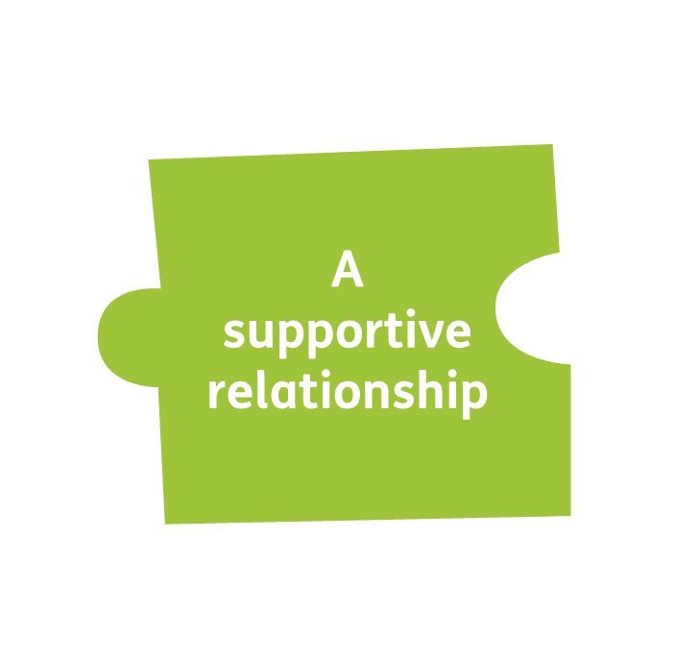
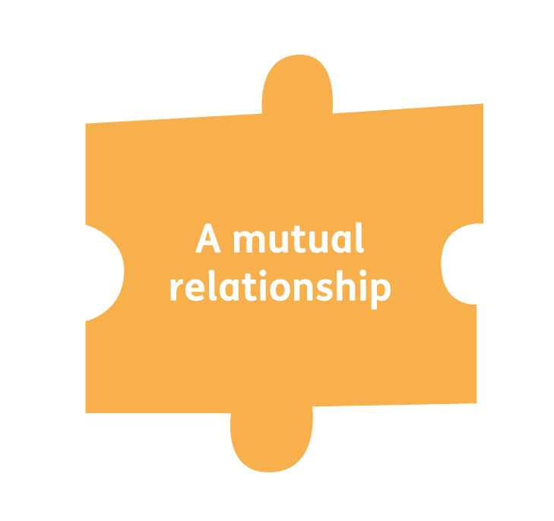


Activity two: Navigating discomfort with peer values
The facilitator will read out scenarios based on peer support experiences. You will then choose one of the peer values that you would draw on most when navigating this scenario. Think about:
- Why did you choose this value?
- What would this value look like in action?
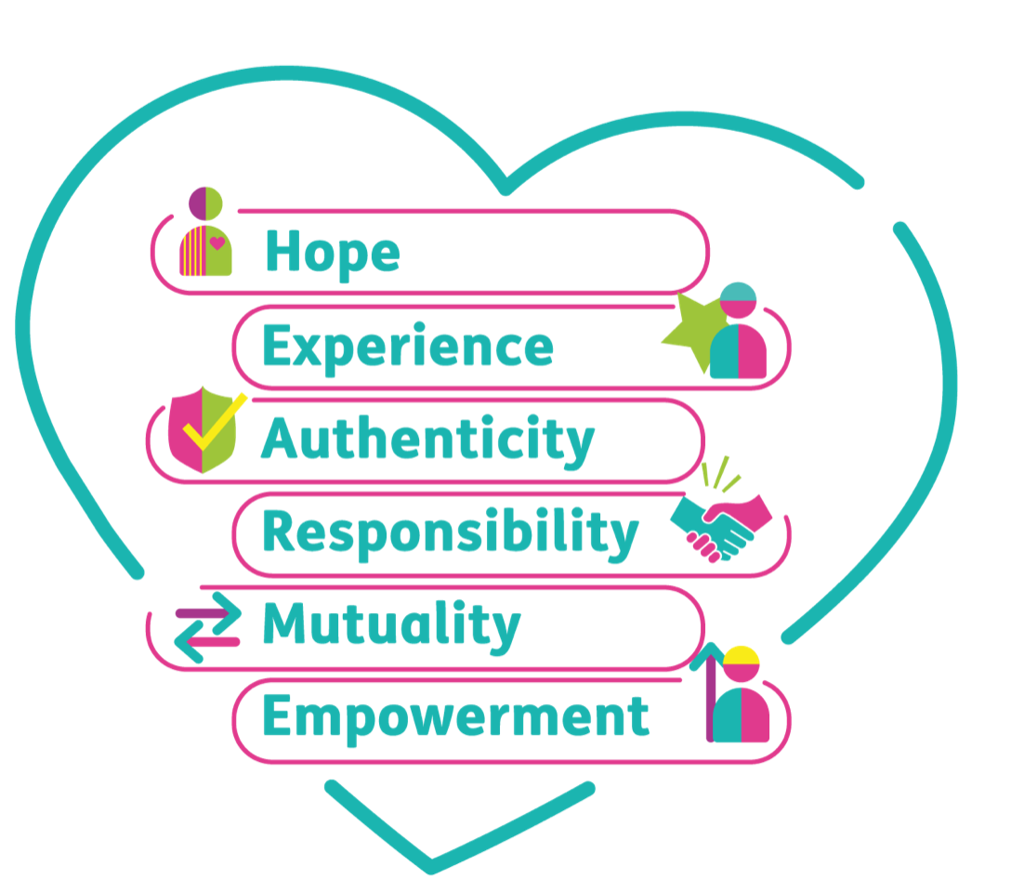

Reflection and support
Reflection and support are important to peer practice. Discomfort can be an insightful learning experience. Making the time and space to intentionally reflect on points of discomfort provides peer workers with the opportunity to understand what may have led to discomfort, build resilience and grow in their peer role.
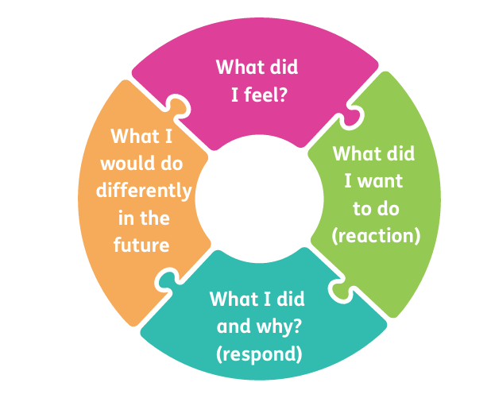
Reflecting with others can help peer workers understand something from a different perspective. Ways that peer workers have found useful include self-reflection, journaling, peer reflection with other peer workers and within support and supervision. The peer reflective circle above can be useful for this process. There are reflective tools for peer workers in the Navigating Discomfort in the Peer Relationship practice guide.

Activity three: Reflective practice
In pairs, one person describes a situation where they experienced discomfort in their peer relationship. Think about:
- What happened?
- What may have been going on for the other person?
- What were your initial feelings or reactions?

Using the peer reflective circle worksheet in over page, the partner will guide a conversation with the person sharing their experience.
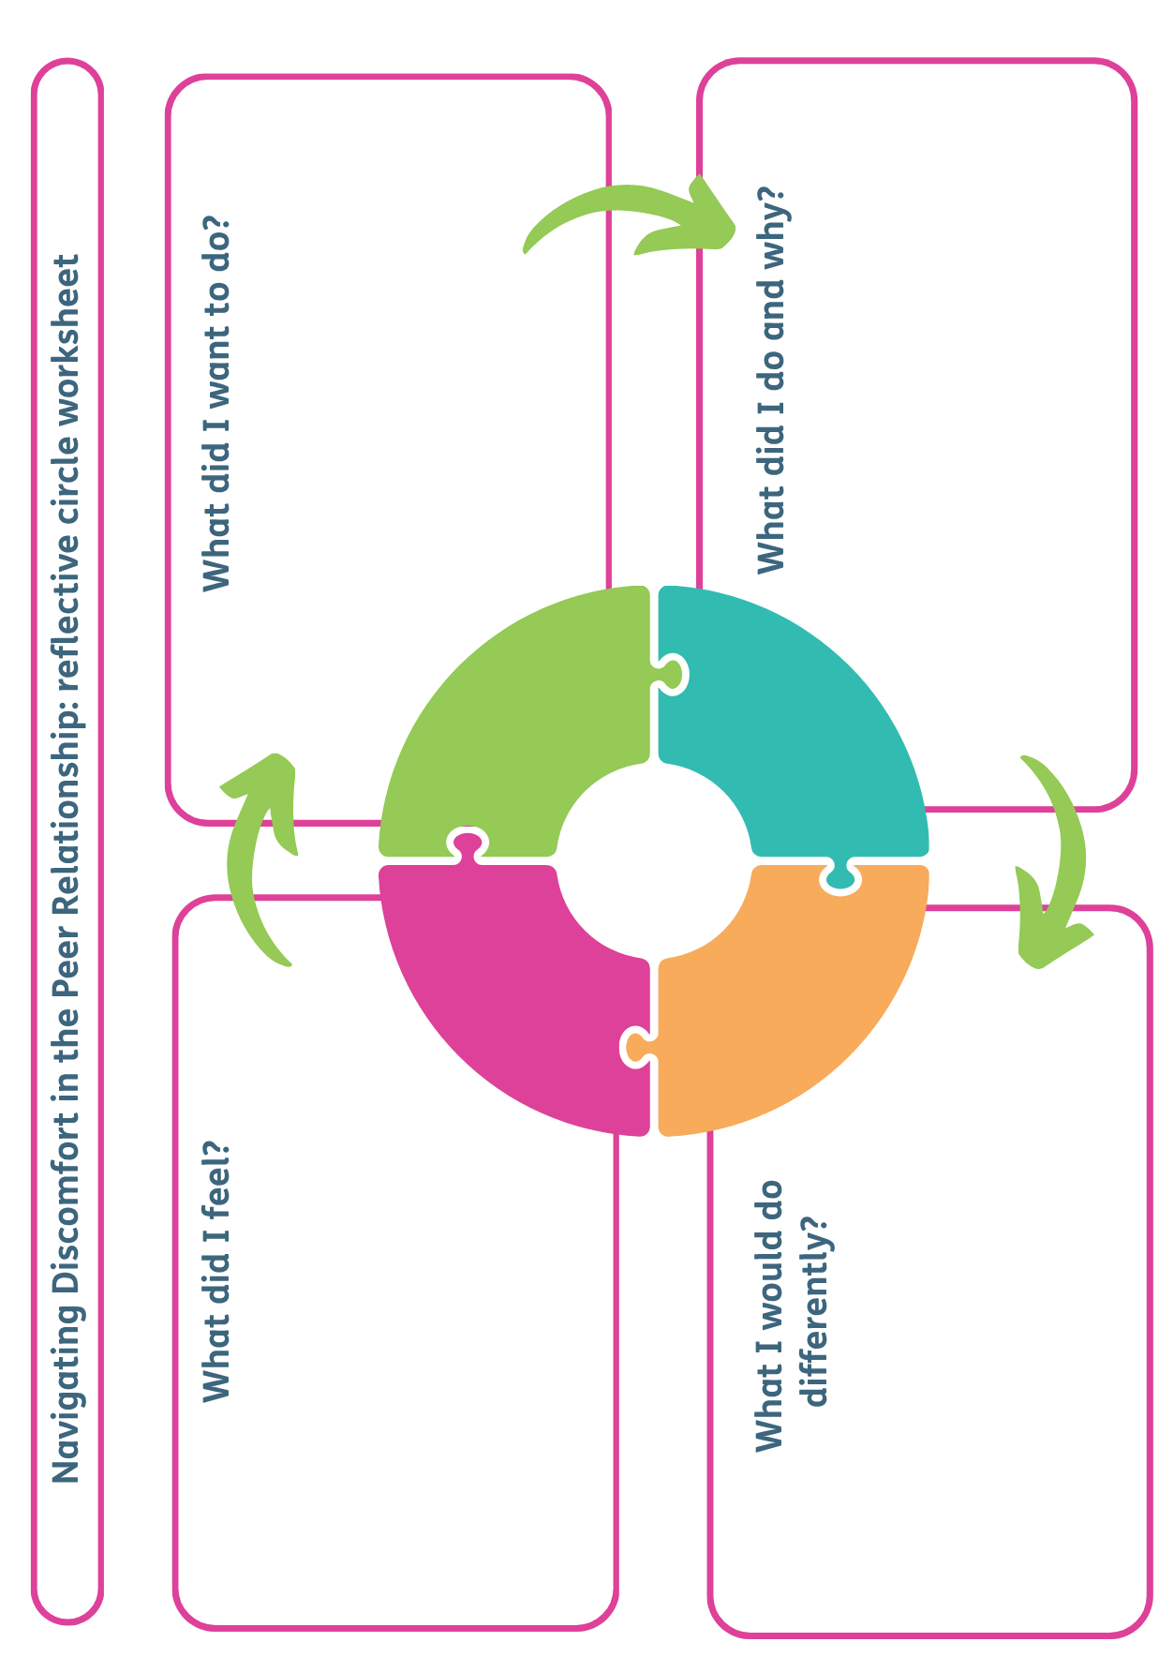
Closing reflection: What’s one thing you are taking away from today’s session?
Resource list
Films
- Navigating discomfort in the peer relationship – Scottish Recovery Network and Bipolar Scotland
Further quotes and reading
- Navigating discomfort practice guide – Scottish Recovery Network
- Creating Hope with Peer Support resources – Scottish Recovery Network
- Holding space for distress – Blog by Paul Byrne, Peer Recovery Development Worker

