
An introduction to
understanding trauma

Peer2Peer: module three, session two
Participant workbook


Module three: peer concepts and practice
Welcome to module three of Peer2Peer!
This module explores the practical application of peer knowledge and skills in supporting the recovery journey of others. It introduces key concepts of peer practice and provides opportunities to develop and apply these skills in real-world contexts. Peer supporters may find these sessions useful as Continuing Professional Development.
Purpose of the participant workbook
The workbook is designed to support your learning journey. It gives you space to prepare for each session, reflect on your experiences, and capture your own thoughts. There are no right or wrong answers and facilitators won’t be reading what you write.
Peer2Peer is a learning experience where you will be encouraged to draw on your lived experience to facilitate learning and skills development. It’s important you only share what you are comfortable with and that we recommend making time for self-care after the sessions.

Doing the pre-work before each session helps you arrive with clear thinking and makes it easier to contribute to conversations. It’s a good habit to build for your peer role, or for a future one.

Session two: An introduction to understanding trauma
Learning intentions
- Understand trauma from different perspectives
- Reflect on our own experiences of trauma and how they show up in our practice
- Explore how trauma can be experienced individually, relationally and systemically

Checking in question
In pairs you will co-reflect on one of the following questions
- Why do we need to understand experiences of trauma in peer support?
- How do experiences of trauma show up in our peer-to-peer relationships?

Understanding trauma
Trauma is a complex and deeply personal experience that influences how people see themselves, others, and the world. In peer support, understanding the complexities of trauma is essential because many people who seek or offer peer support have lived through or are living through experiences that may still be impacting their lives. Trauma can be individual, relational, or systemic or a combination of all three and its effects often show up in ways that shape our communication, ability to feel trust, impacts our sense of safety, and can keep us disconnected.


Activity one: Understanding trauma from different perspectives
Below are different definitions and quotes on trauma that you should read, self-reflect on then discuss in your groups. You might want to highlight or circle some of the words that jump out for you or that you connect to in the quotes.
Quotes and definitions
Being able to feel safe with other people is probably the single most important aspect of mental health; safe connections are fundamental to meaningful and satisfying lives. ― Bessel A. van der Kolk

Trauma is not what happens to you; it is what happens inside you as a result of what happens to you. ― Gabor Mate
There is no thing as a single-issue struggle because we do not live single-issue lives. ― Audre Lorde
After a traumatic experience, the human system of self-preservation seems to go onto permanent alert, as if the danger might return at any moment. ― Judith Herman
Trauma is hell on earth. Trauma resolved is a gift from the gods. ― Peter A. Levine
Group discussion
- What jumps out for you from the quotes shared and why is it important for peer support practice?

Activity two: Your own experiences of trauma and how they show up in practice
Individual reflection
Create your own definition of trauma that makes sense to you:
Group discussion:
How does your own definition or understanding of trauma show up in your peer-to-peer practice?

Notes/self-reflection thoughts:
Activity three: Continuum on the impact of trauma
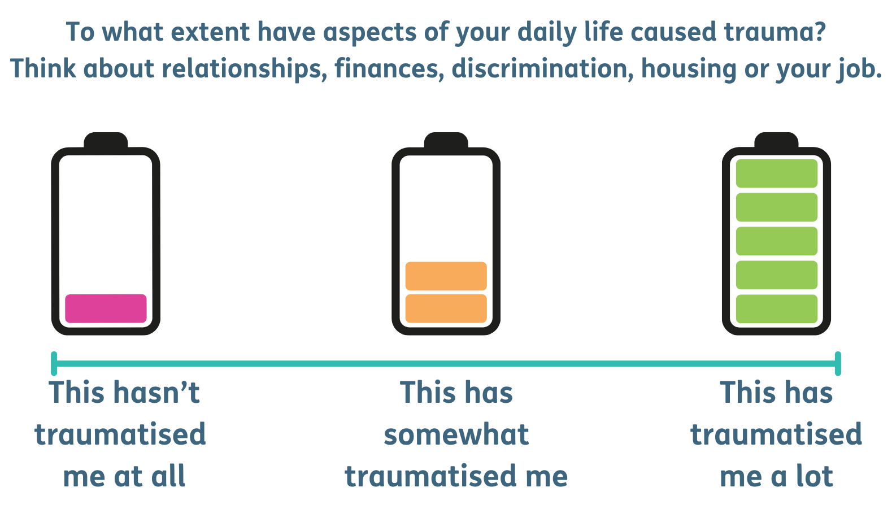
Mark the place where you think you fit on the continuums below:
Notes/self-reflection thoughts:

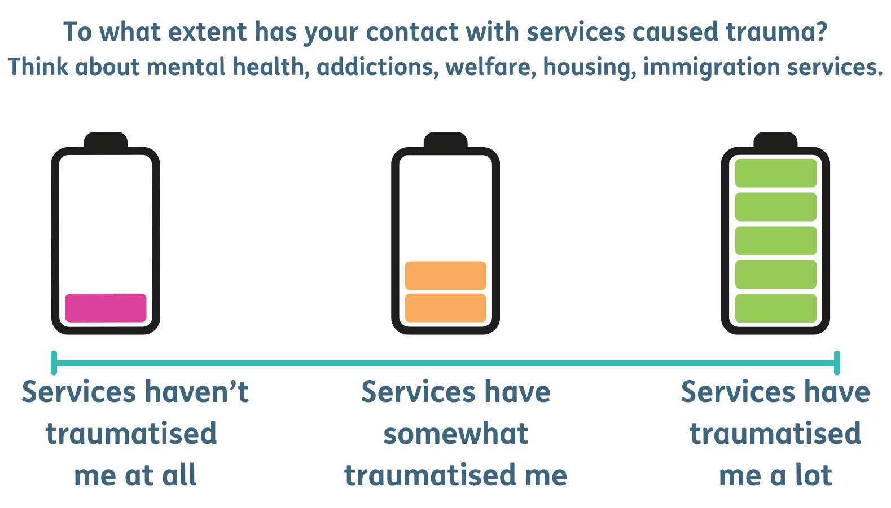
Notes / self-reflection thoughts:

Trauma and peer support
In peer support, understanding trauma encourages us to recognise the importance of relational safety, mutuality, and authentic connection. It invites us to reflect on our own experiences of trauma, noticing how our lived experiences influence the way we show up for others and the language we might use. Peer relationships are built on reciprocity, and understanding trauma helps us to connect, share our worldviews, negotiate relational accountability and be more aware of power dynamics.

Closing reflection: What’s one thing you are taking away from today’s session?

Resource list
Films
- What does living with trauma feel like for different people? – Scottish Recovery Network
- The Body Keeps the Score (7m 48s) - Bessel van der Kolk
- The secret to healing trauma - Gabor Mate
Books
- On our own: patient-controlled alternatives to the mental health system - Judi Chamberlin
- Warp & Weft: Psycho-Emotional Health, Politics and Experiences – Lisa Fannen
- Trauma and recovery – Judith Herman
- Waking the tiger: Healing trauma: the innate capacity to transform overwhelming experiences – Peter A. Levine
- Sister Outsider: Essays and Speeches (Crossing Press) – Audre Lorde
- The myth of normal: trauma, illness, & healing in a toxic culture - Gabor Maté and Daniel Maté
- Trauma industrial complex: how oversharing became a product in a digital world – Darren McGarvey
- The Body Keeps the Score: Brain, Mind, and Body in the Healing of Trauma – Bessel van der Kolk

Further quotes and readings
Recovery can take place only within the context of relationships; it cannot occur in isolation. ― Judith Herman

If your parents’ faces never lit up when they looked at you, it’s hard to know what it feels like to be loved and cherished. If you come from an incomprehensible world filled with secrecy and fear, it’s almost impossible to find the words to express what you have endured. If you grew up unwanted and ignored, it is a major challenge to develop a visceral sense of agency and self-worth. ― Bessel A. van der Kolk

Poetry
The trauma said, “Don’t write these poems.
Nobody wants to hear you cry
about the grief inside your bones.”
My bones said, “Write the poems.”

― Andrea Gibson, The Madness Vase

“and when we speak we are afraid
our words will not be heard
nor welcomed
but when we are silent

we are still afraid
So it is better to speak

remembering
we were never meant to survive”
― Audre Lorde, The Black Unicorn: Poems

