

Peer values into practice

Peer2Peer: module two, session three
Facilitator session plan



Module two: The peer support relationship
Welcome to module two of Peer2Peer!
This second module begins to explore the skills we will draw on through peer practice. Through completing this module, participants will move from being informed about peer support, to feeling confident in their ability to support others through peer practice, having a deep understanding of the skills involved.
The session plan offers some handy background information and a suggested plan, but feel free to adapt it to fit your group. Be mindful your role isn’t about being the “expert with all the answers,” it’s about creating a learning space that draws on the knowledge and lived experience in the room.

Before starting this module
We recommend participants complete Preparing for Peer2Peer: participant readiness workbook and Introduction to peer support (module one).
Before facilitating take time to get familiar with this module two, session three plan and the associated participant workbook. Make sure everyone has their own copy of the participant workbook for this session and encourage them to look over the reflection activities beforehand. Ask them to bring their participant workbook along on the day and keep a few spares handy just in case.

After the session
- Complete the facilitator reflections template
- Remind participants to review and finish the reflection activities in their participant workbook before the next session
- Update the group learning agreement slide after the session, ready for future sessions

Session three: Peer values into practice
Learning intentions
- Understand the core values of peer support and their purpose
- Explore how peer values shape the development and delivery of peer support
- Explore how reflecting through the peer values framework can strengthen peer practice
Peer values
In peer support, values come from lived experience and have a history rooted in the survivor and social justice movements. Values shape how peer support is developed, guide how it is delivered and support it to stay true to its roots. Peer values are essential to peer practice and ensure that the relationship is centred on shared lived experience, mutuality, and respect. In Scotland, Scottish Recovery Network, worked with peer workers to develop a peer values framework which anchors peer support in six core values that we call HEAR ME.
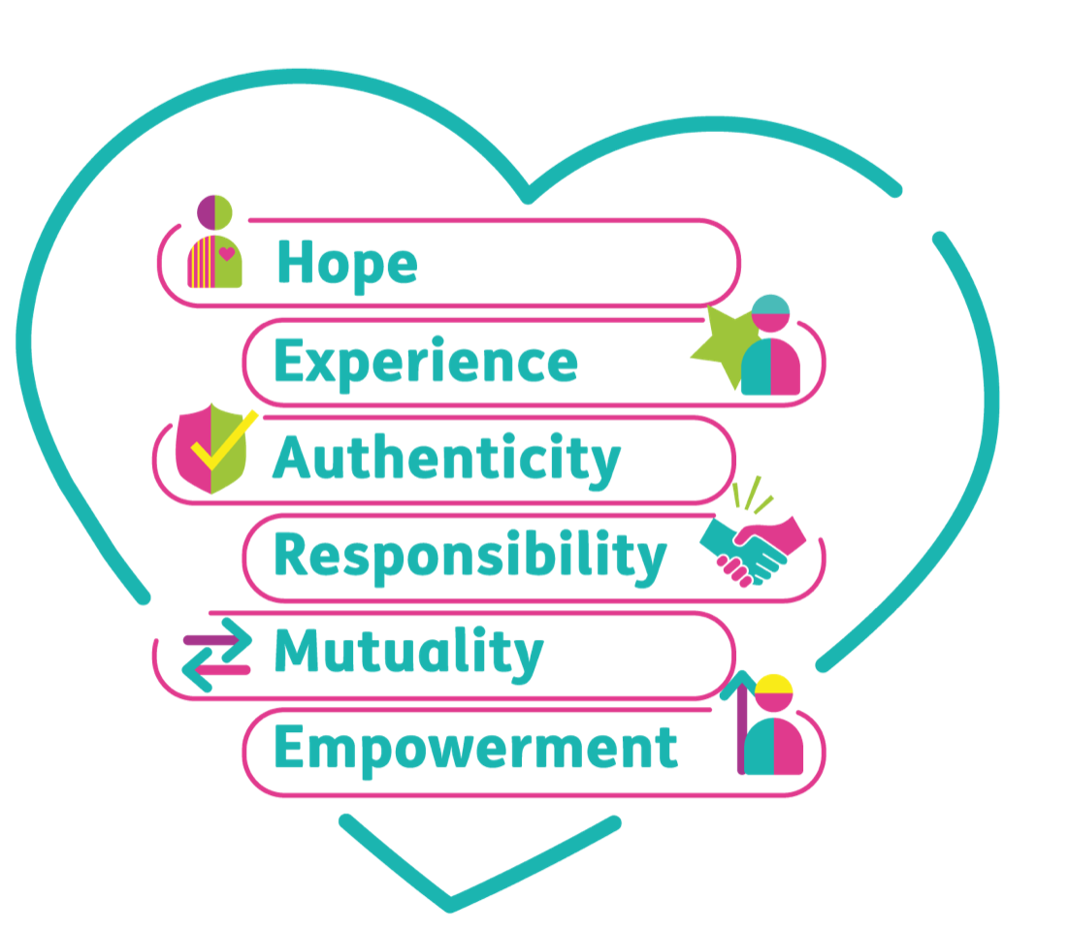
Hope: The belief that mental health recovery is possible for everyone
Through shared experiences and mutual connection, peer relationships offer hope and optimism. Peer workers carry visible proof that recovery is possible and help to create conditions for change.
Experience: Recovery is a personal and shared experience
Lived experience offers a depth of understanding that comes from having navigated challenges, change and growth. It brings insight into what recovery feels like and the possibilities. The sharing of experiences can be a powerful catalyst for change. Peer support adapts to cultural values, language and community-specific needs. In peer relationships we are all experts of our own experiences
Authenticity: Being authentic is about being true to yourself
Peer relationships are built on trust, openness and shared humanity. Authenticity means showing up as a real person, not as a role, a script or a set of techniques. When peer supporters are able to be genuine, relationships feel safer and more equal. Authenticity creates space for honesty, vulnerability and growth.
Responsibility: Mental health, wellbeing and recovery involves taking responsibility
Peer support is rooted in ‘being with’ a person rather than ‘doing for’. This approach supports people to strengthen their agency, choice and ownership of their recovery. Responsibility is mutual, it includes caring for yourself and the peer relationship by upholding the integrity of peer values in practice.
Mutuality: The peer relationship is two-way, both people learn, grow, and benefit
Mutuality sits at the heart of peer support and recognises that everyone in the peer relationship brings knowledge, strengths and insight. It is a collaborative relationship built through dialogue, shared experience and trust.
Empowerment: Power is shared and people are supported to make decisions that feel right for them
Within peer support, empowerment is grounded in a belief in recovery and that each person has control over their own journey. It’s about experiencing and reclaiming personal power. Peer support creates space to explore and rediscover this.
In the peer support role, it is critical we understand our own values and how these show up in our behaviour especially if they take us to the helper or fixer roles. Peer values shape what peer support looks and feels like in real life interactions. Looking at the peer values in practice means noticing how these values show up in our tone, our boundaries, our assumptions, and the choices we make in the moment.
Peer values in practice
Peer values help to differentiate peer support from other kinds of support. They anchor both development and delivery by shaping the why, the what and the how. They help to focus service development on recovery principles and prioritise the role of lived experience.
In delivery, they guide the interactions between people to ensure they mutual, relational, and intentional. Putting the Pieces Together: A Framework for Mental Health Peer Support in Scotland explores many examples of how peer values show up through the development and delivery of peer support, below is an example of this.
Peer value | How this value guides the  development of peer support | How this value shows up in  the delivery of peer support
Hope | Be strengths-based and use language that focuses on possibility and future | Model recovery in your practice by sharing experiences intentionally
Experience | Create systems and process that capture, reflect on and learn from people’s experiences | Centre the person as the expert in their own experiences by listening with curiosity, openness and respecting their choices
Authenticity | Create a culture and environment where authenticity is valued and staff bring their true selves | Practice self-awareness and self-compassion, recognising that authentic connection begins with knowing and caring for yourself
Responsibility | Provide reflective, peer-informed supervision that strengthens peer identity and values-led practice | ‘Be with’ by listening curiously, asking open questions to explore situations further, validating feelings and encouraging small steps
Mutuality | Embed lived experience at every level of service design and delivery | Stay aware of power dynamics and actively work to create balance through open dialogue, joint decision making and mutual reflection
Empowerment | Develop policies and structures that share power and enable shared decision making | Encourage people to make informed choices and set their own goals, supporting them to source the information they need

Values-led reflective practice
Reflection is a core part of peer practice because it helps us stay connected to our own personal recovery and the purpose of the role, which in turn prevents peer drift. Peer support is a relationship built on mutual learning, so when we pause to reflect, we create space to notice opportunities for growth and development.
Using the HEAR ME as a framework for reflection helps us stay grounded in the values of peer support, especially when things feel complex or emotionally charged. Reflection keeps our practice intentional and relational, which is aligned with the purpose of the peer role.

Session plan
Two-hours and 30 minutes session. Deliver in person or online. Recommend no more than 15 participants for two facilitators. Participants should review and complete the reflective activities in their workbook before the session and bring this along on the day.

Activities  & timing | Resources needed | Guidance
Welcome and introductions  10 minutes | Slide one  Sticky label name badges | Welcome participants when they arrive, make everyone feel comfortable, use people’s names, and thank them for coming.  - 5 minutes: Cover any housekeeping and break times  - 5 minutes: Facilitators and Participants all invited to share their names and pronouns. This can be done verbally or, if online, using the chat as an introduction.  A reminder to keep this introduction brief to one or two sentences to keep to time. Invite but do not force people to share their pronouns.
Learning intentions  5 minutes | Slide two | Share the learning intentions from the slide helps participants to know the purpose of the session and what to expect. Facilitators can read them out or invite a participant to read each one.  Check in to see if everyone understands them. Answer any questions people may have at this point.
Group learning agreement  15 minutes | Slide three | To ensure this space remains positive, safe, and empowering for everyone, we will co-create and/or review our group learning agreement.  - If this is the first session: dedicate time to creating the learning agreement together, using CHIME as a guiding framework  - If this is a subsequent session: begin by reviewing the existing agreement, inviting participants to check in and suggest additions or changes
Checking in  10 minutes | Slide four | At the start and end of each session, we’ll use a simple check-in and check-out question. Everyone gets a couple of minutes to think about it and jot down notes if they wish.  Checking in question: What value do you draw on most when supporting someone else? (Model your own to begin)  After two minutes, model your response then invite people to share their thoughts. Thank each person as they speak, but don’t add your own commentary. Once everyone’s had a turn, reflect back some of the common themes you heard. Wrap it up by saying this is a great way to get everyone’s voice in the room and set the tone together.
Introduction to the topic  30 minutes | Slide five – six  Slide five  Slide six  Participant workbook | Purpose: To understand the core values of peer support and their purpose.  - 5 minutes: Facilitators should read out, or invite a few participants to volunteer to read out, the slide on peer values.  Sample script: “Peer values are essential to peer practice and ensure that the relationship is centred on shared lived experience, mutuality, and respect. In Scotland, Scottish Recovery Network, worked with peer workers to develop a peer values framework which anchors peer support in six core values that we call HEAR ME.”  Activity one: HEAR ME  - 5 minutes: Individual reflection: Participants will take 5 minutes to read through the information in their workbook around HEAR ME values. Encourage them to highlight or circle points they relate to or can see in their own practice.  - 15 minutes: Group discussions: Break the participants into groups of 3-4. Groups will discuss the following questions:  - Why are peer values important for the peer relationship?  - Looking at the HEAR ME values, which ones feel most familiar or intuitive to you, and why?  - 5 minutes: Invite the groups to briefly share their learning and reflections from the discussions.  Key points: Participants will recognise that HEAR ME values are what make peer support distinct from other forms of support. They keep the relationship grounded in shared lived experience and mutuality, rather than traditional hierarchical models of support. Key themes around why values matter are: they protect the integrity of the peer role, and they keep our practice intentional and relational.
10 minutes | Slide seven | Comfort break  (suggest setting a timer to alert participants when to return)
Peer values into practice  30 minutes | Slide eight – ten  Slide eight – nine  Slide ten  Participant workbook | Purpose: To explore how peer values shape the development and delivery of peer support.  Sample script: “Peer values guide peer support at every level. From how roles are designed and supported, to how peer workers build relationships and deliver support day‑to‑day. Peer values help to differentiate peer support from other kinds of support. They anchor both development and delivery of peer support by shaping the why, the what and the how.”  - 5 minutes: Facilitators should read out, or invite a few participants to volunteer to read out, the slides on peer values in practice.  Activity two: Peer values into practice  - 15 minutes: Pairs discussion: In pairs, participants will work through the HEAR ME values and explore ways they may show this value in their practice. There is a table in the workbook that shows examples for how each value may look in the development and delivery of peer support to help guide their thinking. Encourage participants to capture their ideas in the workbook.  - 10 minutes: Bring the participants back for a whole room discussion. Work through each value on flipchart or online equivalent and invite participants to share their thinking around what that value may look like in practice.  - Following the session, you may wish to share this write-up with the participants.  Key points: Participants will recognise that the HEAR ME values do not sit in silos. They overlap, reinforce one another, and often show up together in practice. One example of peer practice may reflect several values at once, which is a strength. Encourage participants to notice how their examples link across multiple values and how this interconnectedness strengthens values‑led practice.
Values-led reflective practice  25 minutes | Slide 11 – 12  Slide 11  Slide 12  Participant workbook | Purpose: To explore how reflecting through the peer values framework can strengthen peer practice.  Sample script: “Peer support is a relationship built on mutual learning, so when we pause to reflect, we create space to notice opportunities for growth and development. Using the HEAR ME as a framework for reflective practice helps us stay grounded in the values of peer support, especially when things feel complex or emotionally charged.”  - 5 minutes: Facilitators should read out or invite a few participants to volunteer to read out the slide on values-led reflective practice.  Activity three: Reflective practice  - Read out the case study on page 13, remind participants this is in their workbook.  - 20 minutes: Group discussion: In small groups, participants will work through a values-led reflective practice using the tool in their workbook. This practice will be similar to a co-reflection session. Participants can use the case study and reflect as though Luca is a member of the group. They may wish to use a real-life experience of their own, if this is the case one person describes a peer support interaction with a focus on how they responded.  - Using the HEAR ME reflective tool in the workbook, participants should look at where the peer practiced the values well, and areas where they could develop their practice further.  Key points: This is an opportunity for participants to engage in reflective practice which a core part of peer support that helps to deepen self‑awareness and understand relational dynamics. Encourage participants to notice that reflecting on values helps us stay aligned with the ethos of peer support, especially when situations feel complex or emotionally charged.
Learning intentions  5 minutes | Slide 13 | This slide lists the learning intentions we set out to cover at the beginning of the session. Review these again and ask the group if they feel we have covered the topics.
Checking out  10 minutes | Slide 14 | Note: This is a closing activity. If you are running two of these sessions together then save this until the end of the second session.  Closing question: What’s one thing you are taking away from today’s session?  After two minutes, invite people to share their thoughts. Thank each person as they speak, but don’t add your own commentary. Once everyone’s had a turn, reflect back some of the common themes you heard.  Thank everyone, remind them about the next session and the prep for this session outlines in their participant workbook.  As a facilitator if it is helpful, you can complete the facilitator reflections template.

Activity three: Case study
Luca is a peer worker supporting Michael, who has recently moved into temporary accommodation and often talks about feeling overwhelmed. During their meeting, Luca shares parts of his own lived experience of being in similar accommodation, describing how chaotic it felt and what helped him cope. Michael responds saying it helps to know someone else has been through something similar. Their conversation continues with both of them reflecting on small things that get them through difficult days.
As the conversation continues, Luca begins to shift into a more directive approach. When Michael talks about struggling with appointments, Luca tells him he will start booking the appointments to ensure he is available to attend with Michael and says he “needs to get on top of things”. He doesn’t explore what Michael wants or what feels possible for him right now. When Michael mentions feeling unsure about the future, Luca responds by saying, “It’s just the way things are, you just have to get through it” rather than supporting Michael to identify what matters to him.
When Michael mentions feeling embarrassed about struggling, Luca responds “You’re doing the best you can in a tough situation. It took me a long time to realise I didn’t have to handle everything alone.” He checks in with Michael about what he wants their plan to look like going forward. Michael says he’d like to take responsibility for arranging his own appointments and hopes to work towards attending them independently. Luca acknowledges this and says, “You are in the driving seat here. I may have overstepped earlier by trying to fix things. Let’s take a step back and make a plan together for the next few weeks.” He acknowledges the strength Michael has shown in getting through the past few weeks. This helps Michael feel more empowered and less alone.

