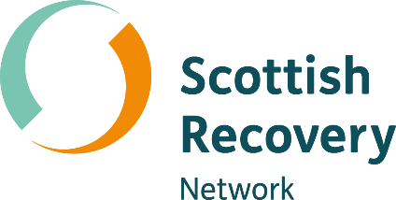

Connecting through communication
[Grab your reader’s attention with a great quote from the document or use this space to emphasize a key point. To place this text box anywhere on the page, just drag it.]

Peer2Peer: module two, session two,
Facilitator session plan




Module two: The peer support relationship
Welcome to module two of Peer2Peer!
This second module begins to explore the skills we will draw on through peer practice. Through completing this module, participants will move from being informed about peer support, to feeling confident in their ability to support others through peer practice, having a deep understanding of the skills involved.
The session plan offers some handy background information and a suggested plan, but feel free to adapt it to fit your group. Be mindful your role isn’t about being the “expert with all the answers,” it’s about creating a learning space that draws on the knowledge and lived experience in the room.

Before starting this module
We recommend participants complete Preparing for Peer2Peer: participant readiness workbook and Introduction to peer support (module one).
Before facilitating take time to get familiar with this module two, session two plan and the associated participant workbook. Make sure everyone has their own copy of the participant workbook for this session and encourage them to look over the reflection activities beforehand. Ask them to bring their participant workbook along on the day and keep a few spares handy just in case.

After the session
- Complete the facilitator reflections template
- Remind participants to review and finish the reflection activities in their participant workbook before the next session
- Update the group learning agreement slide after the session, ready for future sessions
Session two: Connecting through communication
Learning intentions
- Explore connection, disconnection and reconnection in the peer relationship
- Understand different communication skills and recovery language
- Practice active listening skills
Connecting in the peer relationship
Connection sits at the heart of peer support because it’s the foundation for trust and mutuality. We build that connection through the way we communicate; our words, our presence, curiosity, and willingness to really listen. Our Creating Hope with Peer Support project worked with peer workers to develop a pathway that represents the journey peer supporters go on whether it is in a one-to-one or group setting:
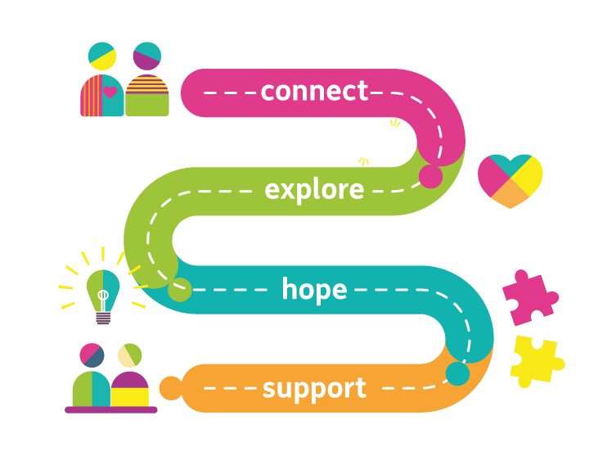
- Connect – establishing and developing connections and relationships, building the trust needed for peer support
- Explore – using curiosity and compassion to enable people to explore their emotions and experiences in a way that makes them feel heard, valued and validated
- Hope – discovering the power of hope and facilitating hopeful conversations
- Support – how peer workers can look after their own wellbeing

Effective communication skills
Communication in peer support is a powerful way of building trust, mutuality, and connection. When we’re intentional about how we communicate, we create conversations that feel hopeful and empowering. The way we speak, listen, and write shapes how we show our intent, how we build relationships, and how we support each other. Below are ten key skills and techniques of effective and intentional communication:
- Active listening: An acquired skill which is hard work and takes practice because it’s not something we necessarily normally do. Active listening means coming in with curiosity and helps develop a deeper understanding of the other person and what is important to them.
- Listening from a position of not knowing: Staying curious and setting aside assumptions creates space for mutual learning and connection.
- Listening for the untold story: Paying attention to how someone has learned to tell their story helps us explore meaning rather than reacting only to what’s on the surface.
- Providing validation: Acknowledging someone’s feelings and experience without jumping into fixing helps them feel heard and connected.
- Reflecting on feelings and emotions: Noticing and naming emotion, rather than assuming or overlooking it, helps us understand the fuller story being shared.
- Asking clarifying questions: Curious conversations help us move beyond assumptions and understand what someone’s words truly mean to them.
- Asking powerful questions: Future focused questions open up possibilities and support people to move toward what they want and feel hopeful about the future.
- Using recovery language: Hopeful, strengths-based language helps build mutuality and highlight resilience.
- Direct, honest and respectful communication: Speaking openly and kindly, even when emotions are involved, deepens trust and supports relationships that go beneath the surface.
- Sitting comfortably with silence: Silence is an essential part of communication which people may find difficult. It gives people space to think, feel, and find their own words, while we stay present and work on connecting with the non-verbal.
Ting
- The Chinese character 聽 (Ting) is often used in communication training because it visually breaks down into several components that together describe how to listen with your whole self. It helps to describe active listening through the following components:
- Ear: We listen with our ears to the words being spoken. This is the surface level: the sounds, the content, the story.

- Eye: We listen with our eyes by noticing body language, emotion, pacing, and what’s not being said. In peer support, this is often where we catch the real meaning.
- Heart: We listen with our heart by bringing empathy, compassion, and non‑judgment. This is the values‑aligned bit: being with someone, not fixing them.
- Respect: Sometimes explained as “holding the person in high regard,” reminding us to honour their experience and autonomy.
- Undivided attention: Being fully present in the moment. Not planning your response or drifting, just being with.
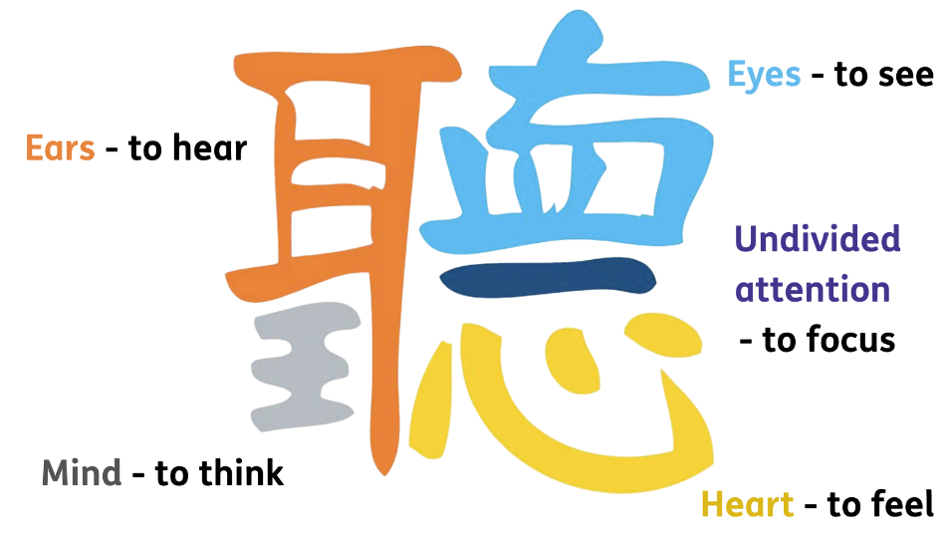
Active listening in peer support is a way of being. The symbol Ting reminds us that real listening uses our ears, eyes, mind, and heart.

Recovery language
Language is one of the ways to foster and enhance recovery-supporting environments. Recovery language is closely associated with our ability to share hope and identify strengths. The language we can use is also important in the development of empathic and mutual relationships. However, it is not fixed and the words we use change over time and between cultures.
When peer workers use person‑first, respectful language it reinforces that people are human beings before any diagnosis or service involvement and avoids labels that can limit identity or reinforce a “them and us” dynamic. When peer supporters describe someone by their strengths and individuality rather than by illness or service use, they help protect identity and promote recovery. Because language can empower or stigmatise, peer workers should be mindful of the words they choose, avoid assumptions, and challenge unhelpful labelling when it appears in conversations or written notes.

Session plan
Two-hours and 30 minutes session. Deliver in person or online. Recommend no more than 15 participants for two facilitators. Participants should review and complete the reflective activities in their workbook before the session and bring this along on the day.

Activities  & timing | Resources needed | Guidance
Welcome and introductions  10 minutes | Slide one  Sticky label name badges | Welcome participants when they arrive, make everyone feel comfortable, use people’s names, and thank them for coming.  - 5 minutes: Cover any housekeeping and break times  - 5 minutes: Facilitators and Participants all invited to share their names and pronouns. This can be done verbally or, if online, using the chat as an introduction.  A reminder to keep this introduction brief to one or two sentences to keep to time. Invite but do not force people to share their pronouns.
Learning intentions  5 minutes | Slide two | Share the learning intentions from the slide helps participants to know the purpose of the session and what to expect. Facilitators can read them out or invite a participant to read each one.  Check in to see if everyone understands them. Answer any questions people may have at this point.
Group learning agreement  10 minutes | Slide three | To ensure this space remains positive, safe, and empowering for everyone, we will co-create and/or review our group agreement.  - If this is the first session: dedicate time to creating the learning agreement together, using CHIME as a guiding framework  - If this is a subsequent session: begin by reviewing the existing agreement, inviting participants to check in and suggest additions or changes  These are our shared boundaries for keeping this a positive and safe learning space. We will return to them at the start of every session, so this is a living resource.
Checking in  10 minutes | Slide four | At the start and end of each session, we’ll use a simple check-in and check-out question. Everyone gets a couple of minutes to think about it and jot down notes if they wish.  Checking in question: Think of a time when you felt genuinely listened to. What was it about the interaction that helped you feel understood and connected?  After two minutes, invite people to share their thoughts. Thank each person as they speak, but don’t add your own commentary. Once everyone’s had a turn, reflect back some of the common themes you heard. Wrap it up by saying this is a great way to get everyone’s voice in the room and set the tone together.
Making connections  35 minutes | Slides five – seven  Slide five  Slide six  Slide seven  Scenario sheets | Purpose: To explore connection, disconnection and reconnection in the peer relationship.  - 5 minutes: Facilitators should read out the slide on the Creating Hope with Peer Support pathway, explaining the points:  - Connect – establishing and developing connections and relationships, building the trust needed for peer support  - Explore – using curiosity and compassion to enable people to explore their emotions and experiences in a way that makes them feel heard, valued and validated  - Hope – discovering the power of hope and facilitating hopeful conversations  - Support – how peer workers can look after their own wellbeing  - Facilitators should read out, or invite a few participants to volunteer to read out, the slide connections, disconnection and reconnection  Activity one: Reflecting on personal limits  - 10 minutes: Invite a participant to role play Scenario 1 (page 15) on ‘Connection’ with you. Invite the room to comment on what they observed.  - 10 minutes: Invite a different participant to role play Scenario 2 (page 16) on ‘Disconnection’ with you. Invite the room to comment on what they observed.  - 10 minutes: Invite a different participant to role play Scenario 3 (page 17) on ‘Reconnection’ with you. Invite the room to comment on what they observed.  Key points: Being able to notice when connection slips, even in small ways, is part of what makes peer support intentional. Moments of disconnection are opportunities to be curious and check in with each other about what’s happening in the peer relationship. These skills are important to developing an authentic peer relationship.  Sample script: “Connection sits at the heart of peer support because it’s the foundation for trust and mutuality. We build connection through the way we communicate. When both people take shared responsibility for the relationship, it becomes easier to name any disconnection, explore it with compassion and curiosity, and find a way back into connection. This cycle of connection, disconnection, and reconnection is what builds trust over time and is a natural part of the peer relationship.”
10 minutes | Slide eight | Comfort break  (suggest setting a timer to alert participants when to return)
Active listening - Ting  25 minutes | Slides nine – 11  Slide nine  Slide ten  Slide eleven | Purpose: To practice active listening skills  - 5 minutes: Facilitators should read out, or invite a few participants to volunteer to read out, the slide around active listening and the Chinese symbol Ting. Use the notes at the beginning of the session plan to explain the parts of Ting.  Sample script: “Active listening is one of the most powerful skills in peer support because it helps people feel genuinely heard and valued. When we listen with our full attention, not trying to fix or rush ahead, we create real connection. The Ting symbol reminds us that listening is about our ears, eyes, heart, presence, and the respect we bring into the relationship.”  Activity two: Active listening  - 15 minutes: Pairs discussion: Split participants into pairs to complete the following active listening activity using Ting.  - Round 1: Everyday listening  One person is the speaker who will talk for 1-2 minutes about a neutral topic (e.g. highlights from the last week). The listener will listen as normal, using no techniques. Facilitator will let pairs know when the time is up and the listener has 1 minute to feedback what they heard.  Quick debrief for one minute (capture in workbooks)  - Speaker: What did it feel like to be listened to in that way?  - Listener: What did you notice about your attention?  - Round 2: Listening with Ting  The speaker will now talk for 1-2 minutes about a topic they feel a little more passionate about (e.g. something they are looking forward to or a hobby). This time the listener will intentionally listen using the elements of Ting (noted in workbook as a prompt). Facilitator will let pairs know when the time is up and the listener has 1 minute to feedback:  - What they heard  - What they sensed  - What they felt moved by  Quick debrief for one minute (capture in workbooks)  - Speaker: What felt different this time?  - Listener: Which parts of Ting were easiest or hardest to do?  - Pairs to swap roles and repeat the activity  - 5 minutes: Bring the pairs back as a whole room to briefly reflect on the following:  - What changed when Ting style listening was used?  - Which element of Ting made the biggest difference?  Key points: Participants will experience the contrast between ordinary listening and active listening using the Ting principles. It highlights how attention, presence, empathy, and respect can change the quality of a conversation. Participants will notice which elements of Ting come naturally or require more intention. The debrief supports reflection on how these skills strengthen connection and trust in peer relationships.
Communication skills  30 minutes | Slides twelve - fourteen  Slides twelve - thirteen  Slide fourteen  Participant workbook | Purpose: To understand different communication skills and recovery language, and practice these through empowering interactions  - 5 minutes: Facilitators should read out, or invite a few participants to volunteer to read out, the slides around the 10 key communication skills and recovery language.  Sample script: “Peer workers are skilled at creating conversations that feel hopeful, respectful, and empowering. These ten skills highlight what that looks like in practice and combined with recovery focused language can help create relationships where people feel genuinely understood and connected.”  Activity three: Empowering interactions  - 20 minutes: Group discussion: Break the participants into groups of 3 to practice communication skills through role playing peer support scenarios. Each person will take on the role of:  - Person being supported  - Peer worker  - Observer  - The person being supported should think of a scenario they wish to discuss or use one of the examples from the participant workbook. The peer worker takes the discussion from there and they should have a conversation for 5 minutes.  - The observer should use the table of the 10 key communication skills to record what they see (tick or make notes). After the role play, the observer should aim to use these same skills to describe the positives and areas for improvement (2 minutes)  - Swap roles and repeat so each person has the opportunity to practice their communication skills and provide feedback.  - As a facilitator be mindful of time during this activity and call out the room when they should be closing the scenarios, giving feedback then swapping roles.  - 5 minutes: Bring the groups together and invite a few brief reflections from this activity  Key points: This type of communication takes considerable practice. In the beginning it might not feel very natural or authentic. Doing this type of intentional communication is new and challenging, but with practice it enables people to build stronger connections and better relationships. This applies to all aspects of life – not just when in a peer support role.
Learning intentions  5 minutes | Slide fifteen | This slide lists the learning intentions we set out to cover at the beginning of the session. Review these again and ask the group if they feel we have covered the topics.
Checking out  5 minutes | Slide sixteen | Note: This is a closing activity. If you are running two of these sessions together then save this until the end of the second session.  Slide ten: This slide asks the question: What’s one thing you are taking away from today’s session?  After two minutes, invite people to share their thoughts. Thank each person as they speak, but don’t add your own commentary. Once everyone’s had a turn, reflect back some of the common themes you heard.  Thank everyone, remind them about the next session and the prep for this session outlines in their participant workbook.  As a facilitator if it is helpful, you can complete the facilitator reflections template.

Scenario one: Connection
Peer worker:
Hello [name]. How’s your day been so far?
Person:
Honestly, it’s been a bit heavy. I’ve just had a lot on my mind.
Peer worker:
Thanks for sharing that. I’m here with you, what’s been feeling heavy?
Person:
I’m just overwhelmed at work. I feel like I’m constantly behind
Peer worker:
That sounds really stressful. I can hear how much pressure you’re carrying. What feels the hardest right now?
Person:
Probably feeling like I’m letting people down.
Peer worker:
That sounds tough. I’m really glad you said it out loud. Do you want to tell me a bit more about that feeling?
Person:
Yeah… it actually feels good to talk about it.
Peer worker:
I’m right here with you. Take your time.

Key themes on how this shows connection:
- Warm greeting
- Curiosity
- Validation
- Reflecting emotion
- Open questions
- Presence and pace

Scenario two: Disconnection
Peer worker:
So what do you want to talk about today?
Person:
Emm, I’m feeling a bit overwhelmed at work.
Peer worker:
Have you tried making a to do list? That usually helps.
Person:
…I mean, I guess. I’ve tried a few things- [gets cut off before finishing sentence]
Peer worker:
Yeah, you probably just need to get more organised. It’s not that complicated.
Person:
[Makes a confused face] Right… okay.
Peer worker:
And honestly, if it makes you feel better, everyone feels behind sometimes. It’s just part of life so you are best to get used to it.
Person:
Okay. Thanks…maybe we should just talk about something else.

Key themes on how this shows disconnection:
- Jumping into fixing
- Minimising the person’s experience
- Making assumptions
- Moving away from curiosity
- Lack of empathy
- Dismissive
Scenario three: Reconnection
Following on from scenario two, re-read this one if people need a reminder.
Person:
Okay. Thanks…maybe we should just talk about something else.
Peer worker:
[Pauses for a moment] I noticed you pulled back a bit just now. I might have jumped in too quickly earlier.
Person:
…yeah, it felt a bit like you were telling me what to do.
Peer worker:
Thank you for saying that. I can see how that landed. I really want to understand your experience. Can we slow down for a moment?
Person:
Okay…yeah.
Peer worker:
What feels most important for you right now? I want to make sure we’re talking about what matters to you.
Person:
I think I just needed you to hear how overwhelmed I’ve been.
Peer worker:
I’m hearing that now. It sounds really heavy, and I’m here with you. Do you want to tell me a bit more about what that overwhelm feels like?
Person:
Yeah, I would. What’s been happening is…
Key themes on how this shows reconnection
- Awareness of disconnection (“I noticed you pulled back…”)
- Owning their part without defensiveness
- Curiosity (“What feels most important for you right now?”)
- Mutuality, both people shape the reconnection
- Validation

