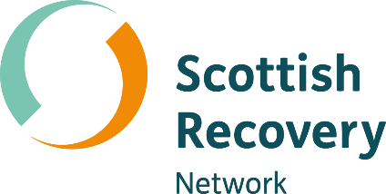

Connecting through
communication

Peer2Peer: module two, session two Participant workbook


Module two: The peer support relationship
[Grab your reader’s attention with a great quote from the document or use this space to emphasize a key point. To place this text box anywhere on the page, just drag it.]
Welcome to module two of the Peer2Peer group course!
This second module begins to explore the skills we will draw on through peer practice. Through completing this module, you will move from being informed about peer support, to feeling confident in your ability to support others through peer practice, having a deep understanding of the skills involved.

Purpose of the participant workbook
The workbook is designed to support your learning journey. It gives you space to prepare for each session, reflect on your experiences, and capture your own thoughts. There are no right or wrong answers and facilitators won’t be reading what you write.
Peer2Peer is a learning experience where you will be encouraged to draw on your lived experience to facilitate learning and skills development. It’s important you only share what you are comfortable with and that we recommend making time for self-care after the sessions.

Doing the pre-work before each session helps you arrive with clear thinking and makes it easier to contribute to conversations. It’s a good habit to build for your peer role, or for a future one.

Session two: Connecting through communication
Learning intentions
- Explore connection, disconnection and reconnection in the peer relationship
- Understand different communication skills and recovery language
- Practice active listening skills
Checking in question
- Think of a time when you felt genuinely listened to. What was it about the interaction that helped you feel understood and connected?

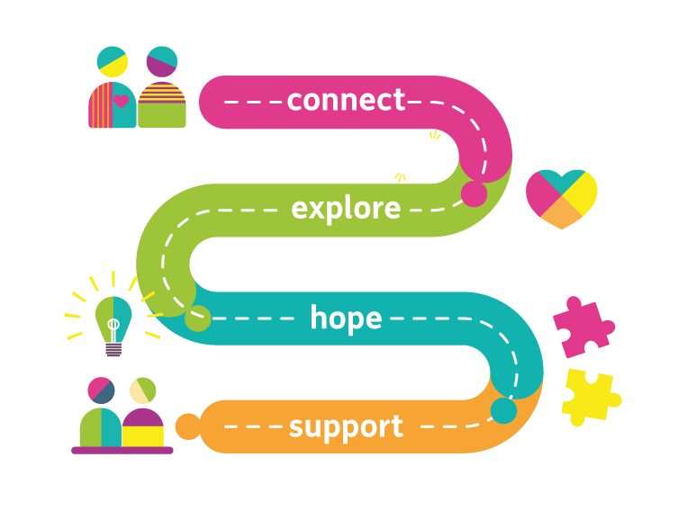
Connecting in the peer relationship
Connection sits at the heart of peer support because it’s the foundation for trust and mutuality. We build that connection through the way we communicate; our words, our presence, curiosity, and willingness to really listen. Our Creating Hope with Peer Support project worked with peer workers to develop a pathway that represents the journey peer workers go on whether it is in a one-to-one or group setting:
- Connect – establishing and developing connections and relationships, building the trust needed for peer support
- Explore – using curiosity and compassion to enable people to explore their emotions and experiences in a way that makes them feel heard, valued and validated
- Hope – discovering the power of hope and facilitating hopeful conversations
- Support – how peer workers can look after their own wellbeing
Being able to notice when connection slips, even in small ways, is part of what makes peer support intentional and mutual. Moments of disconnection are invitations to pause, get curious, and check in with each other about what’s happening in the peer relationship. These skills are important to developing an authentic peer relationship built on trust and connection.

Activity one: Reflecting on personal limits
The facilitator will invite participants to join them in a role play that explores three different scenarios: Connection, Disconnection, and Reconnection. Following each scenario, you will be invited to comment on what you observed.
Ting
The Chinese character 聽 (Ting) is often used in communication training because it visually breaks down into several components that together describe how to listen with your whole self. It helps to describe active listening through the following:
- Ear: We listen with our ears to the words being spoken. This is the surface level: the sounds, the content, the story.

- Eye: We listen with our eyes by noticing body language, emotion, pacing, and what’s not being said. In peer support, this is often where we catch the real meaning.
- Heart: We listen with our heart by bringing empathy, compassion, and non‑judgment. This is the values‑aligned bit: being with someone, not fixing them.
- Respect: Sometimes explained as “holding the person in high regard,” reminding us to honour their experience and autonomy.
- Undivided attention: Being fully present in the moment. Not planning your response or drifting, just being with.
Active listening in peer support is a way of being. The symbol Ting reminds us that real listening uses our ears, eyes, mind, and heart.
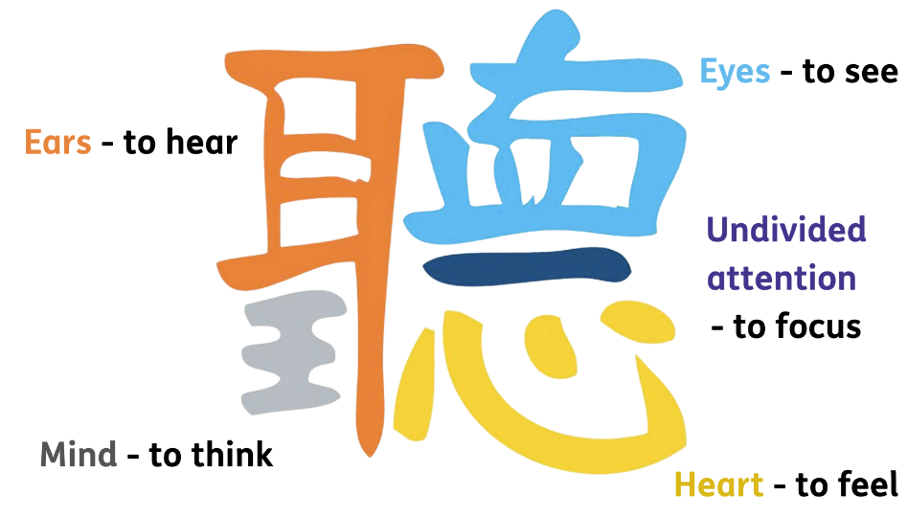
Activity two: Active listening
In pairs you will complete the following active listening activity using Ting.

Round one: Everyday listening

- One person is the speaker who will talk for 1-2 minutes about a neutral topic (e.g. highlights from the last week)
- One person is the listener who will listen as normal, using no techniques. You will feedback for around 1 minute what you heard

Round one debrief:
Speaker: What did it feel like to be listened to in that way?

Listener: What did you notice about your attention?

Round two: Listening with Ting

- The speaker will now talk for 1-2 minutes about a topic they feel a little more passionate about (e.g. something they are looking forward to or a hobby)
- The listener will intentionally listen using the elements of Ting. You will feedback for around 1 minute the following:

- What you heard
- What you sensed
- What you felt moved by

Round two debrief:
Speaker: What felt different this time?

Listener: Which parts of Ting were easiest or hardest to do?

Group discussion
- What changed when Ting style listening was used?
- Which element of Ting made the biggest difference?

Effective communication skills
Communication in peer support is a powerful way of building trust, mutuality, and connection. When we’re intentional about how we communicate we help create conversations that feel hopeful and empowering. The way we speak, listen, and write shapes how we show our intent, how we build relationships, and how we support each other. Below are ten key skills and techniques of effective and intentional communication:
- Active listening: An acquired skill which is hard work and takes practice because it’s not something we necessarily normally do. Active listening means coming in with curiosity and helps develop a deeper understanding of the other person and what is important to them.

- Listening from a position of not knowing: Staying curious and setting aside assumptions creates space for mutual learning and connection.

- Listening for the untold story: Paying attention to how someone has learned to tell their story helps us explore meaning rather than reacting only to what’s on the surface.

- Providing validation: Acknowledging someone’s feelings and experience without jumping into fixing helps them feel heard and connected.

- Reflecting on feelings and emotions: Noticing and naming emotion, rather than assuming or overlooking it, helps us understand the fuller story being shared.

- Asking clarifying questions: Curious conversations help us move beyond assumptions and understand what someone’s words truly mean to them.

- Asking powerful questions: Future focused questions open up possibilities and support people to move toward what they want and feel hopeful about the future.

- Using recovery language: Hopeful, strengths-based language helps build mutuality and highlight resilience.

- Direct, honest and respectful communication: Speaking openly and kindly, even when emotions are involved, deepens trust and supports relationships that go beneath the surface.

- Sitting comfortable with silence: Silence is an essential part of communication which people may find difficult. It gives people space to think, feel, and find their own words, while we stay present and work on connecting with the non-verbal.
Recovery language
Language is one of the ways to foster and enhance recovery-supporting environments. Recovery language is closely associated with our ability to share hope and identify strengths. The language we can use is also important in the development of empathic and mutual relationships. However, it is not fixed and the words we use change over time and between cultures.
When peer workers use person‑first, respectful language it reinforces that people are human beings before any diagnosis or service involvement and avoids labels that can limit identity or reinforce a “them and us” dynamic. When peer workers describe someone by their strengths and individuality rather than by illness or service use, they help protect identity and promote recovery. Because language can empower or stigmatise, peer workers should be mindful of the words they choose, avoid assumptions, and challenge unhelpful labelling when it appears in conversations or written notes.

Examples of recovery language
Deficit based language | Recovery language
You’re overreacting. | It sounds like this has been a really heavy time for you.
We need to focus on your risks first. | Let’s explore what matters most to you right now.
We need to note you are being non-compliant. | What would help you feel more in control?
We need to measure the service goals first. | Your goals are important, let’s look at how we can achieve them.
We are following the clinical pathway based on your diagnosis. | You are the expert in your own experience.
You aren’t managing your symptoms well. | What’s been helping you manage lately?
You need to follow your care plan. | What support feels most useful for you today?

Activity three: Empowering interactions
In groups of three, practice communication skills through role playing peer support scenarios. You may wish to use one of the examples or create your own. Continue the role play conversation back and forth until the facilitator calls time. Each person will take on one of the following roles:
Person being supported should think of a scenario they wish to discuss with the peer worker or use one of the examples below
The peer worker takes the discussion from there and they should have a conversation for 5 minutes back and forth
The observer should use the table of the 10 key communication skills over page to record what they see – either tick or make notes. After the role play, the observer should aim to use these same skills to describe the positives and areas for improvement.
Role play starter examples:
- I’ve been feeling really overwhelmed at work lately
- My relationship has recently broken down and I’m really struggling
- I’ve noticed my confidence has taken a dip recently and it’s starting to affect things
- I had to cancel plans with a friend last minute and now I’m worried I’ve upset them
- I bumped into someone from my past yesterday and it’s stirred up a lot more than I expected
Each person will swap roles, so everyone has the opportunity to practice communication skills and provide feedback.

Active listening
Listening from a position of not knowing
Listening for the untold story
Providing validation
Reflecting on feelings and emotions
Asking clarifying questions
Asking powerful questions
Using recovery language
Direct, honest and respectful communication
Sitting comfortably with silence

Closing reflection: What’s one thing you are taking away from today’s session?

Resource list
Films
- Connection, disconnection and reconnection – Intentional Peer Support
- Active listening skills – Communication Coach
- The power of recovery language – The Academy SDSU
- Empathetic listening – An example from Inside Out
Further quotes and reading
- Peer Support Work in Mental Health Services – Michael John Norton
- Peer Support in Mental Health – Emma Watson
- Peer2Peer Manual Session 7 (page 76) - Peer2Peer project partners: Scottish Recovery Network (Scotland), Fundación INTRAS (Spain), EASP (Spain), Martín Tellez (Spain). Pro mente Oberöstereich (Austria). LRPSM (Romania)
- Creating Hope with Peer Support resource – Scottish Recovery Network
- How to practice active listening - Dr. Amanda O'Bryan, PhD, LPCA
- Connection, disconnection and reconnection - Post-Secondary Peer Support Training Curriculum

Poem
Listen
When I ask you to listen to me and you start giving advice you have not done what I asked.
When I ask you to listen to me and you begin to tell me why I shouldn’t feel that way, you are trampling on my feelings.
When I ask you to listen to me, and you feel you have to do something to solve my problems you have failed me, strange as that may seem.
Listen! All I ask is that you listen, not talk or do – just hear me.
Advice is cheap: 60 cents will get you both Dear Abby and Billy Graham in the same newspaper.
And I can do for myself: I’m not helpless; maybe discouraged and faltering, but not helpless.
When you do something for me that I can and need to do for myself, you contribute to my fear and weakness.
But, when you accept as a simple fact that I do feel, no matter how irrational, then I can quit trying to convince you and get about the business of understanding what’s behind the irrational feeling.
And when that’s clear the answers are obvious and I don’t need advice. Irrational feelings make sense when you understand what’s behind them.
Perhaps that’s why prayer works, sometimes, for some people, because God is mute and doesn’t give advice or try to fix things.
God just listens and lets you work it out for yourself.
So, please listen and just hear me. And if you want to talk, wait a minute for your turn, and then I’ll listen to you. - Anonymous

