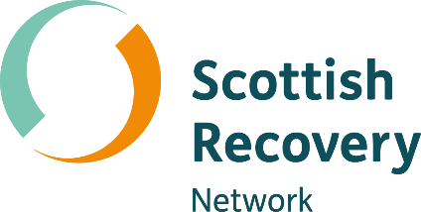
Peer values

Peer2Peer: module one, session four Participant workbook


[Grab your reader’s attention with a great quote from the document or use this space to emphasize a key point. To place this text box anywhere on the page, just drag it.]
Module one: Introducing peer support
[Grab your reader’s attention with a great quote from the document or use this space to emphasize a key point. To place this text box anywhere on the page, just drag it.]
Welcome to module one of the Peer2Peer group course!
This first module sets the scene, giving space to explore recovery and peer support together at an introductory level. The module will look at how we create an empowering and safe learning environment, as well as introduce peer support, the recovery approach and peer values.

Purpose of the participant workbook
The workbook is designed to support your learning journey. It gives you space to prepare for each session, reflect on your experiences, and capture your own thoughts. There are no right or wrong answers and facilitators won’t be reading what you write.
Peer2Peer is a learning experience where you will be encouraged to draw on your lived experience to facilitate learning and skills development. It’s important you only share what you are comfortable with and that we recommend making time for self-care after the sessions.

Taking a bit of time to prepare before each session can help you arrive feeling clear and ready to take part in the conversations. It’s also a useful habit to build as you develop in your peer role, and beyond.

Session four: Peer values
Learning intentions
- Explore how personal values can guide peer-to-peer interactions
- Understand the core values of peer support, including their roots in lived experience movements
- Reflect on how peer values influence peer practice
Checking in question
- What’s something you think makes support feel ‘human’ rather than ‘formal’?

Activity one: Personal values
Values are the guiding principles or beliefs that shape what a person, group, or community sees as important, meaningful, or “the right thing to do”. They influence how we make decisions, how we behave, and what we prioritise in everyday life.
Individual reflection
You can go online and complete this mini values assessment for fun and see where it takes you. https://personalvalu.es/ You may wish to note your top five values below and name these during the session. Alternatively have a look at the values examples over page and circle ones you feel are important to you.

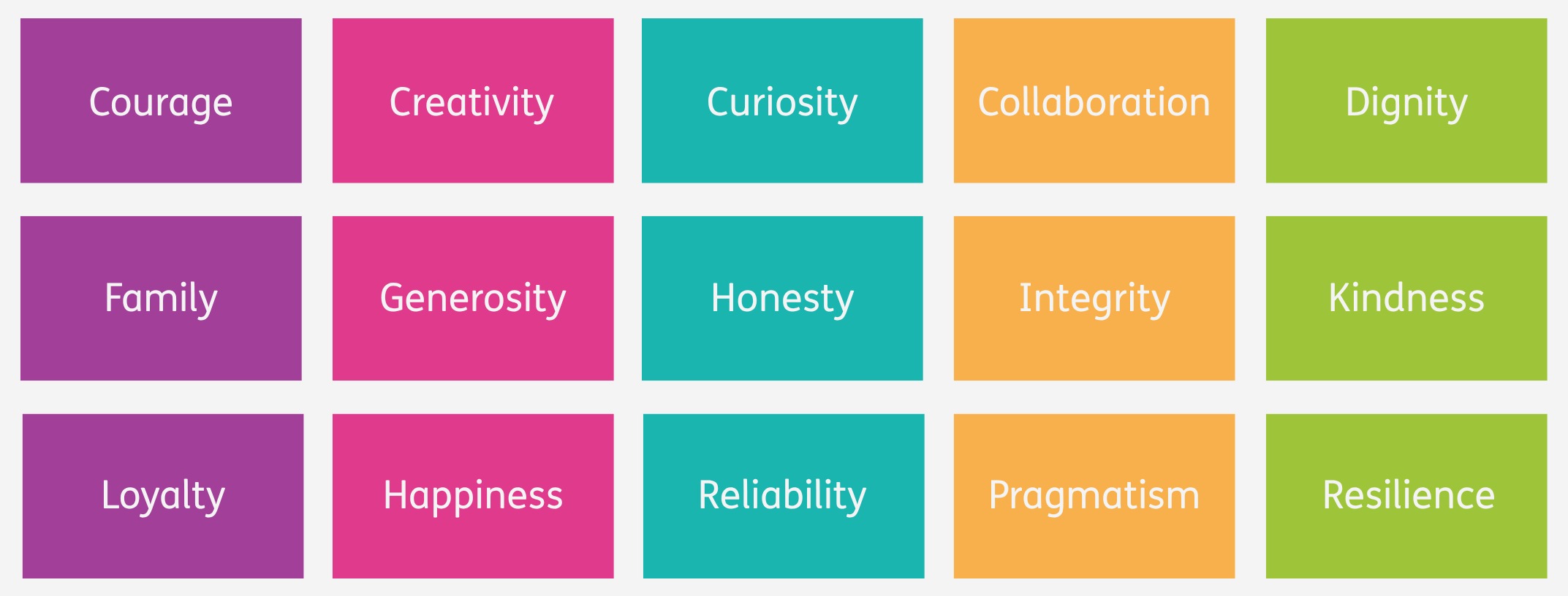
- Word version of the core values

What are your personal values?

Group discussion
- Think of a time someone supported you in a way that really helped. What did they do, and how might that shape the way you support others?
- When you’re with someone who’s struggling, what values might you draw on to support them?

Peer values
Peer values are the principles that guide how we show up for one another in the peer support relationship. These values come from lived experience and have a history rooted in the survivor and social justice movements.
Mutual aid and community care
Long before peer support had a name, people relied on each other for emotional and practical support. These early traditions emphasised solidarity, connection, and shared responsibility.
Survivor and lived-experience movements
In the 1960s and 70s, people with lived experience of mental health services organised to challenge coercive, medicalised systems. They emphasised dignity, autonomy, and the belief that people are experts in their own lives.
Rights-based and social justice movements
Disability rights, civil rights, and feminist movements shaped peer support by highlighting equality and the importance of challenging oppressive structures.
Recovery and peer-led practice
As peer roles developed, lived-experience leaders created the values framework that make peer support unique.
Peer support values are rooted in real struggles, communities, and relationships. Understanding this history helps us be clear about what peer support is and what makes it different from traditional, hierarchical models of care.

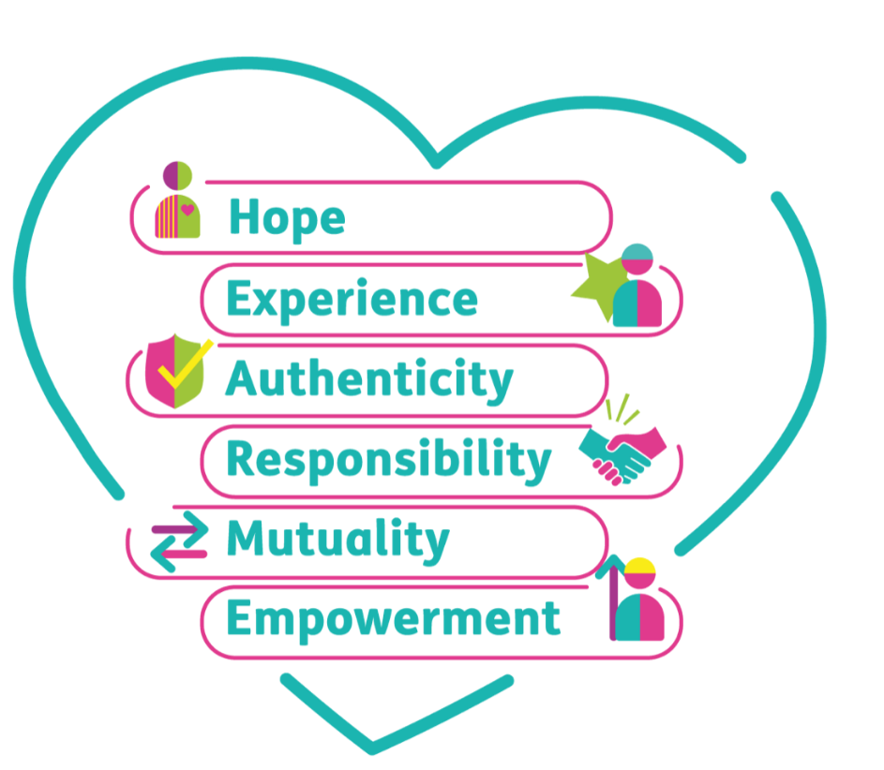
HEAR ME
Putting the Pieces Together: A Framework for Mental Health Peer Support in Scotland was developed with peer workers. The aim is to improve understanding of peer support and ensure that the role of peer workers is clear and remains true to the peer support ethos. Peer support is grounded in six core values which we call HEAR ME.

- Hope: The belief that mental health recovery is possible for everyone
- Experience: Recovery is a personal and shared experience
- Authenticity: Being authentic is about being true to yourself
- Responsibility: Mental health, wellbeing and recovery involves taking responsibility
- Mutuality: The peer relationship is two-way, both people learn, grow, and benefit
- Empowerment: Power is shared and people are supported to make decisions that feel right for them

Activity two: Peer support scenarios
In small groups you will now work through each scenario below and try to spot the values being drawn on by the peer worker. There are no right or wrong answers, what’s important is to hear different interpretations and reflections on the scenarios. For each scenario, discuss the following:
- Which HEAR ME values do you see here?
- How might this value influence peer practice?
Scenario 1
Callum is supporting someone who’s feeling overwhelmed after a breakup. Instead of offering solutions, Callum says “Take your time, we can figure this out together.” They share a bit about a similar experience in their own life, just enough to help the person feel less alone.
Scenario 2
Someone comes to a peer session feeling hopeless. The peer worker doesn’t dismiss their feelings but says “I’ve seen people come through really tough times. I don’t know what’s next for you, but I believe things can shift. The fact you have come to this session shows you are taking steps forward.”
Scenario 3
Harley, a peer group facilitator, notices a person becoming quieter in the group. They check in afterwards, saying, “I want you to feel safe here. Is there anything we can change to make this space work better for you?”
Scenario 4
Two peers disagree about how to approach a challenging situation. Instead of one taking charge, they talk it through, both sharing their ideas, and decide on a plan that feels fair and shared.
After the small group discussions, the whole room will reflect on the following:
- Which values were easiest to spot?
- Which ones felt more subtle?

Closing reflection: What’s one thing you are taking away from today’s session?

Resource list
Films
- Helen’s Story: Being a peer worker – Scottish Recovery Network and NHS Scottish Borders
- What makes peer support unique? – Scottish Recovery Network
Further quotes and reading
- The roots of peer support – Understanding Voices
- The values of peer support - Understanding Voices
- The Early Peer Support Movement - Colorado Mental Wellness Network
- Principles adopted by 1982 gathering of psychiatric survivors – Mind Freedom International

