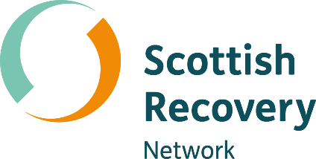

Co-creating a safe and empowering learning environment

Peer2Peer: module one, session one Participant workbook


Module one: Introducing peer support
Welcome to module one of the Peer2Peer group course!
This first module sets the scene, giving space to explore recovery and peer support together at an introductory level. The module will look at how we co-create a safe and empowering learning environment, as well as introduce peer support, the recovery approach and peer values.

Purpose of the participant workbook
The workbook is designed to support your learning journey. It gives you space to prepare for each session, reflect on your experiences, and capture your own thoughts. There are no right or wrong answers and facilitators won’t be reading what you write.
Peer2Peer is a learning experience where you will be encouraged to draw on your lived experience to facilitate learning and skills development. It’s important you only share what you are comfortable with and we recommend making time for self-care after the sessions.

Taking a bit of time to prepare before each session can help you arrive feeling clear and ready to take part in the conversations. It’s also a useful habit to build as you develop in your peer role, and beyond.

Session one: Co-creating a safe and empowering learning environment
Learning intentions
- Work with the group to define and agree what makes a safe and empowering learning space
- Come together as a learning group to share your hopes and fears for Peer2Peer
- Create a group learning agreement that reflects everyone’s input
Checking in question
- Share what you hope to gain from undertaking this Peer2Peer programme
Reflection activity: Preparing for session one
In preparation for session one take some time to reflect on the following questions. Remember there are no right and wrong responses, only what feels right for you.

What feels positive about undertaking Peer2Peer?

Is there anything that feels challenging?

What helps you feel comfortable and able to take part in honest conversations?
What behaviours make it easier for you to learn, share, and feel included?
What can you bring from your own journey that will help the group learn together?
What strengths could you use to support others to feel confident speaking up and engaging in discussions, even when the topics are challenging?

Group learning agreement
In Peer2Peer we want to create a safe, empowering learning space. To help with this, we use the first session to co-create a group learning agreement. This is a common approach in peer support settings. Rather than a set of rules set by a facilitator, it’s a shared agreement that we build together – helping us shape how we work as a group and what we need from each other.
It’s more than a ‘comfort agreement’. It’s about what helps each of us feel safe enough to take part in open and sometimes challenging conversations. Everyone is invited to share what supports their sense of safety and empowerment, and facilitators may also add practical points – such as agreeing start and finish times. The group learning agreement is a living resource. We’ll come back to it at the start of each session and update it as we go, so it stays relevant to the group.
We also use CHIME as a helpful framework to guide this process. Some people find it useful as a starting point for thinking about what matters to them, as it’s grounded in a recovery approach. You can choose to use CHIME in a way that works for you – or not at all. It’s simply there as a support if it helps. In this session, you’re invited to draw on your own reflections to help shape the group learning agreement in a way that feels meaningful to you.
CHIME
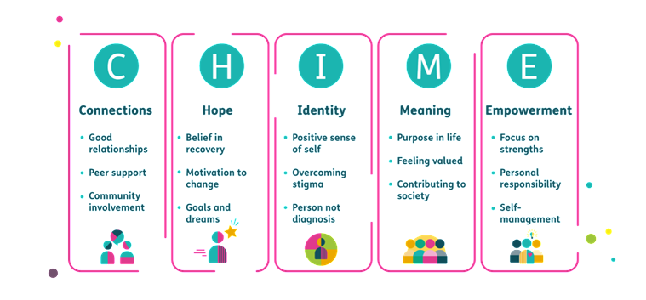
CHIME is a recovery framework (Leamy et al. 2011) made up of five key principles that many people find helpful in understanding their own recovery. It’s a useful way to support conversations about mental health and wellbeing. We’ll explore it further in module one, session three, but for now a basic awareness is all you need.

- A Word version of this CHIME diagram.
Watch our Let’s talk about recovery CHIME animation to learn more.

Closing reflection: What’s one thing you are taking away from today’s session?

Resource list
Films
- Let’s talk about recovery – Scottish Recovery Network
- Comfort agreement – Bipolar Edinburgh
Further quotes and reading
- Good conversations guide – Scottish Recovery Network
- Creating Safe Spaces Practice Guide – Scottish Recovery Network
- Group agreements for workshops and meetings – Seeds for Change
- Working with groups – Mind

