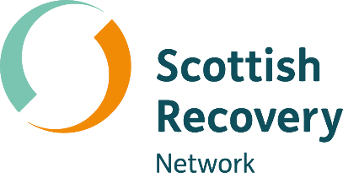
Peer2Peer history acknowledgement
The Peer2Peer programme has a long journey of development and has grown thanks to the support of peer workers across Scotland.
The initial Peer2Peer training manual was created as part of the European Union Lifelong Learning Programme funded project: “Peer2Peer: A Route to Recovery of People with Mental Illness Through Peer Support Training and Employment.” Scottish Recovery Network joined partners across Europe to collaborate on the development of this manual.
After the publication of the manual in 2015, Peer2Peer became widely used across Scotland as a training resource for people with lived experience looking to step into mental health peer support roles. Scottish Recovery Network worked with many organisations across the country to learn from their experiences of using the Peer2Peer manual. We shared this learning through ‘Let’s do Peer2Peer’, a companion resource to support the planning and delivery of Peer2Peer.
The latest version of Peer2Peer is an updated, modular approach to learning. It covers everything from introductory sessions to continuing learning and development and learning for those who are developing and managing peer support. It is designed to suit those just starting their peer support journey, through to those already in peer roles looking to further develop their practice.
This new Peer2Peer builds on the original manual and the wealth of learning from peer workers and those using Peer2Peer in their practice. We have also worked with a small number of consultants who helped us reshape Peer2Peer as a modular learning resource and brought their expertise to curriculum development.
Scottish Recovery Network want to thank all who shared their knowledge, experience and insight which has contributed to the development of Peer2Peer over the years.

