
Preparing for Peer2Peer
Participant readiness workbook


Preparing for Peer2Peer: Participant readiness workbook
Learning intentions
- Complete a pre-programme personal stock take
- Explore the recovery story approach
- Reflect on the above work and decide next steps together
Introduction
If you are reading this, then you are considering undertaking a Peer2Peer course. You may already be in a peer support role (paid or unpaid), or you may be taking the first step in your peer support journey.
Peer2Peer is a space for building confidence, skills, and good practice around offering peer support. It’s not designed to be a support group or a therapeutic space, so it’s important that you feel ready to engage in the activities and conversations. Taking part when you’re not in the right headspace can feel overwhelming rather than helpful. The ‘Preparing for Peer2Peer’ process can be a helpful way of reflecting together with the facilitator on whether you are ready to undertake the Peer2Peer course.
Preparing for Peer2Peer: The process
It is likely that you will be supported through this reflective process by a peer facilitator. This could be a 1-1 conversation or a conversation in a small group. There are no right or wrong answers. We encourage you to complete the reflection within an agreed period of time and then have a further conversation. At that point you and the peer facilitator can decide the next steps. It’s your workbook so you can print it out or complete it electronically, whatever works best for you.

Purpose
It’s a personal commitment to be a peer worker and inspiring others. In that process you will be supporting others to think through their mental health recovery journey from a strengths-based perspective, so it’s good practice to do some of that reflection yourself, irrespective of where you are on your peer journey.
You may have previously undertaken a personal stock take or written your recovery story as part of your own journey. This reflective workbook helps you to explicitly begin to see, feel and frame that in your role as a peer worker.
Using your lived experience to inspire and empower others
Peer support is a way of offering help and support on a more equal footing. It’s about people finding a way forward together, where people are recognised as experts in their own experience. Good peer support also works in a way that acknowledges that both parties can learn things from each other and support each other’s recovery journey. They are not based on trying to fix people or one person being the professional expert. This is different from the expert-patient dynamic.
In the peer support relationship, using and drawing on your personal recovery experiences is a powerful tool in communicating hope and creating connections with others. Sharing your recovery experiences provides others with the opportunity to practice what you have learned about how role modelling can communicate possibility and potential.

Activity one: Personal stock take
The first reflective activity is to complete a personal stock take. The ladder of change is a simple self-review which can help you see where you are in your thinking and behaviour. This ladder is laid out over the next few pages.
In terms of using this as a reflective tool the following could be helpful:
- Read through the full ladder of change before you mark / write anything
- Mark the statements that feel real to you in the moment, not where you have been or want to be, but a snapshot in time
- With the statements you do choose, take it a step further and think about what this means in your developing role in peer support
- Finally, on page six, think about and respond to the two questions and note down anything you would like to discuss
Stuck
1 | I am not interested in thinking or discussing my situation. I may be causing myself harm, or harming others, due to either lack of awareness or a willingness to open up. I am not achieving my full potential.
2 | I am fed up with the status quo and may see the potential for change. I am not ready to engage with others or seek support.
How can you use this in a positive way in your role / emerging role in peer support?

Accepting help

3 | I am feeling more and more that I don’t like how things are. Change may still be feeling impossible or scary, but I’m ready to engage with others to move forward.
4 | I am engaging with others in a more consistent and helpful way. I may not be driving the change, or taking full personal responsibility, but I am in the process.
How can you use this in a positive way in your role/emerging role in peer support?

Believing
5 |  | I can see that I want change, I know what I want and what I don’t. I am accepting that it is down to me to make change happen with support from others. My thinking and behaviour is changing, and I am more focused, and self-determined.
6 |  | I am experimenting and doing things differently. Some things are working, others are not, I’m using my support mechanisms to keep my hopes alive.
How can you use this in a positive way in your role/emerging role in peer support?

Learning

7 | I am open and ready to learn, I am motivated, believing more in myself and my capacity to change things. I am actively engaging the support of others, especially in reflecting on the impact of the changes.
8 | I have overcome significant setbacks with the support of others and my personal learning reflections. I have thought about giving up, but I am managing to stay focused on my goals.
How can you use this in a positive way in your role/emerging role in peer support?

Self-reliance

9 | I have new ways of doing things and these are well established. Mostly I can manage change but at times of crisis, I may be at risk of slipping back. I have someone/people who check I’m OK, help me recognise the trigger points and take action when needed.
10 | I am self-reliant and behave in ways that work well for me and people around me. I can manage by myself and equally know where and how to get support if I need it.
How can you use this in a positive way in your role/emerging role in peer support?

What have you discovered from completing this personal stock take?

What feels positive about the contribution you can make to others?

Note down anything you would like to discuss further.

Activity two: Personal recovery story
Peer support is a relationship that enables peers to role model hope and recovery within the peer relationship.
- Peer workers are evidence of the reality of recovery
- It is evidence that people can learn and grow from challenges and setbacks
- It is evidence that we all have hopes, dreams, and aspirations and can work towards and live out our potential
- This offers something for people to aspire to
Recovery stories in peer support are personal accounts people choose to share about their mental health journey around challenges, strengths and hope for the future. Creating a recovery story can help you think about what parts of your lived experience you want to share, really focusing on what would help model recovery for others. The way in which you frame your recovery story will be different in different situations, what’s important is that you are intentional in the positive impact you want your story to have.
To support you in developing your story we have created a framework for reflection and recording. At this point you are writing this for yourself. This process supports you towards intentionally using the learning from your journey to support others.
The writing of your story can help you to claim and build on your lived experience and use that as the building block to your future in peer support. The recovery story is focused on experiences, strengths, choices, growth and learning. It is likely that the story will describe difficult times and setbacks, however the purpose is to record how you learned and moved on from these places.
You are likely to find that some of the thoughts you recorded on the personal stock take activity are helpful here too. To help you get started, have a read of Sam’s story over the next few pages then review the recovery story framework that follows to begin your own story.
Sam’s story
Introduction
My name is Sam. I work for a small charity as a peer worker. Spending time with my family and friends fills my cup. I love dance, I’ve been dancing for as long as I can remember, and movement has always felt like a way for me to express who I am and how I am feeling. After studying dance at college, I imagined my future would be filled with studios, music, and the dance community. I had my life all planned out and felt excited about the future. I had no idea how much my plans would change.
In my peer relationships, I draw on these parts of who I am to demonstrate authenticity and invite others to feel safe doing the same.

The beginning
When COVID hit and lockdown began, everything I relied on to keep me well disappeared almost overnight. Dance classes stopped and living alone meant I had no one around me. The isolation slowly grew into severe social anxiety and eventually agoraphobia, making even stepping outside feel impossible. The impact this had on my life was tremendous. Once lockdown lifted and things slowly began to return to normal, I found I couldn’t get into the office anymore. Eventually I had to quit my job because I simply couldn’t make it through the door. Days blurred together, and without dance, I felt like I’d lost a huge part of myself. My mental health sank deeper than I’d ever experienced. On advice from my mum, I contacted the GP and began receiving support from mental health services, however I still felt like things would never get better.
In my peer relationships, I use this experience to have empathy and compassion for others.

The turning point
Things began to shift when my GP’s community link worker told me about a local peer support group. At first, I joined their online session and kept my mic and camera off. Seeing how welcoming and supportive the group were gave me the confidence to return the next week, and the next week and the next. I began participating more until one day I decided to challenge myself to attend their in-person group. Walking through the door the first time was terrifying, but the warmth and understanding I found there made me feel less alone. Around the same time, I discovered a Zumba class which took place in the same community hall as my peer support group. Since I was already familiar with the space, I felt confident enough to give it a go. The mix of movement and connection reignited a spark I thought I’d lost. As I kept attending the peer group, I slowly got more involved, eventually helping to facilitate sessions. Supporting others gave me a sense of purpose again and the confidence to imagine a future for myself.
In my peer relationships, I share this experience so others can see that change is possible, even when progress feels slow.

On the journey
As I kept attending the peer support group and my Zumba classes, I learned to set boundaries to keep myself well. Things like pacing myself, saying no when I needed to, and giving myself permission to take breaks without guilt. The support from the group, especially on the days when I felt low, helped me stay engaged because people there genuinely understood what it meant to struggle and still keep going. Over time I began helping to facilitate the group, the connection and support from others gave me the confidence to want to contribute more meaningfully to the group. I started using my strengths, like my body awareness from years of dance, to notice early signs of overwhelm or behaviours that might trigger setbacks, such as withdrawing and isolating myself. With each small step I rebuilt confidence and trust in my ability to move forward. I rediscovered my identity as a dancer which has given me a strong sense of self and hope for the future.
In my peer relationships, I use this experience to encourage others to discover their strengths, feel confident setting boundaries and to create hope for the future.

Surviving and thriving
After two years of developing skills in the peer support group I finally felt confident enough to apply for the Peer Support Practitioner role when it appeared online. Now, I work as a peer worker, and my vision for the future is to keep growing in this role. I’m nourishing my mind, body and spirit through creative expression and connecting with others who just get it and get me. I’ve built social connections that bring joy and learning into my life and these relationships remind me that I don’t have to do life alone. I’m also taking positive, considered risks, like stepping into new responsibilities at work or trying activities that once felt intimidating, because they move me closer to the future I want. I still have tough days, but I meet them with more confidence now, knowing they come and go and that I have the tools to get myself through.
In my peer relationships, I hold onto this vision of growth and possibility, encouraging others to take positive risks and imagine futures that feel meaningful to them.

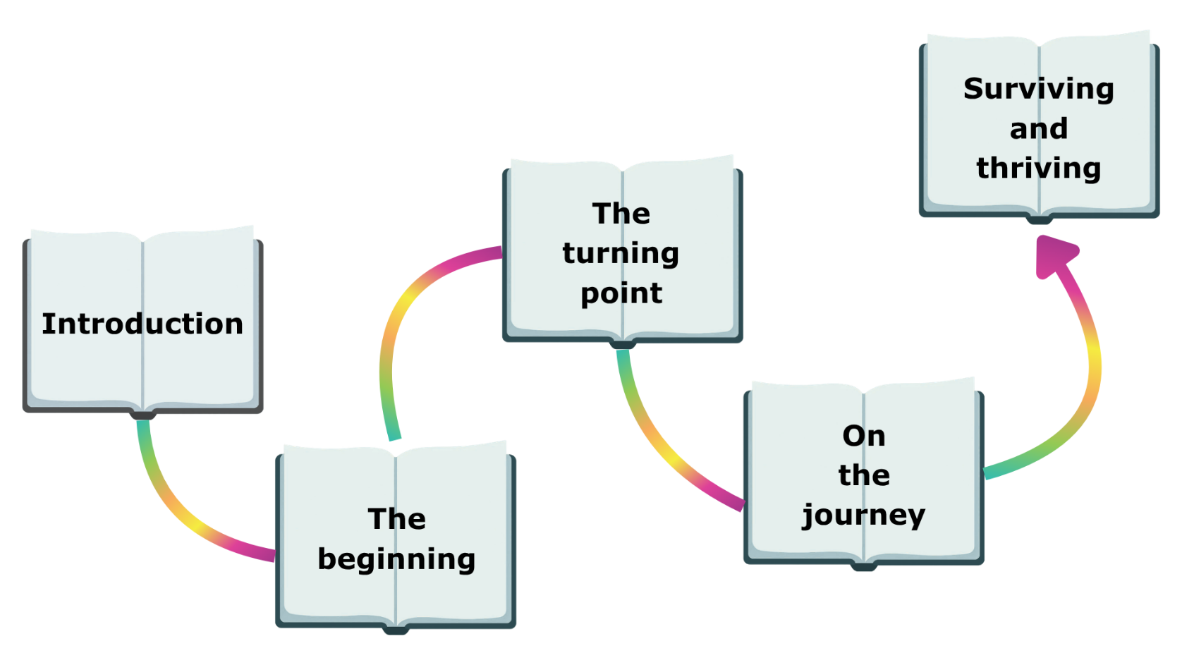
Recovery story key chapters

Introduction to you
- Who are you?
- What matters to you?
- What do you love doing?
- What are you good at?

The beginning
Lots of people have struggled with mental health challenges, yet these can be hard to talk about due to stigma. Even those going through the recovery process may experience it hard to find their voice.
- When were you aware something was wrong?
- What were the early signs, what did you notice, what were you feeling?
- Do you remember the lowest point, how did that feel and what was happening?
- How did this impact you and others at the time?
- How were you coping?
How can you use this part of your experience to connect to others?

The turning point
The idea that certain key life events can trigger turning point experiences offers a valuable way to think about change. It is unlikely to be one giant lightbulb moment that is the turning point (although it may be) and more likely a growing feeling that change is required.
- When were you aware something was changing, and that you wanted to move forward?
- What were the significant turning points, what did you notice, what were you feeling?
- Do you remember how your thinking changed, and you felt hope for the future?
- How did this impact you and others at the time?
- What were your first few steps on the road to recovery?
How can you use this part of your experience to connect to others and create hope?

On the journey
We all need people and activities in our lives that make us feel good and help us to grow and learn. Trauma of any sort can disrupt connection with others. Taking action to improve connections is likely to be a core part of the recovery journey.
- What are the boundaries you set that supported you on the recovery journey?
- What types of support have had the greatest impact, especially when you were feeling low?
- Do your strengths help you recognise situations and behaviours that might trigger setbacks?
- How are you regulating your thoughts, behaviours and emotions?
How can you use this part of your experience to encourage and empower others?
Surviving and thriving
When surviving, you tend to focus on immediate needs and live day-to-day without taking the time to consider your long-term goals, dreams or aspirations. On the other hand, thriving involves embracing a growth mindset and actively seeking opportunities for personal growth and development.
- Describe in a few words your vision for the future, including for your role in peer support.
- What types of self-care are nourishing your mind, body and spirit, right now?
- How have you created social connections that provide joy and learning, that can support you moving forward?
- How are you taking positive and considered risks to support your vision for the future?
How can you use this part of your experience to empower others to thrive?

Language and impact
Remember peer support is a mutual relationship – walking alongside and learning from each other – your story will not have all the answers. It is part of the peer relationship not the whole thing.
It can be helpful at this stage just to revisit your thinking on the previous pages.
Are you satisfied that the story reflects what you want to say, in the context of using your experience intentionally to support others in a peer relationship?
- Are you comfortable with the level of personal disclosure (not over familiar or over emotional)?
- Have you checked your story contains positive and encouraging language?
- Have you checked that your story, as best you can, is unlikely to adversely trigger others?
- Are you satisfied that your story would inspire others through the sharing of strategies and support?

Last thoughts
Having completed the personal reflection process, how do you feel about your current/desired role in peer support?
After working through the reflective activities together, you and the facilitator will take some time to discuss whether you both feel it’s the right moment for you to take part in Peer2Peer.

