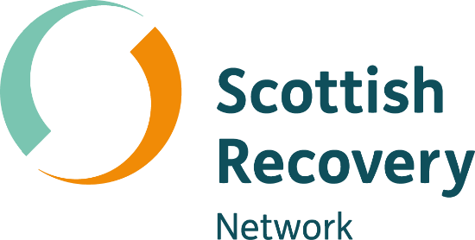

Peer2Peer
Facilitator handbook
Who is Peer2Peer for?
Participants may already be in a peer role as a peer worker (paid or unpaid) or have the aspirations to take on a peer role. The programme will prepare participants to use their lived experience to intentionally support others and develop a deep understanding of peer practice and skills.
Scottish Recovery Network will provide resources and materials for facilitators to deliver this content as provided or use as a framework to design their own programmes. This programme aims to provide a flexible approach; facilitators may choose to run all of the modules or deliver a one-off session.
Preparing for Peer2Peer
We have created guidance for a pre-programme conversation and/or session that helps explore participant’s readiness for Peer2Peer. It introduces the importance of using their lived experience to inspire and support others.
We recommend every participant undertaking a Peer2Peer module, irrespective of skills and experience, completes the Preparing for Peer2Peer part of the programme.
Participants can work through the Preparing for Peer2Peer: participant readiness workbook which includes reflective activities.
As a facilitator you can then use the Preparing for Peer2Peer: facilitator session plan to hold 1-1 conversations or a group session to decide together whether Peer2peer is the right fit.
- This is unlikely to be required for a one-off session of Peer2Peer; however it is there if needed.
Programme modules
The programme has three modules, and each has a series of sessions. Each session is designed for 2.5 hours which means two sessions could be delivered over a day. You can find more information about the content in each module on page three.

The modules are:
- Module one: Introducing peer support
Understanding mental health recovery and peer support
- Module two: The peer support relationship
Exploring peer values, relationships, boundaries and power
- Module three: Peer concepts and practice
Preparing to put peer knowledge and skills into practice
Peer2Peer online toolbox
We have designed an online toolbox to support the facilitation of Peer2Peer. The toolbox has a pathway for facilitators and another for participants.
Participants can access a workbook for each module, including films from the sessions and further reading and resources.
Facilitators can access session plans, slides, facilitator reflection sheets, and additional resources to support you to facilitate Peer2Peer.
Facilitator preparation
We recommend two facilitators co-facilitate the sessions. Given the topic it can be helpful to be able to support each other, and support participants if needed. To bring authenticity and lived experience to the sessions, we advise at least one of the facilitators has lived experience of practicing peer support which they feel comfortable drawing on during the sessions.
Participant preparation
Each module has its own participant workbook. We recommend that the participants are provided with a printed copy of workbook relevant to the module you are planning to deliver.
The workbook holds resources and handouts as well as questions and space for reflection. This is a supportive resource for facilitators and provides a personal document for participants.

Module overview
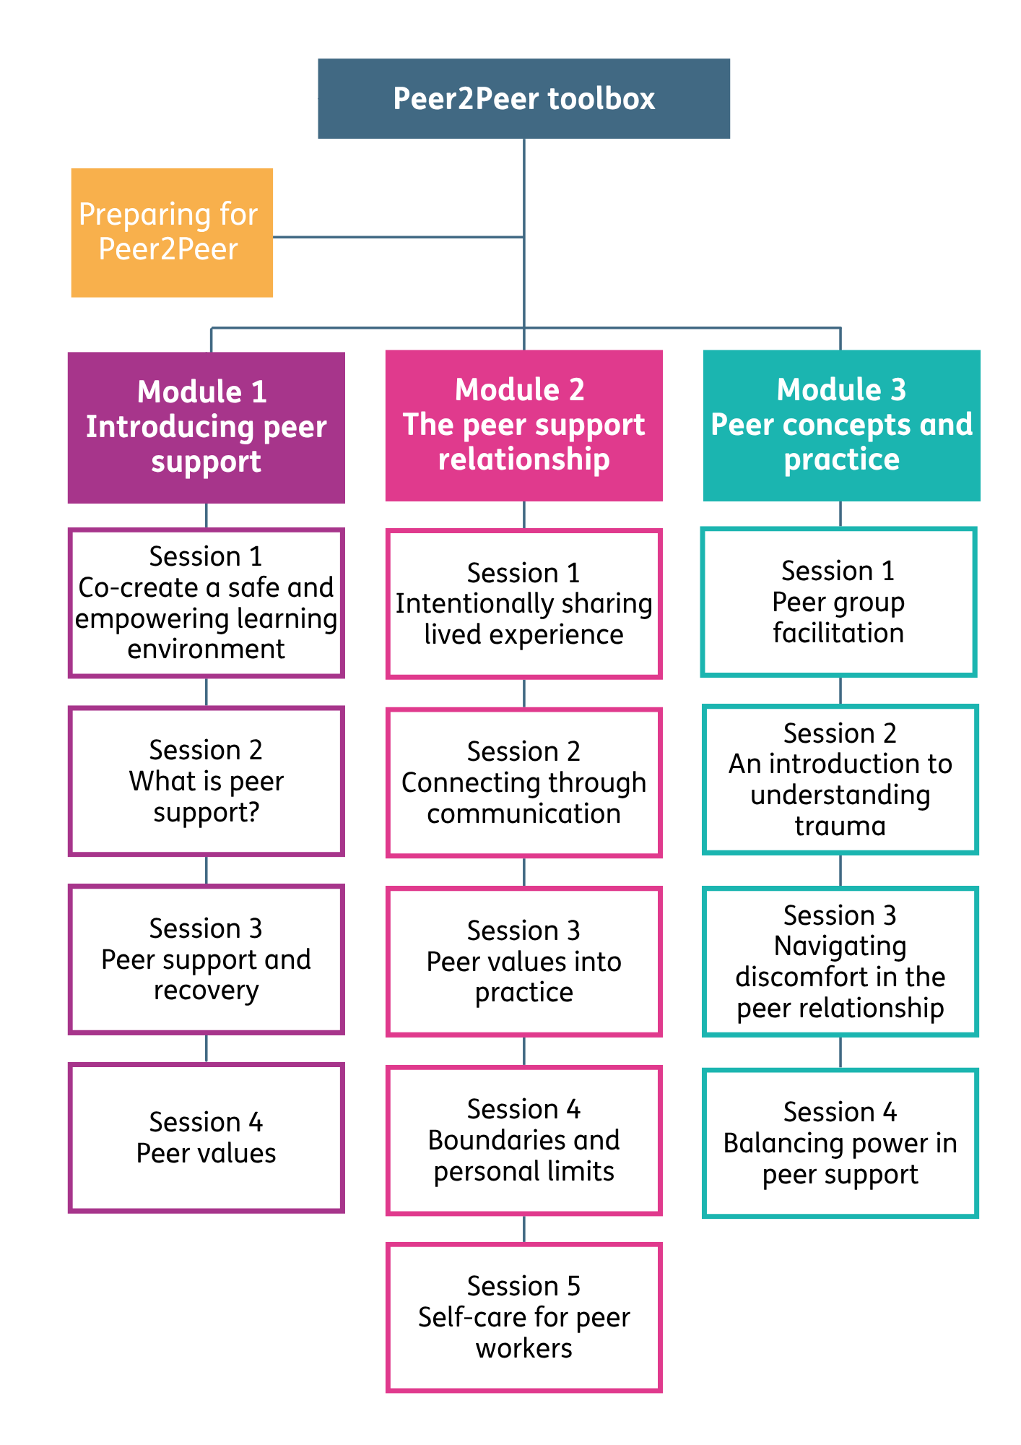
- Word version of this module overview
Session structure
The sessions all follow a similar structure, which helps maintain a consistent flow and means participants know what to expect from each session. The sessions are structured as follows:
- Welcome and housekeeping | Meeting the group and outlining practical information (breaks, approach, timings).
- Learning intentions | Brief overview of the session aims.
- Group learning agreement | Collaborative creation of our group guidelines for learning together.
- Checking in | Opening discussion around a question related to the session topic.
- Two/three core activities (with a break in between) | The main learning section of the session, using interactive activities and discussions to explore the key themes.
- Learning intentions | Returning to the learning intentions to reflect on the aims of the session.
- Checking out | Sharing final reflections and key learnings from the session.
Learning intentions
Learning intentions anchor the sessions because they give everyone a clear sense of purpose and direction. They link directly to each activity in the session and help participants understand why we’re doing what we’re doing.
Reviewing the learning intentions at the start allows us to check that they make sense and ensure the group feels aligned with the plan. A simple question such as ‘How do you feel about our learning intentions for today?’ can clarify early on the assumptions about purpose of the session.
Returning to the learning intentions at the end of the session creates a moment of reflection around what we have covered and identify anything participants may want to explore further.
Group learning agreement
At the beginning of every session, we will start by creating a group learning agreement. This is an approach we are adapting from peer support. A group agreement is a collaboratively created set of guidelines that helps create safety, trust, and mutual respect within the group. It’s not just a list of rules imposed by the facilitator; it’s a shared understanding of how participants and facilitators will work together and hold space for learning.
For this programme the group learning agreement is designed around the CHIME model of recovery (Leamy et al. 2011).
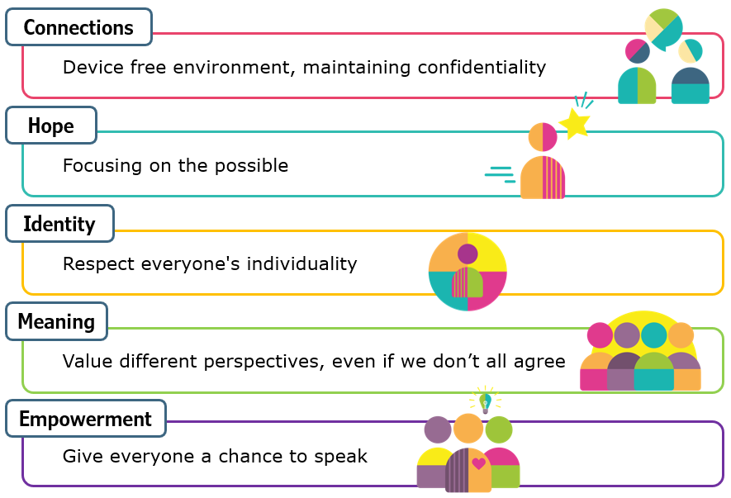
- Word version of this CHIME diagram
To create the group agreement, we suggest you review the starter points provided in the format of CHIME, then invite participants to contribute points they think will help create a safe and empowering learning environment.
Give everyone a turn to speak if they wish to do so. Remind the participants of our group learning agreement throughout the sessions, particularly if you come across challenging discussions where boundaries may be encroached. The group learning agreement is not set in stone, and we encourage you to revisit it at the start of every session and invite participants to make changes and additions as they see fit.
Checking in and checking out
Checking in is an opportunity to hear every voice in the room and support participants to ‘warm up’ before the key activities. Each session has a checking in question connected to the session content and a checking out question reflecting on experience. You can of course change and edit these to suit your purpose if that is helpful.
Facilitation time
As a facilitator, your role is to hold the structure of the session through keeping an eye on time and helping participants stay focused by reminding them how long they have left during smaller group activities. This is not to rush people but to support the group to use the time intentionally.
When rich discussion is happening, but you notice the session is running over, you can pause and invite participants to choose how they want to proceed: continue the conversation and revisit remaining activities another time or wrap up and move on. This approach keeps the session on track, while still empowering participants to shape their own learning.
Each session is designed to last 2.5 hours; however, we encourage you to use your judgement around if you need more or less time based on your group size. Given the nature of the sessions, we recommend running the sessions with a minimum of around seven to eight, and no more than 15 participants.
Role of the facilitator
Unlike traditional training courses, the role of the facilitator is not to be the expert or to ‘teach’ the content. In Peer2Peer it’s about holding the space so the wisdom, experience and knowledge already in the room can be shared. A good facilitator creates the conditions for learning by guiding the group to explore the key themes and learn from one another.
The role of the facilitator is to ask powerful questions, encourage curiosity and support the group to stay connected to the learning intentions. This can be done by thinking about the following:
Awareness of impact of language | Using positive, strengths-based questions and language.
Planning and preparation | Demonstrating your respect for participants by planning and preparing.
Probing | Using probing ‘powerful’ questions, comments and observations to support deeper exploration of learning.
Respecting | Encouraging contributions from everyone.
Engaging and empathetic | Being authentic and fully present, listening, nurturing and reassuring so that everyone has their voice heard.
Curiosity and challenge | Demonstrating your natural curiosity about what’s been happening with the learning journey of participants, challenging behaviour that doesn’t sit with peer values.
Insight | Providing feedback on the impact of participants by sharing what you are sensing and observing.
Attentive | Listening to stories and experiences, hearing the essence as well as the words, checking for resonance between language and behaviour.
Integrity | Being supportive during the conversation and maintaining confidentiality.
Verbal and non-verbal behaviour | Sensing and checking your personal impact, when and how to respond to the flow of the conversation.
Energy | Bringing your physical energy and enthusiasm to the conversation, thinking about the positive impact of the pace, tone, resonance and energy of your voice.

Powerful questions
In a world where facilitators are expected to come up with the answers, this is a different kind of conversation where you use powerful questions and deep listening to create space for others to think.
These conversations do not have a right and a wrong answer, it’s about exploring the content together. It’s important to allow silence without rushing to fill it, and to resist the pull towards giving advice. Asking power questions can be the key to drawing out the knowledge and experience participants already have within.
Below are some examples of powerful questions:
- Can you tell me a bit more about what you meant there?
- What makes that important to you?
- What did you learn from that experience?
- What else is coming up for you as you think about this?
- Does this resonate with anyone else in the room?
- Could you give us an example to help us understand it more clearly?
- What might you try next time you are in a similar situation?

Growing peer support together
Now that you have read the facilitator handbook, we encourage you to explore the online Peer2Peer toolbox.
By facilitating Peer2Peer you are playing a key role in growing peer support capacity in Scotland and developing the peer workforce. Thank you for helping to create meaningful learning opportunities for peer workers. We wish you all the best on your Peer2Peer journey!

