

Peer group facilitation

Peer2Peer: module three, session one
Facilitator session plan



Module three: Peer concepts and practice
Welcome to module three of the Peer2Peer group training course!
This module builds on the foundations developed in Modules one and two, focusing on applying peer support concepts and skills in practice. It is designed for people who already have a solid understanding of peer support or experience delivering it and can also be used as continuing professional development for existing peer workers. This module supports participants to deepen their practice and strengthen their confidence in supporting the recovery journey of others.

Before starting this module
We recommend participants complete Preparing for Peer2Peer: participant readiness workbook.
Before facilitating take time to get familiar with this module three, session one plan and the associated participant workbook. Make sure everyone has their own copy of the participant workbook for this session and encourage them to complete the pre-work activity on pages 2 – 3 in the workbook ahead of the session. Ask them to bring their participant workbook along on the day and keep a few spares handy just in case

After the session
- Complete the facilitator reflections template
- Remind participants to review and finish the reflection activities in their participant workbook before the next session
- Update the group learning agreement slide after the session, ready for future sessions

Session one: Peer group facilitation
As part of their role many peer workers are involved in facilitating peer support groups. Throughout this session we will refer to a peer worker as a peer group facilitator.
Learning intentions
- Explore how the role of the peer group facilitator in creating empowering peer spaces
- Understand group dynamics and explore the facilitators' role in responding to challenging group
dynamics
- Explore boundaries in peer group settings

What is peer facilitation?
Peer facilitation can be described as people with lived experience of mental health challenges facilitating a peer led support group. There is a small but significant difference between being a facilitator and a peer facilitator. A peer facilitator is a peer with their own lived experience and as such not bringing a 'professional' perspective to the role. Without lived experience, it is a facilitator holding a peer space. Peer facilitation is a skill and something to be developed through practice. The role of the peer facilitator is to host the group, to hold a safe space for people to contribute, to gently steer the group and to role model engagement and participation.
Creating empowering spaces
The peer facilitator role is hugely important because it will help guide conversations and create empowering spaces. When done right, it can enable peer groups to flourish. Group agreements, structure, and a clear purpose are the foundations of an empowering peer support space:
- Group agreements help everyone co‑create the conditions they need to feel safe, respected, and able to participate in a way that feels right for them
- A simple structure gives the group predictability which can reduce anxiety and help people stay engaged
- Being clear about the purpose of the group ensures that everyone understands why they’re there, what the space is for, and how they can contribute. It also makes clear what the group space is not for, which is important when it comes to setting boundaries
Together, these elements create empowering spaces where power is shared, and people are able to fully engage in the peer support offering.
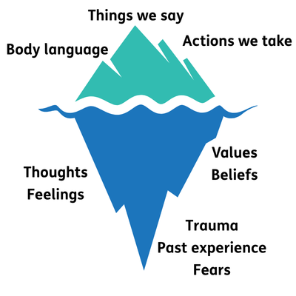
Language and communication
In peer group facilitation, the language we use and the way we communicate are important to create safe empowering spaces where peer support can happen. Recovery language helps create hope within the group. When thinking about how peer facilitators communicate within the group, the iceberg metaphor can be helpful to consider.
Above the water are the things we can observe things people say, the actions they take, and their body language. But below the surface are what shapes those behaviours: thoughts, feelings, values, beliefs, fears, trauma, and past experiences. When peer group facilitators remember that there is more to a person than what appears on the surface, they can approach facilitation with more curiosity, compassion, and patience.
As a peer group facilitator, it can be worthwhile putting into practice skills such as active listening (look at Ting from module two, session two), noticing body language and tone of voice. Being aware of potential triggers and over disclosure can help keep the group safe. There is no ‘one size fits all’ way to facilitate however, one approach to consider the Five I's outlined on the next page.
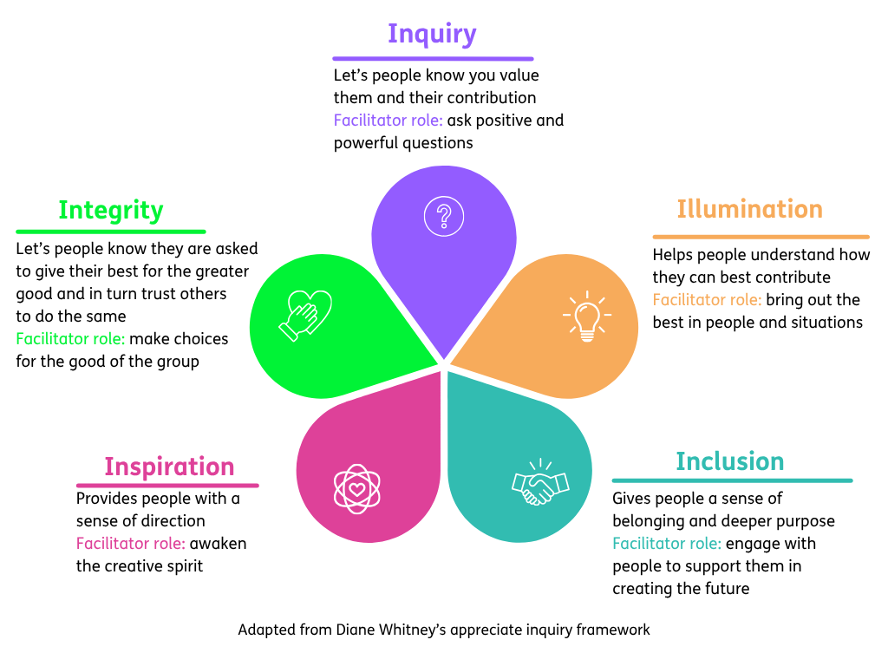

- Word version of the appreciative enquiry framework diagram.
Understanding group dynamics
As peer facilitators it is important to have an awareness of group dynamics and play an active role in creating harmony within the group. There are many models and theories around group dynamics, we have chosen to focus on Tuckman’s stages of group development. Having an awareness of this model can help the facilitator feel confident in their role of leading the group and anticipating various group dynamics. Each stage calls for a different type of support from the facilitator, as outlined in the diagram below.
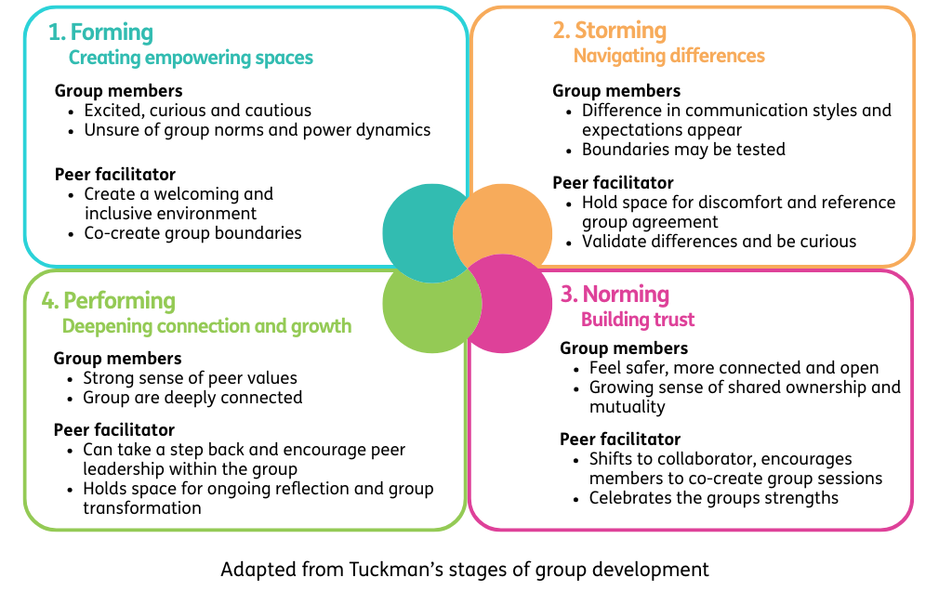

- Word version of stages of group development diagram.
It’s also important to recognise that every group is made up of different people with different personalities, communication styles, and comfort levels, all of which influences the group dynamics. Clear structure and agreed boundaries help hold the group through any challenging group dynamics.
Boundaries in group settings
Peer facilitators must be conscious of maintaining boundaries for themselves and the group. Learning to share only enough of their experience where relevant, to enable others to share can be an important role of the facilitator. Boundaries exist on several levels:
- Personal boundaries that protect our own wellbeing
- Group boundaries that keep the space safe and empowering
- Wider societal boundaries that shape how people understand safety, trust, and power
Group agreements are a widely used tool in peer support which can help set and remind us of these boundaries, offering a shared reference point when things feel unclear (see module one, session one for more on creating a group agreement). Groups are made up of a variety of personalities, so naturally boundaries will be tested or slip. A skilled peer facilitator will be able to name boundary slips and remind the group of the agreed boundaries. It’s also good practice for facilitators to debrief after sessions, either alone or with a co‑facilitator, to reflect on any boundary challenges and learning for future. Role clarity is important here too. When facilitators are clear that their role is as a peer (not a clinician or fixer) this helps prevent role drift and protects boundaries.

Session plan
Two-hours and 30 minutes session. Deliver in person or online. Recommend no more than 15 participants for two facilitators. Participants should review and complete the reflective activities in their workbook before the session and bring this along on the day.

Activities  & timing | Resources needed | Guidance
Welcome and introductions  10 minutes | Slide one  Sticky label name badges | Welcome participants when they arrive, make everyone feel comfortable, use people’s names, and thank them for coming.  - 5 minutes: Cover any housekeeping and break times  - 5 minutes: Facilitators and Participants all invited to share their names and pronouns. This can be done verbally or, if online, using the chat as an introduction.  A reminder to keep this introduction brief to one or two sentences to keep to time. Invite but do not force people to share their pronouns.
Learning intentions  5 minutes | Slide two | Share the learning intentions from the slide helps participants to know the purpose of the session and what to expect. Facilitators can read them out or invite a participant to read each one.  Check in to see if everyone understands them. Answer any questions people may have at this point.
Group learning agreement  15 minutes | Slide three | To ensure this space remains positive, safe, and empowering for everyone, we will co-create and/or review our group learning agreement.  - If this is the first session: dedicate time to creating the learning agreement together, using CHIME as a guiding framework  - If this is a subsequent session: begin by reviewing the existing agreement, inviting participants to check in and suggest additions or changes  Sample script: “These are our shared boundaries for keeping this a positive and safe learning space. We will return to them at the start of every session, so this is a living resource. Group agreements are a tool peer facilitators use to collectively create and set boundaries for the group. As we move through today’s session, you’ll see different techniques in action that you might want to take into your own groups.”
Checking in  10 minutes | Slide four | At the start and end of each session, we’ll use a simple check-in and check-out question. Everyone gets a couple of minutes to think about it and jot down notes if they wish.  Checking in question: What kind of facilitator do you want to be?  After two minutes, invite people to share their thoughts. Thank each person as they speak, but don’t add your own commentary. Once everyone’s had a turn, reflect back some of the common themes you heard. Wrap it up by saying this is a great way to get everyone’s voice in the room and set the tone together.  Sample script: “Before we begin, you will have completed the short reflective activity in your workbook on the kind of facilitator you want to be. Draw on this to help answer todays checking in question.”
Creating empowering spaces  25 minutes | Slide five – seven  Slide five  Slide six  Slide seven | Purpose: To explore how we create empowering peer group spaces.  - 5 minutes: Facilitators should read out, or invite a few participants to volunteer to read out, the slide on the role of peer group facilitators.  Activity one: Creating empowering spaces  - 10 minutes: Group discussions: Break the participants into groups of 3 - 4 to discuss the following questions:  - What does an empowering peer space look and feel like?  - What can the peer group facilitator do to create this space?  - 10 minutes: Invite the groups to share their learning from the discussions around what needs to be in place to achieve an empowering peer space. Share slide seven to cover some examples.  Key points: Creating empowering spaces involves being intentional about power dynamics, encouraging participation in different ways, and co-creating boundaries for the space together. Participants will draw on their own experiences of peer spaces to reflect on what made it feel safe and then link this to their practice as a facilitator and the role they play in creating these conditions.  Sample script: “A key role for peer group facilitators is to create spaces where people feel empowered and where they can show up as themselves and contribute in ways that feel meaningful to them. Empowering spaces are shaped by how as facilitators we hold the room, how we share power, and how we communicate with others.”
10 minutes | Slide eight | Comfort break  (suggest setting a timer to alert participants when to return)
Understanding group dynamics  40 minutes | Slide nine – 10  Slide nine  Slide 10  Flipchart or online equivalent  Participant workbook | Purpose: To understand group dynamics and explore the facilitators’ role in responding to challenging group dynamics  Sample script: “We’re going to look at group dynamics and the facilitator’s role when things feel challenging. Understanding the stages of group development can help us recognise what might be happening beneath the surface when groups behave in certain ways. This can also help us know how best to respond to these group dynamics.”  - 5 minutes: Facilitators should read out, or invite a few participants to volunteer to read out, the slide on the stages of group development.  Activity two: Understanding group dynamics  - 20 minutes: Group discussions: Break the participants into four groups and assign each group a scenario. The participants have these in their workbooks. Groups should discuss the following:  - What might be influencing this behaviour?  (Think about the iceberg metaphor)  - What could the facilitator do in the moment?  - What could the facilitator do following the session?  Scenario 1: Side conversations  During the session, Simon and Joe keep whispering to each other whilst other people are sharing with the group. Others in the group look distracted.  Scenario 2: Emotional responses  Jessie becomes upset and starts crying whilst someone else is sharing. The group freezes and are unsure how to respond to this. The person who was sharing also pauses, unsure whether to continue sharing or not.  Scenario 3: Conflict between members  Amber and Ella disagree strongly about a topic that was raised during a group discussion. They begin shouting at each other during their disagreement, and the group feels tense.  Scenario 4: Testing boundaries  Sarah repeatedly arrives late to the group and causes interruption when they enter. They don’t follow the group agreement around using their phone during the session.  - 15 minutes: Facilitators should invite each group to share their scenario and gather facilitation techniques. Themes you may notice:  - Naming what’s happening  - Revisiting group agreement  - Structure the group to address dynamics  - Encourage shared responsibility within the group  - Draw on peer values  - Debrief to learn from challenging situations  - Close the activity by asking participants to note in their workbook what facilitation skill/technique they want to practice when working with challenging group dynamics.  Key points: Highlight that challenging dynamics are a normal part of group development and often reflect unmet needs or confusion around expectations. Emphasise that group facilitators don’t need to “fix” everything in the moment, but learning from the experience is an important step afterwards.
Boundaries in group settings  20 minutes | Slide 11 – 12  Slide 11  Slide 12  Participant workbook | Purpose: To explore how confident we feel in setting and maintaining boundaries in group settings.  Sample script: “Peer group facilitators play a key role in setting and maintaining boundaries in the group space. Everyone will vary when it comes to how confident we feel setting and maintaining boundaries in group settings. There is no shame in this, it’s important this is a safe space we can be honest with ourselves around where we feel confident, and where we feel less confident as it helps us identify areas for growth.”  - 5 minutes: Facilitators should read out or invite a few participants to volunteer to read out the slide on boundaries  Activity three: Boundaries continuum  - Invite participants to join in this continuum activity. Before starting, let participants know there is no right or wrong answer.  - In Person: Place an A4 Card at one end of the room with “Strongly disagree” on it and another with “Strongly agree” and ask people to stand between the cards at the place that reflects where they are on the continuum. You will then invite a few people to share (as much as they feel comfortable) why they positioned themself where they are.  - Online: Using the slides or the images in the workbooks, participants should place a “X” on the continuum that reflects where they are. You will then invite a few people to share they positioned themself where they are.  Spend 15 minutes asking participants to place themselves on the continuum and reflect on why they placed themselves there. Participants have the below prompts in their workbook, invite them to pick what one they wish to discuss and work through until time has run out.  - I’m confident naming when a boundary is crossed in a group.  - I feel comfortable reminding the group about our group agreement.  - I can recognise when my own boundaries are being stretched.  - I feel confident asking someone to step back and make space for others.  - I can notice when I’m slipping into helper role and take a step back.  - I can redirect the conversation when it goes off track  - I’m comfortable saying “That’s not my role”  - I feel confident checking in with someone privately after a group session.  - I can stay calm when someone is upset or distressed.  Key points: Boundaries are an empowering tool for creating safety and shared responsibility in peer groups. Confidence in boundary‑setting grows with practice. Encourage participants to be honest with themselves and notice where their comfort levels vary. Participants should reflect on what areas around boundaries they want to further develop their confidence around.
Learning intentions  5 minutes | Slide 13 | This slide lists the learning intentions we set out to cover at the beginning of the session. Review these again and ask the group if they feel we have covered the topics.
Checking out  10 minutes | Slide 14 | Note: This is a closing activity. If you are running two of these sessions together then save this until the end of the second session.  Closing question: What’s one thing you are taking away from today’s session?  After two minutes, invite people to share their thoughts. Thank each person as they speak, but don’t add your own commentary. Once everyone’s had a turn, reflect back some of the common themes you heard. Wrap it up by saying this is a great way to get feedback on the session.  Thank everyone, remind them about the next session and the prep for this session outlines in their participant workbook.  As a facilitator if it is helpful, you can complete the facilitator reflections template.

