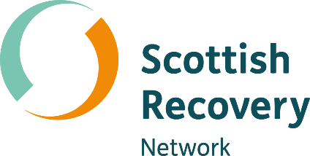

Peer group facilitation

Peer2Peer: module three, session one
Participant workbook



Module three: Peer concepts and practice
Welcome to module three of the Peer2Peer group training course!
This module builds on the foundations developed in modules one and two, focusing on applying peer support concepts and skills in practice. It is designed for people who already have a solid understanding of peer support or experience delivering it and can also be used as continuing professional development for existing peer workers. This module supports you to deepen your practice and strengthen your confidence in supporting the recovery journey of others.

Purpose of the participant workbook
The workbook is designed to support your learning journey. It gives you space to prepare for each session, reflect on your experiences, and capture your own thoughts. There are no right or wrong answers and facilitators won’t be reading what you write.
Peer2Peer is a learning experience where you will be encouraged to draw on your lived experience to facilitate learning and skills development. It’s important you only share what you are comfortable with and that we recommend making time for self-care after the sessions.

Doing the pre-work before each session helps you arrive with clear thinking and makes it easier to contribute to conversations. It’s a good habit to build for your peer role, or for a future one.

Session one: Peer group facilitation
As part of their role many peer workers are involved in facilitating peer support groups. Throughout this session we will refer to a peer worker as a peer group facilitator.
Learning intentions
- Explore the role of the peer group facilitator in creating empowering peer spaces
- Understand group dynamics and explore the facilitators' role in responding to challenging group
dynamics
- Explore boundaries in peer group settings

Checking in question
- What kind of peer group facilitator do you want to be?
(see the below pre-session reflection to help you prepare for this question)
Pre-session reflection
Below are different types of facilitation styles. As you read notice what feels most like you.
- The connector– focuses on building relationships and helping people feel included, prioritises connections
- The guide – holds structure and keeps the group on track, prioritises time keeping
- The space holder – creates a safe space where people can open up, prioritises emotional safety
- The co-learner – facilitates alongside the group and shares power, prioritises being curious
- The activator – brings energy and momentum, helps people turn ideas into action, prioritises encouragement

Which of these styles feels most like you?

What qualities do you want to strengthen more?

As a facilitator, I want to be someone who…

Creating empowering spaces
The peer facilitator role is hugely important because it will help guide conversations and create empowering spaces. When done right, it can enable peer groups to flourish. Group agreements, structure, and a clear purpose are the foundations of an empowering peer support space:
- Group agreements help everyone co‑create the conditions they need to feel safe, respected, and able to participate in a way that feels right for them
- A simple structure gives the group predictability which can reduce anxiety and help people stay engaged
- Being clear about the purpose of the group ensures that everyone understands why they’re there, what the space is for, and how they can contribute. It also makes clear what the group space is not for, which is important when it comes to setting boundaries
Together, these elements create empowering spaces where power is shared, and people are able to fully engage in the peer support offering.

Activity one: Creating empowering spaces
Group discussion
- What does an empowering peer space look and feel like?
- What can the peer group facilitator do to create this space?

Facilitators can create empowering spaces by…

Language and communication
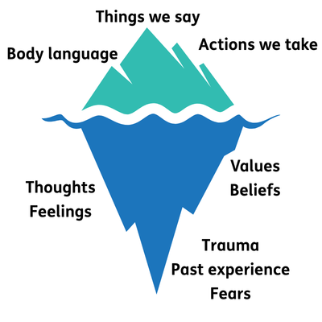
In peer group facilitation, the language we use and the way we communicate are important to create safe empowering spaces where peer support can happen. Recovery language helps create hope within the group. When thinking about how peer facilitators communicate within the group, the iceberg metaphor can be helpful to consider.
Above the water are the things we can observe things people say, the actions they take, and their body language. But below the surface are what shapes those behaviours: thoughts, feelings, values, beliefs, fears, trauma, and past experiences. When peer group facilitators remember that there is more to a person than what appears on the surface, they can approach facilitation with more curiosity, compassion, and patience.
As a peer group facilitator, it can be worthwhile putting into practice skills such as active listening (look at Ting from module two, session two), noticing body language and tone of voice. Being aware of potential triggers and over disclosure can help keep the group safe. There is no ‘one size fits all’ way to facilitate however, one approach to consider the Five I's outlined on the next page.

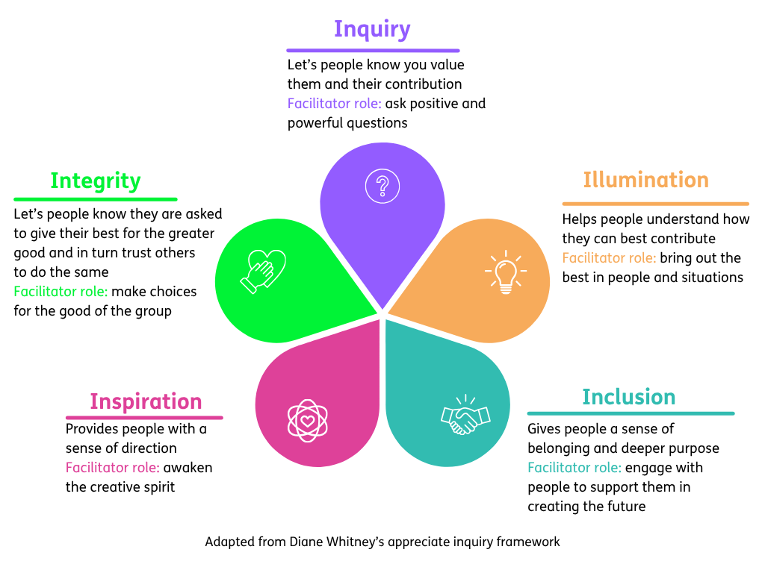

- Word version of the appreciative enquiry framework diagram.
Understanding group dynamics
As peer facilitators it is important to have an awareness of group dynamics and play an active role in creating harmony within the group. There are many models and theories around group dynamics, we have chosen to focus on Tuckman’s stages of group development. Having an awareness of this model can help the facilitator feel confident in their role of leading the group and anticipating various group dynamics. Each stage calls for a different type of support from the facilitator, as outlined in the diagram below.
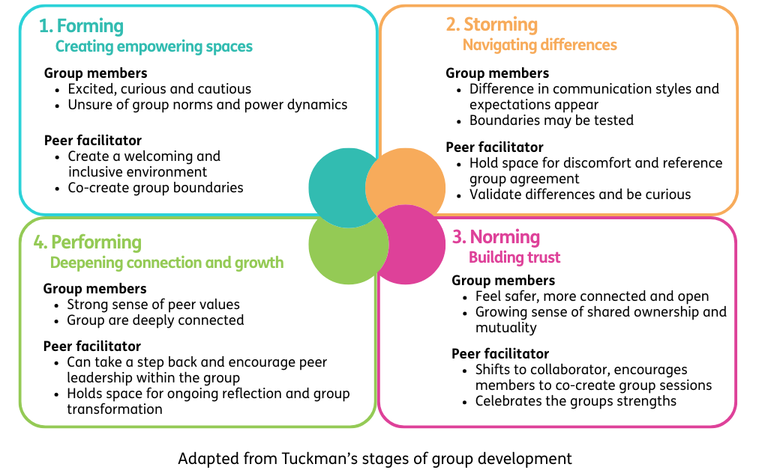

- Word version of stages of group development diagram.
Activity two: Understanding group dynamics
The facilitator will assign one of the following scenarios to your group:
Scenario 1: Side conversations
During the session, Simon and Joe keep whispering to each other whilst other people are sharing with the group. Others in the group look distracted.
Scenario 2: Emotional responses
Jessie becomes upset and starts crying whilst someone else is sharing. The group freezes and are unsure how to respond to this. The person who was sharing also pauses, unsure whether to continue sharing or not.
Scenario 3: Conflict between members
Amber and Ella disagree strongly about a topic that was raised during a group discussion. They begin shouting at each other during their disagreement, and the group feels tense.
Scenario 4: Testing boundaries
Sarah repeatedly arrives late to the group and causes interruption when they enter. They don’t follow the group agreement around using their phone during the session.
Group discussion
- What might be influencing this behaviour? (refer to iceberg image on page 5)
- What could the facilitator do in the moment?
- What could the facilitator do following the session?

One facilitation skill or technique I want to practice is…

Boundaries in group settings
Peer facilitators must be conscious of maintaining boundaries for themselves and the group. Learning to share only enough of their experience where relevant, to enable others to share can be an important role of the facilitator. Boundaries exist on several levels:
- Personal boundaries that protect our own wellbeing
- Group boundaries that keep the space safe and empowering
- Wider societal boundaries that shape how people understand safety, trust, and power
Group agreements are a widely used tool in peer support which can help set and remind us of these boundaries, offering a shared reference point when things feel unclear (see module one, session on for more on creating a group agreement). Groups are made up of a variety of personalities, so naturally boundaries will be tested or slip. A skilled peer facilitator will be able to name boundary slips and remind the group of the agreed boundaries. It’s also good practice for facilitators to debrief after sessions, either alone or with a co‑facilitator, to reflect on any boundary challenges and learning for future. Role clarity is important here too. When facilitators are clear that their role is as a peer (not a clinician or fixer) this helps prevent role drift and protects boundaries.
Activity three: Boundaries continuum
As a group, decide what statements below you wish to focus on. You may wish to create your own statement to share with the group. Then place yourself on the continuum where you relate to the statement.
- I’m confident naming when a boundary is crossed in a group
- I feel comfortable reminding the group about our group agreement
- I can recognise when my own boundaries are being stretched
- I feel confident asking someone to step back and make space for others
- I can notice when I’m slipping into helper role and take a step back
- I can redirect the conversation when it goes off track
- I’m comfortable saying “That’s not my role”
- I feel confident checking in with someone privately after a group session.
- I can stay calm when someone is upset or distressed.
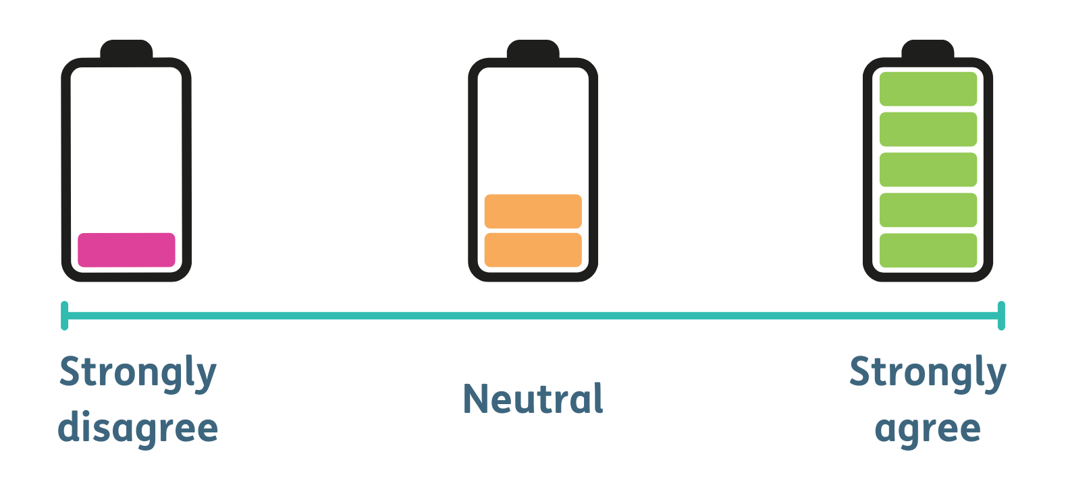
Closing reflection: What’s one thing you are taking away from today’s session

Resource list
Films
- Fine tuning your peer facilitation skills – Scottish Recovery Network
- Let’s do peer group facilitation top tips - Scottish Recovery Network
- Scott: Attending peer support groups – Scottish Recovery
- Bipolar Edinburgh – Comfort agreement – Bipolar Edinburgh
Further quotes and reading
- Let’s do peer group facilitation guides – Scottish Recovery Network
- Group facilitation toolkit – Support House Centre for Innovation in Peer Support
- Working with groups – Mind
- Running a peer meeting: some useful facilitation skills – Peer Connect

