

Peer values
[Grab your reader’s attention with a great quote from the document or use this space to emphasize a key point. To place this text box anywhere on the page, just drag it.]
[Grab your reader’s attention with a great quote from the document or use this space to emphasize a key point. To place this text box anywhere on the page, just drag it.]
Peer2Peer: module one, session four,
Facilitator session plan



Module one: Introducing peer support
Welcome to module one of Peer2Peer!
This first module sets the scene, giving space to explore recovery and peer support together at an introductory level. The session plan offers some handy background information and a suggested plan, but feel free to adapt it to fit your group. Be mindful your role isn’t about being the “expert with all the answers,” it’s about creating a learning space that draws on the knowledge and lived experience in the room.

Before starting this module
We recommend participants complete the Preparing for Peer2Peer: participant readiness workbook and have a 1-1 or group facilitated conversation with you.
Before facilitating session take time to get familiar with this session plan and the associated participant workbook. Make sure everyone has their own copy of the participant workbook for this session and encourage them to look over the reflection activities beforehand. Ask them to bring their participant workbook along on the day and keep a few spares handy just in case.

After the session
- Complete the facilitator reflections template
- Remind participants to review and finish the reflection activities in their participant workbook before the next session
- Update the group learning agreement slide after the session, ready for future sessions

Session four: Peer values
Learning intentions
- Explore how personal values can guide peer-to-peer interactions
- Understand the core values of peer support, including their roots in lived experience movements
- Reflect on how peer values influence peer practice

Personal values
Values are the guiding principles or beliefs that shape what a person, group, or community sees as important, meaningful, or “the right thing to do.” They influence how we make decisions, how we behave, and what we prioritise in everyday life. Personal values are the beliefs that guide your actions, thoughts and feelings. These are shaped by our life experiences, such as our family, schools and community in our early years and they continue to develop as we experience life. In practice, personal values might appear in things like how we listen, how we handle conflict, the pace we work at, or the kind of support we naturally offer.
You can go online and complete this mini values assessment for fun and see where it takes you. https://personalvalu.es/ You may wish to note your top 5 values below and name these during the session to model activity 1 for participants.

Peer values
Peer values are the principles that guide how we show up for one another in the peer support relationship. These values come from lived experience and have a history rooted in the survivor and social justice movements (more on the history of peer support in Module One Session Two).
Mutual aid and community care
Long before peer support had a name, people relied on each other for emotional and practical support. These early traditions emphasised solidarity, connection, and shared responsibility.
Rights-based and social justice movements
Disability rights, civil rights, and feminist movements shaped peer support by highlighting equality and the importance of challenging oppressive structures.
Survivor and lived-experience movements
In the 1960s and 70s, people with lived experience of mental health services organised to challenge coercive, medicalised systems. They emphasised dignity, autonomy, and the belief that people are experts in their own lives.
Recovery and peer-led practice
As peer roles developed, lived-experience leaders created the values framework that make peer support unique.
Peer support values are rooted in communities, and relationships. Understanding this history helps us be clear about what peer support is and what makes it different from traditional, hierarchical models of support.

HEAR ME
Putting the Pieces Together: A Framework for Mental Health Peer Support in Scotland was developed with peer workers. The aim is to improve understanding of peer support and ensure that the role of peer workers is clear and remains true to the peer support ethos. Peer support is grounded in six core values which we call HEAR ME.

- Hope: The belief that mental health recovery is possible for everyone
- Experience: Recovery is a personal and shared experience
- Authenticity: Being authentic is about being true to yourself
- Responsibility: Mental health, wellbeing and recovery involves taking responsibility
- Mutuality: The peer relationship is two-way, both people learn, grow, and benefit.
- Empowerment: Power is shared and people are supported to make decisions that feel right for them.

In the peer support role, it is critical we understand our own values and how these show up in our behaviour especially if they take us to the helper or fixer roles.

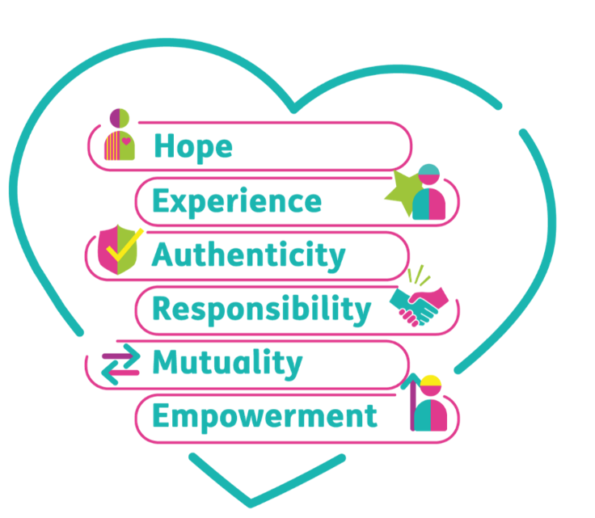

Session plan
Two-hours and 30 minutes session. Deliver in person or online. Recommend no more than 15 participants for two facilitators. Participants should review and complete the reflective activities in their workbook before the session and bring this along on the day.

Activities  & timing | Resources needed | Guidance
Welcome and introductions  10 minutes | Slide one  Sticky label name badges | Welcome participants when they arrive, make everyone feel comfortable, use people’s names, and thank them for coming.  - 5 minutes: Cover any housekeeping and break times  - 5 minutes: Facilitators and Participants all invited to share their names and pronouns. This can be done verbally or, if online, using the chat as an introduction.  A reminder to keep this introduction brief to one or two sentences to keep to time. Invite but do not force people to share their pronouns.
Learning intentions  5 minutes | Slide two | Share the learning intentions from the slide helps participants to know the purpose of the session and what to expect. Facilitators can read them out or invite a participant to read each one.  Check in to see if everyone understands them. Answer any questions people may have at this point.
Group learning agreement  15 minutes | Slide three | To ensure this space remains positive, safe, and empowering for everyone, we will co-create and/or review our group learning agreement.  - If this is the first session: dedicate time to creating the learning agreement together, using CHIME as a guiding framework  - If this is a subsequent session: begin by reviewing the existing agreement, inviting participants to check in and suggest additions or changes  These are our shared boundaries for keeping this a positive and safe learning space. We will return to them at the start of every session, so this is a living resource.
Checking in  10 minutes | Slide four | At the start and end of each session, we’ll use a simple check-in and check-out question. Everyone gets a couple of minutes to think about it and jot down notes if they wish.  Checking in question: What’s something you think makes support feel ‘human’ rather than ‘formal’?  After two minutes, invite people to share their thoughts. Thank each person as they speak, but don’t add your own commentary. Once everyone’s had a turn, reflect back some of the common themes you heard. Wrap it up by saying this is a great way to get everyone’s voice in the room and set the tone together.
Introduction to topic  35 minutes | Slide five - six  Slide five  Participant workbook  Slide six | Purpose: To explore our personal values and how they may guide our peer-to-peer interactions  - 5 minutes: Facilitators should read out slide 5 explaining what we mean by personal values and the examples. You may wish to share some of your own personal values.  Activity one: Personal values  - 5 minutes: Individual reflections: Participants will now self-reflect for 5 minutes on their own personal values. They may have done the personal values quiz ahead of time or do this now. There is a section for notes in their workbook to add their personal values.  - 15 minutes: Group discussions: Break the participants into groups of 3 - 4 to discuss the following questions:  - Think of a time someone supported you in a way that really helped. What did they do, and how might that shape the way you support others?  - When you’re with someone who’s struggling, what values might you draw on to support them?  - 10 minutes: Invite a few participants to reflect on their discussions and share any learnings from this activity.  Key points: Participants will explore what matters to them personally and how those qualities can shape the way they show up in peer support. By grounding the idea of “values” in real experiences of when support felt helpful, participants begin to recognise the principles or values that guide behaviour.  Sample script: “We’ve spent some time looking at what we mean by personal values and hopefully through personal reflections you started to notice the things that guide how you move through the world, even if you have never named them before. By thinking about the qualities you lean on when you’re with someone who’s struggling, we can see that peer support is shaped by who we are and what we care about. These personal values become the foundations we draw on when building relationships in peer support.”
10 minutes | Slide seven | Comfort break  (suggest setting a timer to alert participants when to return)
HEAR ME  50 minutes | Slide eight – ten  Slide eight  Participant workbook  Slide nine  Slide ten | Purpose: To understand the peer values and their history  Sample script: “Before we look at peer values in practice, it’s helpful to understand where they come from. Peer support grew from communities supporting each other long before formal systems existed. Over time, survivor movements, rights-based activism, and the recovery movement all shaped the values we now recognise in peer work. At the heart of it, peer values come from people showing up for one another as equals and creating relationships built on connection and lived experience.”  - 10 minutes: Facilitators should read out, or invite a few participants to volunteer to read out, the progression of peer values in history on slide 8. There is more information in the participant workbook and at the start of this session plan you may wish to add.  - Read out the HEAR ME values on slide nine. Explain there is more information on this in the participant workbook and a link to the Putting the Pieces Together: A Framework for Mental Health in Scotland resource.  - 5 minutes: Individual reflection: Invite participants to review the information on HEAR ME in their workbooks.  Sample script: “Peer values have existed since the beginning of peer support, it's what makes it peer. We may not have always named the values explicitly, but as peer support has developed and grown we now have a framework to name and articulate the values behind the practice.”  *As a facilitator, you may wish to create your own short scenarios, based on your experience, for the next activity. There are example scenarios in the workbook*  Activity two: Peer support scenarios  - 20 minutes: Group discussion: Break the participants into groups of 3 – 4 to review the scenarios in their workbook.  For each scenario discuss:  - Which HEAR ME values do you see here?  - How might this value influence peer practice?  - 15 minutes: Bring the participants back, read through each scenario and ask what HEAR ME values did they spot?  - Reflecting on the activity as a whole:  - Which values were easiest to spot?  - Which ones felt more subtle?  Key points: By exploring short scenarios and identifying which values are present, participants begin to recognise how peer values shape our practice in peer support.
Learning intentions  5 minutes | Slide 11 | This slide lists the learning intentions we set out to cover at the beginning of the session. Review these again and ask the group if they feel we have covered the topics.
Checking out  10 minutes | Slide 12 | Note: This is a closing activity. If you are running two of these sessions together then save this until the end of the second session.  Slide ten: This slide asks the question: What’s one thing you are taking away from today’s session?  After two minutes, invite people to share their thoughts. Thank each person as they speak, but don’t add your own commentary. Once everyone’s had a turn, reflect back some of the common themes you heard.  Thank everyone, remind them about the next session and the prep for this session outlines in their participant workbook.  As a facilitator if it is helpful, you can complete the facilitator reflections template.

