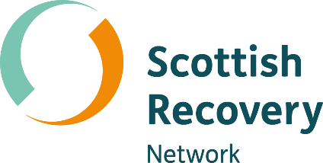
What is peer support?

Peer2Peer: module one, session two Participant workbook



Module one: Introducing peer support
[Grab your reader’s attention with a great quote from the document or use this space to emphasize a key point. To place this text box anywhere on the page, just drag it.]
Welcome to module one of the Peer2Peer group course!
This first module sets the scene, giving space to explore recovery and peer support together at an introductory level. The module will look at how we create an empowering and safe learning environment, as well as introduce peer support, the recovery approach and peer values.

Purpose of the participant workbook
The workbook is designed to support your learning journey. It gives you space to prepare for each session, reflect on your experiences, and capture your own thoughts. There are no right or wrong answers and facilitators won’t be reading what you write.
Peer2Peer is a learning experience where you will be encouraged to draw on your lived experience to facilitate learning and skills development. It’s important you only share what you are comfortable with and that we recommend making time for self-care after the sessions.

Taking a bit of time to prepare before each session can help you arrive feeling clear and ready to take part in the conversations. It’s also a useful habit to build as you develop in your peer role, and beyond.

Session two: What is peer support?
Learning intentions
- Explore the history of peer support
- Understand what peer support is and how it is unique from other types of support
- Discover the many ways peer support can look in practice
Checking in question
- What is different about peer support from other kinds of support?
The history of peer support
Peer support is a practice embedded in mutual relationships where people with shared lived experiences support each to move through challenging times.
Peer support has always existed, as people have always supported one another through shared experiences.
Researchers have tracked the beginnings of formal peer support to a psychiatric hospital in late 18th century France. In Bicêtre Hospital, Paris, Governor Jean‑Baptiste Pussin began employing former patients as staff. The chief physician at the hospital, Philippe Pinel, praised these peer staff for their kindness and humanity, which was a stark contrast to the cruelty of that era. As asylums became more coercive, people with lived experience began forming mutual aid groups and ex patient collectives.
Rights-based and social-justice movements such as the civil rights movement, disability rights movements, the gay rights movement, the women’s movement and indigenous movements all have a rich history. They inspired people with lived experience to organise politically. There was also a lot of intersectional solidarity with groups working together who had shared aims and values. There were two parts to the radical liberation movements of the 1970s - activism and mutual aid. It was the mutual aid arm that grew into what we now call peer support.
Peer support grew out of the consumer/survivor/ex-patient movement and Mad movements and was about a need for more humane ways of supporting people. People wanted to create networks of self-help and community support outside of the mental health system. Groups such as the ‘Alleged Lunatics’ Friend Society’ and ‘Lunacy Law Reform Association’ were concerned with finding ways of being heard in order to stop the inhumane practices they had been subjected to. These groups began from 1970 (the first one in Oregon, USA) and grew out of grassroots liberation movements, which was quite different to the institution-based peer support that Jean-Baptiste Pussin offered.
The recovery movement reframed mental health around hope, empowerment, and self‑defined goals. The initial recovery model was more connected to the social justice and activism space in the 1970s as an alternative to the chronic illness model.
Peer support roles began becoming formalised and appearing in mental health services and communities. Out of a necessity to access funding in the 1980s, many grassroots communities started to take funding from the system. Prior to this, peer supporters had predominantly been voluntary, often surviving on a disability benefit. There was now access to salaries, pensions and entitlements. People who had been institutionalised and told they were so ill that they would never recover, were now in employment and often consequently having a better quality of life. But this also changed the way peer support was delivered, assessed and evaluated - through a system lens rather than a relational lens.
- To learn more about peer support in Scotland, read Insight Report 1 by Scottish Recovery Network.

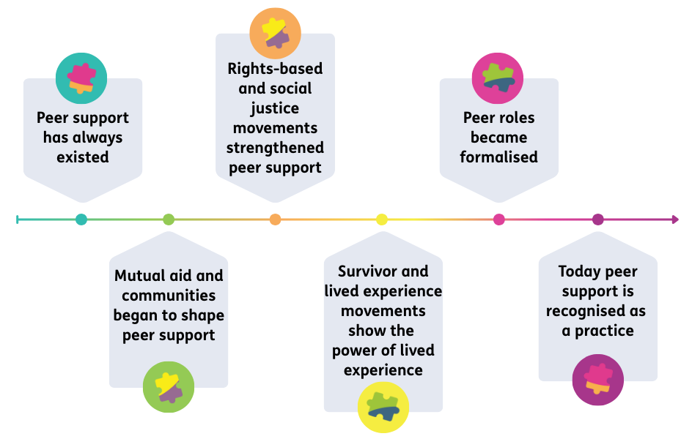

Activity one: Supportive experiences
Individual reflection
When have you felt supported by someone in your life?

What made it feel supportive?

Group discussion
- Did anything surprise you from information on the history of peer support?
- How is peer support different from other kinds of support (like professional help or advice from family)?
Activity two: The components of peer support
In groups, for each of the core components of peer support below, discuss:
- Why does this part of peer support matter?
- Why might this approach be transformational?
Shared lived experiences build trust, empathy and understanding, focusing on the person and their life experiences, not just diagnosis.
Mutual relationships are built on equality; people walk alongside rather than trying to fix one another, valuing lives experience and bringing learning and insight to those involved.
Supportive relationships are rooted in hope. Peers show that recovery is possible and are evidence that things can get better.
Intentional space means peer support isn’t just about telling your story; it’s creating a collaborative space where peers use their experiences purposefully to support others to find their own recovery path.

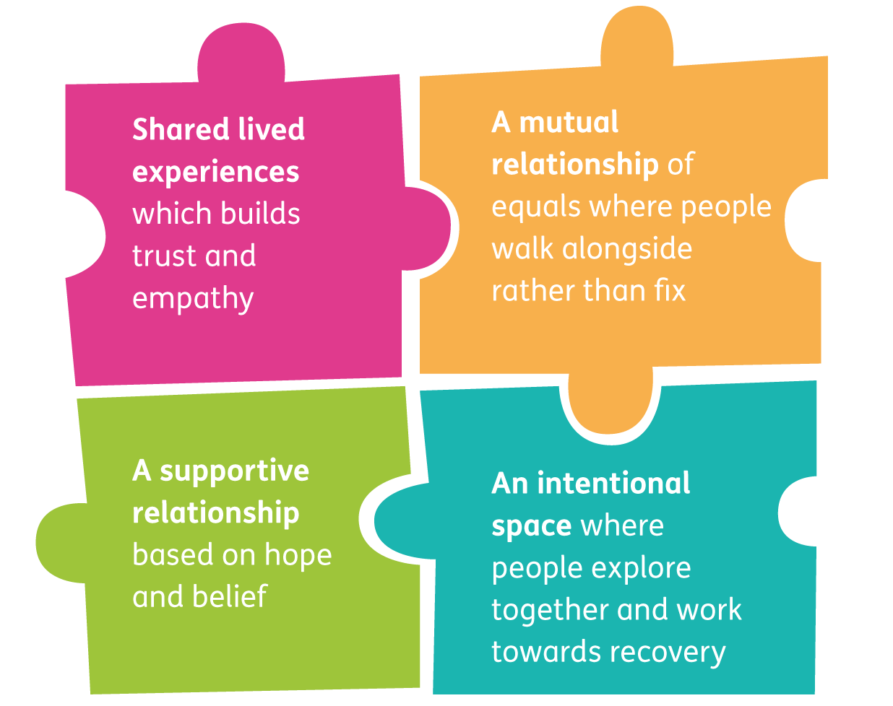
Peer support roles
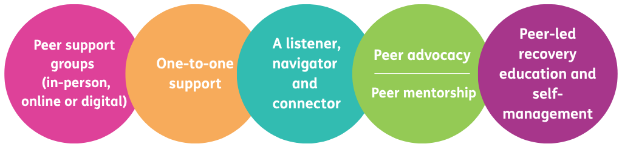
Formalised mental health peer support can look like:
Peer support can be delivered in many different ways, but all are firmly rooted in hope, shared experiences, mutuality and supportive, intentional relationships.
What are you interested in exploring for your own role in peer support?

Closing reflection: What’s one thing you are taking away from today’s session?

Resource list
Films
- What makes peer support unique? – Scottish Recovery Network
- Hollie: what peer support means to me – Scottish Recovery Network
- Scott: attending peer support groups – Scottish Recovery Network
- Peer support helped me both personally and professionally – Scottish Recovery Network
- Helen's Story: Being a Peer Support Worker – Scottish Recovery Network
- Take a dog walk with Toby and Ebby as they talk peer support – Scottish Recovery Network
- Ron Coleman- Scottish Activist - The Privilege of Being in Service – Intentional Peer Support
- Judi Chamberlin: Her Life, Our Movement – Recovery and Hope
- Shery Mead at the Experts by Experience Conference in Scotland – Intentional Peer Support
- Celia Brown - activist and movement leader – Intentional Peer Support
- Presenting the consumer/survivor/ex-patient movement - The G. Raymond Chang School of Continuing Education at Toronto Metropolitan University
Further quotes and reading
- Peer Support in Scotland – Scottish Recovery Network
- Peer Support 101 – Lisa Archibald for Mad in Ireland
- A history of peer support – Love and respect, community for recovery and wellness
- The roots of peer support – Understanding Voices
- The consumer/survivor movement – Mary O’Hagan for Peer Zone
- The Big Scottish Peer Support Survey – Scottish Recovery Network
- Oor Mad History – Caps Advocacy
- Peer2Peer Manual – Session four, pages 51 - 61; Peer2Peer project partners: Scottish Recovery Network (Scotland), Fundación INTRAS (Spain), EASP (Spain), Martín Tellez (Spain). Pro mente Oberöstereich (Austria). LRPSM (Romania).

