

Creating Hope with Peer Support
A resource to help you build the confidence and skills of those offering peer support to people affected by suicide
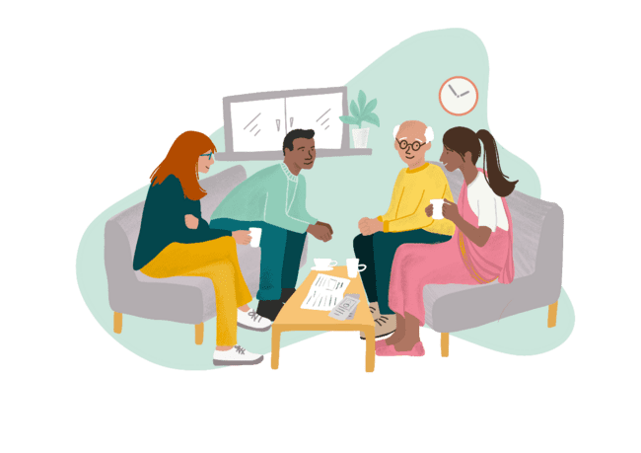


Welcome to Creating Hope with Peer Support
Peer support has a significant role to play in suicide prevention. We know that there are risk factors that can heighten a person’s risk of suicide, such as social isolation, mental and physical health conditions, gender, difficult life events, and experiencing stigma and discrimination as part of a marginalised group. A peer support approach can be a way for people to connect with others with similar experiences. Providing a place where people can share, feel listened to, and explore what could help them find hope. This connection leads to finding a way forward even when people are facing particularly dark times and finding life challenging.
Delivered by Scottish Recovery Network and supported by Scottish Government and COSLA, this project is part of the Creating Hope Together Suicide Prevention Strategy and Action Plan. We are working alongside other organisations to develop the approaches needed to ensure that everyone affected by suicide is able to access high quality, compassionate, appropriate and timely support which promotes wellbeing and recovery (Outcome 3 of Creating Hope Together).
Time, Space, Compassion is the approach developed by Scotland’s national suicide prevention programme. This approach resonates well with the foundations of peer support. It recognises the importance of providing people with time and space in a compassionate way to reduce the number of deaths by suicide. Throughout this guide you will notice that this is referenced within the activities.

Huge thanks to
This resource builds on the knowledge and understanding of the people, groups, organisations and services across Scotland delivering peer support for people affected by suicide. By co-producing this resource, we can ensure that it is based on what is working and what is needed for peer supporters to feel confident in building relationships and supporting people affected by suicide.
A special thank you to all of the peer supporters, groups and services who helped us develop this resource.

The Anchor | Mindspace
Andy’s Man Club | Neil’s Hugs Foundation
Bipolar Edinburgh | Penumbra
Discovery College (Centred) | Sam’s Café (SAMH)
Dundee Volunteer and Voluntary Action | Self–harm Network Scotland
Kick Mental Health | Stepping Stones
Living Warriors Project | The Neuk
Men Matter Scotland | Women’s Wellbeing Club

Contents
Welcome to Creating Hope with Peer Support 2
Huge thanks to 3
How to use this resource 5
Learning outcomes 6
We want to hear from you! 7
What is the Creating Hope with Peer Support Pathway? 8
Developing your peer approach 9
Connect 10
Explore 26
Hope 39
Support 53
Creating Hope with Peer Support Workshop – Half Day Example 65
Creating Hope with Peer Support Workshop – Full Day Example 67
Sharing learning 71

How to use this resource
The Creating Hope with Peer Support resource is adaptable and flexible. We invite you to use it in a way that works for you and the learning needs of your group, organisation or service. Other factors that will influence your workshop planning will include the group you are facilitating, the nature of the organisation, and what areas you feel are particularly strong already and those you would like to explore in more depth.
The learning activities are designed to start discussion, develop and share ideas and experiences, build confidence, and re-enforce existing knowledge. Some things to keep in mind:
- You can use as many activities as feels right.
- Timings can be adjusted depending on the discussions that happen and the number of people attending.
- An icebreaker or check in activity is a great way to start your session and a wellbeing check at the end can help close the session.

Each stage of the Peer Support Pathway can be treated as a single workshop or there are examples of workshop plans that have been used by facilitators at the end of the resource. You can reach out to the Scottish Recovery Network team if you feel it would be helpful to have an external facilitator come to support the delivery of your session.

Discussion prompts and facilitator notes
Some of the activities have additional information to equip you, the Facilitator, with detail to help support discussion should you need it. This information is in the form of discussion prompts and facilitator notes. Both come from examples of peer support from the organisations involved in developing this resource.

Learning outcomes
This resource has been developed to enable you and your fellow Peer Supporters to:
- Explore how peer support can be meaningful and effective in suicide prevention
- Understand the Creating Hope with Peer Support Pathway
- Understand and experience how others are using peer support as an approach
- Understand the practice of peer support through shared language and intentionally sharing experiences
- Describe how to utilise self-care and support strategies

- Recognise the value in what you are doing as a Peer Supporter
This is a compassionate, gentle approach. It humanises suicide in that it doesn’t feel clinical - Creating Hope with Peer Support participant


We want to hear from you!
We hope that as you facilitate this learning with your group, that participants confidence will increase, and existing knowledge will be recognised and discussed. Please feel free to adapt or create new activities relevant to the peer support approach of your participants.
We would love to see how different groups, organisations and services use this resource. Please connect with us on LinkedIn or Facebook and share what you are doing. At the end of the resource, we have some opportunities for you to share your experiences of delivering Creating Hope with Peer Support and to share any learning. This resource will be updated as we share insights and develop new ideas. If you need this resource in a different format, please let us know.
Get in touch
- 0300 323 9956 | Contact Scotland BSL
- info@scottishrecovery.net | www.scottishrecovery.net
- Find out more about the Creating Hope with Peer Support project at www.PeerRecoveryHub.Net







#CreatingHopeTogether #PeerSupportScot #SuicidePreventionScotland

What is the Creating Hope with Peer Support Pathway?
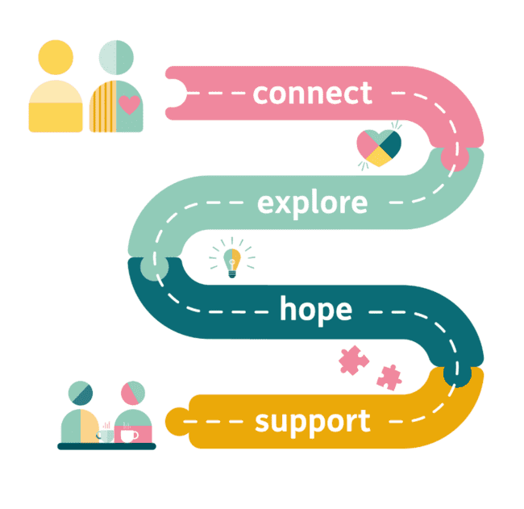
When we first undertook this project we contacted many community-based organisations across Scotland who were supporting people at their most vulnerable using peer support.
We wanted to understand what was working and what they felt was needed to develop confidence and capacity in expanding peer support for people affected by suicide. This extensive piece of work led us to create the Creating Hope with Peer Support Pathway which we will explore throughout this resource. We identified four key stages across peer relationships:

Connect – establishing and developing connections and relationships. Building the trust needed for peer support.
Explore – using curiosity and compassion to enable people to explore their emotions and experiences in a way that makes them feel heard, valued and validated.
Hope – discovering the power of hope and facilitating hopeful conversations.
Support – how peer supporters can look after their own wellbeing.

Developing your peer approach
Each of the four stages of the Creating Hope with Peer Support Pathway is of equal value in developing your peer approach. Giving time to develop each of these stages through practice will improve your confidence as a Peer Supporter. The Pathway represents the journey you will go on as a Peer Supporter, whether that be on a one-to-one basis with someone, or as part of a group. Much of this will already be happening if you are already delivering peer support. This resource will enable you to help yourself and others develop this further.
We will take you through the four stages of the Creating Hope with Peer Support Pathway, enabling you to add to your existing learning along the way. As the Pathway suggests, peer support is not a fixed or linear route, there will be twists and turns. Learning will come from experiencing and adapting, using this resource for yourself, your organisation and the people that you are supporting.
As Peer Supporters we are creating a space to allow us to be curious and enable us to better understand what people are experiencing and how they are affected. This leads us to working together to find a way forward that is focused on the person’s choices, preferences and goals.


Connect
Welcome to the first stage of the Creating Hope with Peer Support Pathway. This stage sets the foundations with an overview of peer support, introduction to the Creating Hope with Peer Support Pathway and exploring the theme of Connect: establishing and developing connections and relationships. Building the trust needed for peer support.
Time | Activity | Page
25 mins | What is peer support? | 11
15 mins | Introduce the Creating Hope with Peer Support Pathway | 15
25 mins | Connect: Time, Space, Compassion | 16
25 mins | Connection & language | 19
25 mins | Boundaries in the peer relationship | 22
5 mins | Summary and reflection | 25

What is Peer Support?
Peer support is a strengths-based approach to supporting someone. The basis of peer support comes from individuals using their lived experience in an intentional way to support the wellbeing of others. Peer support has four key elements that together, make it different to other forms of support.
Activity: Discuss and reiterate the power of peer support.
Purpose: Explore understanding of the key elements in peer support relationships.
Time: 25 minutes.
As a group watch the What makes peer support unique? animation (next page). Using this and the four key elements from the jigsaw diagram (page 13) discuss:
- What is peer support?
- Why is peer support needed?
- How is peer support different to other traditional or clinical support?
- How can it work alongside other support?
- What is your experience of peer support and how has it worked?
- What do the key ingredients look like in practice?

What makes peer support unique?


You can watch the What makes peer support unique? animation by clicking the play icon above or on the Peer Recovery Hub https://scottishrecovery.net/peer-support/what-is-peer-support/

Peer support jigsaw
- A supportive relationship - based on hope and belief
- An intentional space where people explore together with a focus on recovery
- An equal relationship where Peer Supporters ‘walk alongside’ rather than ‘fix’
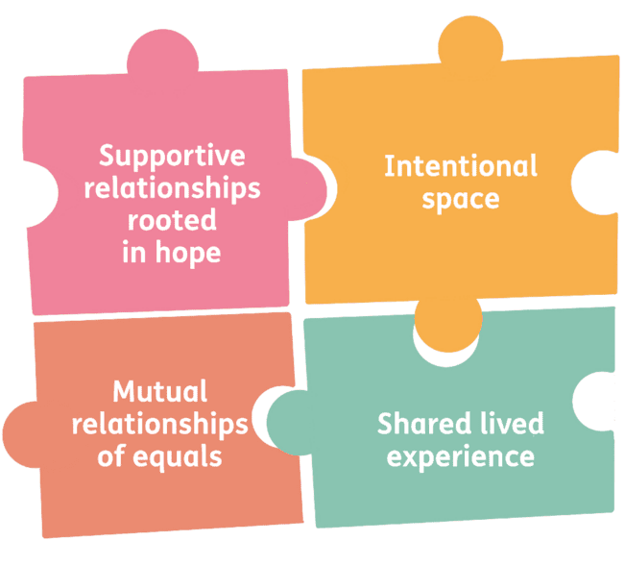
- Shared lived experience builds trust, connection and empathy

Discussion prompts
When discussing peer support look for the following themes:
- The mutual nature of the peer relationship – using your own lived experience to support others to find their own path or journey. Non-hierarchical and learning from each other.
- What peer support means in practice - it’s about being with and alongside people on their journey not ‘fixing,’ listening rather than problem solving and validating experiences and feelings.
- How we use empathy and compassion – be with people and give space to share and explore difficult feelings, empowering support that helps people feel they can find their own way through.

- How peer support can support people – sharing experiences brings hope, you can share resources and tools, provide help accessing other supports.

Introduce the Creating Hope with Peer Support Pathway
This resource will take you through the four key stages of the Creating Hope with Peer Support Pathway which focuses on how you further develop your peer approach. Starting with Connect and how you develop those relationships through to Support, and how you as a Peer Supporter, maintain your own wellbeing.
Activity: Facilitate a discussion on how the Pathway resonates with participants’ experiences.
Purpose: Introduce the Creating Hope with Peer Support Pathway (refer back to page 8 where needed).
Time: 15 minutes.

Connect: Time, Space, Compassion
Connection is an ongoing process that will deepen and need working on throughout the peer relationship to build trust, promote safety and encourage communication.
Activity: Time, Space, Compassion
Purpose: Appreciate the value of connection as part of peer support approach. Explore the impact of how Time, Space, Compassion are key to establishing a strong connection and building a peer relationship.
Time: 25 minutes.
Time, Space, Compassion are important in building and developing a peer relationship. We will also look at the importance of language in building and maintaining the peer support relationship, particularly in reference to suicide.
On three sheets of flipchart paper write Time on one, Space on another and Compassion on the third. Split into three groups to explore the following scenario in relation to each approach. Each group should spend 5 minutes at each flipchart, add to it and then move to the next.
Scenario: A new person has just joined your peer support group or has come along for one-to-one peer support. Using your own experience and sharing ideas, discuss the following:
- What role does Time / Space / Compassion play in building a relationship with this person and why is it important?
- What does this look like in practice?
- How do you know this approach is working?
Make sure to include time to introduce the exercise and for feedback and discussion from the group.

Discussion prompts
Time  Think about whose time it is – the time belongs to the person seeking help. Value time for listening as well as speaking.  How can we be flexible around the length of time for support?  People should feel able to speak if they want but there should be no pressure to speak. | Space  How can you make the space welcoming and comfortable?  How can you make people feel that the space is theirs?  Do you have a quiet space for people if they need a break from a wider group?  How can tea / coffee help build relationships? | Compassion  What can you do to welcome new people and make it non-intimidating?  How can you create a space where everyone feels able to have a voice?  What sort of language (spoken and body) can you use to convey compassion?
Facilitator notes
There are practical and emotional elements to building a peer connection, and utilising the Time, Space, Compassion framework is useful for:
- Creating and ensuring we have protected time
- Ensuring the space is both physically and emotionally safe
- Bringing a compassionate approach

This is especially important when people are experiencing emotional distress, in crisis and/or suicidal. People have shared how important it is to feel safe, supported, valued and validated.
We suggest that new members settle into the space first, observe what's going on, and open up when they're ready. A lot of the time people don’t know what they're coming into. They can feel anxious the first time and by listening to others sharing and talking gives them the courage to do so too. Talking and really being heard saves lives. Andy’s Man Club

Connection and language
We know that language and how we use it is important in peer support. When exploring with Peer Supporters the language of distress and suicide, how we communicate is key.
Activity: Read together Living Warriors Project’s Peer Support in Action example and discuss (next page).
Purpose: Explore the importance of language and communication in peer support.
Time: 25 minutes.
Ask participants to read the example of Peer Support in Action or ask for a volunteer to read aloud for the group. In small groups participants should discuss and take notes on how the Living Warriors Project:

- Helps to develop connection in their group description
- Uses language intentionally and what this communicates
- Is a strengths-based approach and how this is demonstrated? Strengths-based meaning there is a focus on what can be done.
- How is this approach similar / different to your experience / group / organisation?

Bring the group back together to share feedback. Reminder that peer support examples are included not as the ‘correct way’ of doing things but to serve as an example and opportunity to learn from, identifying different features and discussion points.


Peer Support in Action: Living Warriors Project
Living Warriors Project is a peer-support group based in Edinburgh for survivors of attempted suicide. As survivors, we have the unique perspective of what it is like before, during and after a suicide attempt. This allows for an unspoken understanding within the space, taking the pressure off any anxiety or fear about sharing suicidal experiences.
We understand that it can be daunting to talk about suicide when feeling suicidal. The risk of unhelpful reactions from others that could prevent seeking further support or create a traumatic event. It can be difficult to know which spaces are safe to talk about a suicide attempt without fear, judgement or shame. We try to minimize those feelings by giving people explicit permission to talk about it if they wish to do so.
At the beginning of each session, we lay out our group agreements, explaining why they are there and what they mean. The agreements are ongoing, evolving and created by all who attend the group.
What is particularly unique about us being a grassroots community group is that we can create the group how we want. We have a session plan that may involve a themed discussion, discussion topics to randomly select from a jar, and a creative activity using thematic prompts integrated into the second half of the session, to ground and settle the space after sharing. This encourages hope and self-reflection, allowing participants to engage in creative expression of their experiences of suicide and ongoing recovery in whatever way feels right for them. We are always open to ideas and suggestions from group members and will endeavour to integrate these into sessions within the boundaries of our group agreements and project values.

Discussions prompts
- How can we share our lived experience in a way that builds trust but keeps the focus on the other person being supported?
- How can we use language to create connection? What type of language do we feel works best? What should we avoid?
- How can we reinforce language that helps us build strengths-based peer relationships? Are members of the peer group or person being supported leading the choice of language being used?
- Do we make sure that language choice can be flexible and evolve?

Facilitator notes
Language and how we use it is important as it provides signals to others. In a peer space we use non-clinical language to emphasise the human connection and the equality of a mutual relationship, for example avoiding acronyms and jargon. In the discussion the group may want to explore the type of language they use and how they can inform others in the use of language. For example, using died by suicide or ended their own life rather than commits or committed suicide. There is more information available on current terms and ways of talking about suicide provided by Samaritans and other suicide prevention organisations.

Boundaries in the peer relationship
The peer relationship, whether in a group or one-to-one is a mutual one based on shared lived experiences. This can help create safe and empowering spaces but the mutuality in the space also needs to be managed. How we navigate the balance between being friendly without being friends, being clear on what our role is and isn’t, especially in situations where people are distressed or in crisis, can be a challenge.
We know from people and organisations we have spoken to that having clear boundaries from the outset protects everyone involved in the peer approach.

Activity: What are boundaries and why are they important?
Purpose: To explore why we need boundaries in the peer relationship and the types of boundaries that may be considered.
Time: 25 minutes.
Split group into small groups of two or three for five minutes. Ask the small groups to discuss the following question and come up with three things to share with the wider group.
Question: What sort of things make peer support (group or one-to-one) feel safe and empowering for you and other people? Then ask each group to share their three key things.
Next, move on to facilitate a whole group discussion based on the points shared and using the following questions:
- What do we notice about what makes peer support safe and empowering?
- How do we/you make this happen in your group or organisation?
- What do you feel works well?
- What are the challenges you face in setting boundaries to ensure the peer space is safe and empowering?

Activity: Exploring boundaries in practice.
Purpose: Applying knowledge to real life scenarios to explore what boundaries look and feel like in practice.
Time: 25 minutes.
Ask participants for anonymised real-life scenarios (being mindful of confidentiality) or use the example scenarios below.
Example 1: A person is expressing anger and using a lot of swear words.
Example 2: A person is talking about how suicidal they feel and that they feel like they have no-one. They want to talk with you and ask for your phone number and if they can ‘WhatsApp’ you.
Example 3: A person shares that they are feeling so awful and don’t see the point of living anymore. They ask the Peer Supporter if they have attempted suicide and are pushing to find out details.
Split into small groups and discuss a couple of the example scenarios for about ten minutes. Ask the small groups to focus on how Peer Supporters could approach each scenario and what they could do to support the person whilst maintaining a safe and empowering peer space.
Then bring people back together as a whole group to share feedback and reflections.

Discussion prompts
- What feels most challenging?
- What sort of boundaries or guidelines would help you as a peer supporter?
- How can we embed Time, Space, Compassion into our approach and boundary setting?

Summary and reflection
Activity: Summarise to the whole group the key points of learning and allow space for other suggestions from the group to be added.
Purpose: Pulling together and summarising the key points of learning.
Time: 5 minutes.
Examples:
- Building a strong connection starts from the moment of contact
- Think about how Time, Space, Compassion supports the initial and ongoing connection
- Be comfortable with what lived experience you are sharing as a Peer Supporter

- If you are struggling to build a connection, explore different options such as changing the environment, engaging in a group setting, one-to-one conversation or allowing another Peer Supporter to try
- Boundaries are there for you and the peer to stay safe

Explore
Welcome to stage two of the Creating Hope with Peer Support Pathway, Explore: using curiosity and compassion to enable people to explore their emotions and experiences in a way that makes them feel heard, valued and validated.
  Time | Activity | Page
5 mins | Introducing Explore | 27
30 mins | Iceberg analogy | 28
20 mins | Being curious | 31
40 mins | Curious conversations in practice | 33
20 mins | Peer Support in Action: Andy’s Man Club | 36
5 mins | Summary & reflection | 38

Introducing Explore
Activity: Briefly introduce the theme of Explore to the group.
Purpose: Prepare the group for the next theme.
Time: 5 minutes.
Having started to build a connection and establish trust, Peer Supporters can begin to explore with the individual what they are experiencing emotionally. There are likely to be a number of things happening in their lives that are having an impact on them.
In the role of Peer Supporter being curious and exploring with compassion helps the person you are supporting find their voice and discuss what they are feeling. The process cannot be rushed and will be guided by the individual. It is important that they feel in control of what is said and when. This also enables the person to feel heard, believed, valued and validated.
Peer support is different to other support because it is based around people’s shared/similar experiences. When someone hasn’t discussed their feelings in this way before it can help if the Peer Supporter shares something around their own lived experience. Understanding what you are comfortable sharing as a Peer Supporter is useful to know at this point.
Your story isn’t your weakness, it’s your power
Women’s Wellbeing Club

Iceberg analogy
Activity: Iceberg analogy
Purpose: To move conversations from ‘what is wrong with you’ to ‘what has happened to you.’
Time: 30 minutes.
Use the iceberg analogy to encourage exploring in more depth what is going on for the person you are supporting, how they are feeling and the factors that are contributing to them feeling that way.
On a flipchart draw the Iceberg image (see next page) and add the text from the image. Explain to the group that:
- The iceberg above the water is how someone is presenting themselves e.g., their behaviour, how and what they’re communicating, their appearance etc.
- The iceberg below the water is what they are experiencing/feeling
- The sea around them are the factors in their lives that are affecting them
With the group, facilitate a discussion around how someone is acting and presenting themselves, what are the feelings and emotions that could lead them to behave this way? Explore what the contributing factors could be.
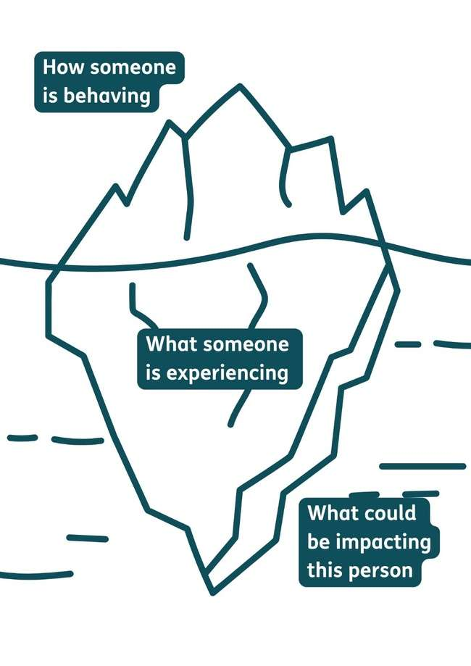
Discussion prompts
- Think about the different ways people present in crisis or challenging times. How does it vary? What assumptions should we avoid making?
- What do we need to be thinking about when someone is e.g., presenting as angry?
- How can we get behind someone’s anger or withdrawal to help them share their feelings?
- What sort of things can result in someone feeling overwhelmed or in crisis?

Facilitator notes
People in crisis or in challenging times will present in many different ways. They may be quiet, withdrawn, angry or distressed. While there may be something that has happened to bring them to crisis there are often many challenging factors in their lives. These can be practical (e.g., money, housing, employment) or emotional (e.g., loss of relationships, bereavement, family breakdown, health, trauma, bullying). Having and showing an appreciation of the experiences and factors that are shaping a person’s feelings allows us to shape the conversation from ‘what’s wrong with you’ to ‘what’s happened to you?’
At this stage of discussion try not to jump into how we can help the person identify what has helped before or what would help without ‘fixing.’

Being curious
Being curious provides opportunities for Peer Supporters to explore with people what they are experiencing and help make sense of overwhelming thoughts and feelings. It allows us to discuss what else is happening in their life that makes them feel this way.
Activity: The value in being curious.
Purpose: Explore the role of curiosity in the peer relationship.
Time: 20 minutes.
With the whole group facilitate a discussion on the key elements of bringing curiosity to the conversations you will have in a peer relationship. The questions below are a great way to get people thinking about bringing their curiosity.
- How do we learn about what the person is experiencing?
- What’s involved in a curious conversation?
- What do we need to be mindful of?
- What are your own experiences of having a curious conversation?
- In what ways are Time, Space, Compassion important?
- What can close people down?
Facilitator notes
You will be looking for participants to talk about the importance of active listening. This includes using open questions that open up space for the person to share their thoughts and feelings. Examples can include:
- What would you say works for you at the moment?
- What else has worked for you at different times?
- What is important for you to think about to keep yourself going through difficult times?
- Reflecting back and rewording what you’ve heard to confirm you’ve understood them clearly.
Active listening is also about showing empathy and compassion. We can do this by responding in a way that focuses on sharing our understanding of what the person is saying and validating their experiences and feelings. It can be difficult for people to open up so sharing relatable experiences can provide a trusted space. Also sharing relatable experiences that focus on moving through crisis and challenge can bring hope and open up the conversation more.

Curious conversations
Exploring with people who are experiencing distress or significant challenges can be a sensitive process. Peer support does this with empathy and compassion and by using our lived experiences to support others to explore theirs. It is important that we share what has worked with each other.
Activity: How we make our conversations curious.
Purpose: Explore different approaches and methods used to encourage others to talk.
Time: 40 minutes.
Ask the group to split into pairs. In their pairs ask each person to share a time when they were able to use curiosity to encourage another person to talk. After each person has shared with the other, ask them to take five minutes to identify the different approaches and methods used. Then bring the whole group back together and ask each pair to share one approach or method. Examples from participants can be from their experience as Peer Supporters or from their life.
Discussion prompts
- Think of the types of questions you would ask to encourage someone to talk? How would you describe these questions?
- How can sharing your own lived experiences encourage others to talk? What has worked for you?
- How did that conversation feel in your pairs? What did your partner say or do that helped you feel listened to and heard?


A note on sharing experiences more widely
Sometimes people feel like they want to share their experiences more widely. This could be done in many ways, for example through a newspaper piece, a social media post, publication or at a conference or event relevant to their experience. This can often be cathartic and using your experience to provide hope for others can be powerful. It can also create challenges.
Working in collaboration with United to Prevent Suicide and Suicide Prevention Scotland Lived Experience panel we have created two guides to support people:

- Preparing to share your experiences is a guide to support you to share your experiences of mental health and suicide in a safe and supported way.
- Gathering lived experiences is a guide for anyone supporting people to share their experiences of mental health and suicide.

Both guides can be downloaded for free from the Scottish Recovery Network Peer Recovery Hub https://bit.ly/SharingLivedExperience

Activity: Curious conversations in practice.
Purpose: To explore how the identified approaches and methods can be put into practice.
Time: 20 minutes.
Share the scenario below with the group. Ask them to get back into their pairs. One person will take on the role of Andrew and the other his Peer Supporter. Using the approaches and methods explored in activity one as well as the wider experiences of being a Peer Supporter, ask each pair to have a conversation that establishes how Andrew is feeling and what has been going on to make him feel this way.
Scenario: Andrew has been attending your peer support group for eight weeks. He has previously spoken about how he tried to end his life when his relationship broke down and was forced to move out of the family home. Recently he has opened up in the group and seemed more positive. He has even mentioned the possibility of a reconciliation with his ex-wife. Both today and last week he seemed really down and has not been speaking to anyone or chatting in the group. You ask him if he wants to meet one-to-one after the group meeting. Bring the group back together to share feedback.
Discussion prompts
- Did you establish what was going on for Andrew?
- What approaches and methods did you use and how did they work?
- Did you use any of your lived experiences? How did that work?

Peer Support in Action: Andy’s Man Club
We have been talking about the approaches and methods we use to encourage people to talk about their feelings. This activity is an opportunity to hear about how one organisation structures their group meetings to provide a space where people are encouraged to talk. This is not us saying it is the ‘right way’ but sharing one approach to open up discussion on how we can do this in different ways.
Activity: How Andy’s Man Club structure their meetings to encourage talking.
Purpose: To learn about different approaches and methods of encouraging people to open up.
Time: 20 minutes.

Share the Andy’s Man Club example with the group (next page). As a group discuss the benefits of this approach and some of the potential challenges.

Andy’s Man Club
Andy’s Man Club is a suicide prevention peer support charity. The peer support groups offer the opportunity for people to come together and talk about how they are feeling, without fear or stigma. When the groups come together a football is passed among the group giving those who have it the opportunity to talk or not.
“The football is a focal point which allows the room to know who is talking and it also gives the lad with the ball something to focus on rather than those in the room and he can speak to the ball which is sometimes easier. The main facilitator asks and answers the questions first then passes the ball to the next lad who then answers. There is never any pressure and if you don’t want to answer the question you pass the ball on.”
Alex McClintock, Senior Project Development Champion (Scotland), Andy’s Man Club
Discussion prompts
- What do think are the benefits of this approach? How would this approach work in your group?
- What could be the challenges with this type of approach? Are there groups where this wouldn’t work? Why?
- What approach do you use in your group or one-to-one peer support?
- How can you learn from others?

Summary and reflection
Activity: Summarise to the whole group the key points of learning, allowing space for other suggestions from the group to be added.
Purpose: Pulling together and summarising the key points of learning.
Time: 5 minutes.
Examples:
- Give time and space to explore what someone is feeling and what factors are contributing to this
- Being curious will likely mean sharing some of your own lived experience
- Let the person you are supporting feel in control of what they say and give them time
- As circumstances and feelings change the need to explore will be ongoing


Hope
The third stage of the Creating Hope with Peer Support Pathway is Hope. Participants will be introduced to the power of hope, how to develop hopeful relationships and facilitate hopeful conversations.

Time | Activity | Page
10 mins | Introducing Hope | 40
20 mins | Exploring hope at different times | 42
35 mins | Peer Support in Action: Neil’s Hugs Foundation | 44
30 mins | Hopeful conversations | 47
20 mins | Facilitating hopeful conversations | 49
5 mins | Summary & reflection | 52

Introducing Hope
When facing extremely challenging times and emotions, the idea of hope and change can be difficult to consider but Peer Supporters can help share how it is possible. Having a clearer sense of what is going on for the individual and how it is impacting them, gives us the opportunity to explore ways in which hope is possible and can be developed. Hope will come from different areas and could focus on meaningful actions, recognising support opportunities or identifying people to connect with.
Activity: Hope in peer support conversations.
Purpose: Understanding the methods for and impacts of developing hope within the peer relationship.
Time: 10 minutes.
Split participants into small groups. Ask them to draw from their experiences as a Peer Supporter and discuss times when they developed conversations about hope in a peer relationship.
Discussion prompts
- In what ways can you introduce hope into a peer support conversation?
- Is hope the right word to use? What do people prefer? Welcome alternatives!
- What stage of the relationship was hope discussed?
- How can you turn conversations about hope into actions and follow up on them?

Facilitator notes
Hope will not necessarily come straight away and can be met with strong resistance or even anger. Focusing on building connection and exploring how the individual is feeling provides the basis for hope in conversations.
For hope to be sustained it needs to be based around actions and ownership. Hope usually starts with small steps and can be informed by thinking about what hope has looked like for the person before. Like any aspect of the Creating Hope with Peer Support Pathway there will be bumps along the road but having a toolbox of support that brings comfort and an ability to deal with what you are going through will help the person’s journey, making those bumps in the road more manageable.
Hope is not a passive feeling – it is active and leads us to action. We do this together, spending the time to help the person identify what they would find useful, where they can find it and who can help. At the heart of our discussion is providing hope and doing so in a caring and compassionate way.
A Peer Worker is a tangible, living, walking, breathing symbol of hope simply because of the words Lived Experience.
- Helen, Peer Support Worker, NHS Borders

Exploring hope at different times
Activity: What gives you hope?
Purpose: Exploring with the group what has given them hope at different points in their lives will give them a better understanding of the value and power of hope.
Time: 20 minutes.
Ask participants to take five minutes to themselves to write down examples of what has given them hope, comfort or support at different times in their lives or at particularly challenging times. In doing this they will be drawing on their own lived experiences. Feel free to give timescales or periods in their lives e.g., 5, 10, and 20 years ago or as a child, a teenager, or an adult.

Then ask participants to share the examples if they are happy to do so.
Facilitate a discussion using the prompts on the next page.

Discussion prompts
- What do we notice about the things that have given us hope, comfort or support? Look for similarities, and variety.
- Can the things that give us hope change over time? Why do we think this is?
- How did we find the things that give us hope? Did we know but needed help to uncover these things or did it happen by accident?
- How do you feel knowing that you have a toolbox that contains things that give you hope, comfort and support.

Facilitator notes
There are a variety of different things that give different people comfort and these can and will change over time. Challenging times may need a different type of support to give hope. What gives us hope normally needs to be found or discovered but occasionally can happen by accident.

Peer Support in Action: Neil’s Hugs Foundation
Peer support is an environment that enables people to share their lived experience and emotions with others who have faced similar challenges. The opportunity to do this in a safe space with no hierarchy or judgement does, in itself, give hope to those sharing. When hearing other people’s experiences there can be a realisation that you are not alone and what you are feeling is not wrong.
Activity: Neil’s Hugs Foundation and the value of sharing experiences.
Purpose: Explore the value of sharing experiences and how this gives encouragement and hope.
Time: 35 minutes.
Share the information about Neil’s Hugs Foundation (next page) with the group.
Split into small groups of 2 or 3 for about ten minutes. Ask them to consider this example and discuss how Neil’s Hugs Foundation develops hope and how those attending the group and the Peer Supporters benefit from this.
Bring the whole group back together and get feedback from each small groups. Discuss the role of sharing experiences in developing hope.


Neil’s Hugs Foundation
Neil’s Hugs Foundation is a charity that was set up by Donna Paterson-Harvie after her son, Neil, felt so overwhelmed with life that he took the option to complete suicide in 2011. The charity’s aim is to support people who are affected by either the attempted or completed suicide of someone close to their heart.
“I think in peer support, if someone walks into the room, they meet me, and I lost my only child in 2011. But I am still surviving and living. It gives you hope – if that person is still here then I can get through this. I always sat in the bereaved family rooms because that’s my people and I needed to be with them as much as they needed me to be there. Albeit I was facilitating, I was still benefitting from being in that room. We’re all survivors, that’s how life made us. We’ll always try to swim if we fall in water. But there comes a time when you need to stop surviving and find life. When someone walks into a peer support group and says I feel really bad, but this is how I feel, you can sit there and say I get that. It’s okay to feel that and those thoughts.”

- Donna Paterson - Harvie (Founder), Neil’s Hugs Foundation

Discussion prompts
- How do we use our lived experience to encourage hope in others? Share examples and approaches.
- How do we know what we are comfortable sharing and can maintain boundaries established?
- How can we ensure that all lived experience is equally valued in our conversations?

Facilitator notes
Sharing lived experience will encourage openness and credibility to your role as a Peer Supporter. However, Peer Supporters should think through and discuss what they feel they are comfortable sharing and how they can best use their lived experience to help others. The sharing of experiences needs to be done in a way that supports the other person and helps them in their journey.
Peer support is a mutual relationship. This means that we can all learn from each other, including how we can find hope. Indeed, supporting others can provide hope and a sense of purpose.

Hopeful conversations
As Peer Supporters we can use the power of hopeful conversations to encourage people to discuss their feelings and explore things that give them hope, comfort or support. Being with someone, listening to how they feel can open possibilities to identify hope and support.
Activity: Hopeful conversations in practice.
Purpose: Practice a peer approach to having a hopeful conversation.
Time: 30 minutes.
Share the scenario that outline’s David’s experience within a men’s peer support group. In pairs each take a role – one as David and one as the Peer Supporter. The Peer Supporter will have a conversation with David exploring what is happening in his life and how it is affecting him. To find out what has changed, explore what could provide hope and work out actions or plan together how David could move forward.
Allow enough time (10 to 15 minutes) so that the pairs can change roles and have the opportunity to experience different perspectives.
Scenario: David regularly attends a men’s peer support group as he struggles with his mental health and gets anxious around meeting new people. This was triggered by the passing of his brother who took his own life two years previously. Prior to that he had an active social life and played and coached football. When speaking within the group he was clearly struggling and spoke of the fact that he has built up debt since losing his job and he is finding himself increasingly isolated. He only leaves his flat to join the group and get groceries in. As the peer supporter facilitating this group you decide to speak to him one-to-one over a coffee at the end of the session. This is something that you do with some of the group when they are struggling.
Bring the whole group back together and discuss how the conversations went using the prompts below.

Discussion prompts
- How did those conversations feel?
- What types of hopeful actions were you able to identify in your conversations?
- Were there any elements of the conversation that felt particularly difficult or challenging? If so
- how did you change approach or overcome this?

Facilitator notes
Look for hopeful actions that are about addressing the issues David is facing but also tapping into the things in life he enjoyed previously. Often we focus on dealing with issues or problems, but it is also important to uncover things that brought people pleasure and hope in the past that they could consider reconnecting with. There is an opportunity to use our lived experience to show understanding of how difficult things are but that also hope can start with very small steps.

Facilitating hopeful conversations
As Peer Supporters we not only use our lived experience but develop questions and approaches to support our conversation and practice. It can be helpful to see this as a peer support toolbox that we can choose from, add to, share and develop.
Activity: Building your peer support toolbox.
Purpose: Identify and collate different questions and approaches to use in our peer support conversations and practice.
Time: 20 minutes.
As a whole group ask participants to share a question they use when introducing hope into peer conversations. Note these on a flipchart. Once you have gathered some questions ask participants to think about the different approaches they use, particularly when someone is distressed and finding communicating verbally difficult.

Discussion prompts
- What questions or types of questions have you found work well for you when trying to develop hope in a conversation?
- How would we describe these questions? Open, strengths-based etc.
- If someone is finding it difficult to talk, what other ways can we encourage them to communicate?
- How can we ensure we are prepared to adapt our approach to meet the person where they are?
- Would our approaches change depending on the method of peer support delivery? E.g., group, 1-1 peer support, online etc.

Facilitator notes
Questions that can develop hope tend to be open and strength-based e.g. Have you been in a similar situation previously? Who/what has helped in the past? Who do you find supportive? If it is possible, it can be good to offer to check in or meet again as this can provide some hope for people.
Focusing on positives such as the act of attending a peer support group or reaching out for help can be an indication that the person is seeking hope or change. This isn’t always easy but identifying and actioning even very small things that can bring hope is important.
At the same time, as a Peer Supporter you should use your skills and understanding of the person or group you’re supporting to recognise when this line of conversation is not helpful. There will be times when someone is not ready to consider actions to take and this must be at their pace and decision.
If someone is finding a conversation difficult you can think about asking them to draw or write how they feel. You can use images or something like a mood wheel to help the person indicate how they are feeling. It is always possible to take some of the pressure off by asking about a song or book that really resonates to help the person verbalise their feelings.

Summary and reflection
Activity: Summarise to the whole group the key points of learning allowing space for other suggestions from the group to be added.
Purpose: Pulling together and summarising of key points of learning.
Time: 5 minutes.
Examples:
- Navigating hopeful conversations are where we sensitively move the conversation on from exploring what the person is experiencing to start to focus on what could make a difference, what would help.
- Support can be practical – knowing what other support is in the area and signposting can help reduce the burden a person is feeling, making it easier to deal with other emotions.
- Try being creative – lots of peer support groups feature activities that people can take part in such as sports, crafting, book clubs, gaming. As well as being a distraction from what they are feeling emotionally they can generate an interest as well as hope.
- Hope is very often about taking small steps – it is important to appreciate these small steps and not just wait for bigger change which may take longer.
- Supporting others can provide hope and purpose.

Support

Welcome to the final stage of the Creating Hope with Peer Support Pathway, which will focus on supporting the Peer Supporters. None of this great work is possible if the Peer Supporters do not get the help and guidance they need to support their wellbeing and practice.
Time | Activity | Page
5 mins | Introducing Support | 54
30 mins | Supporting the Peer Supporters | 56
15 mins | Peer Support in Action: The Anchor | 59
30 mins | Support: self, team and organisation | 61
25 mins | Creating a plan | 63
15 mins | Summary & reflection | 64

Introducing Support
In first three stages we focused on the peer relationship. This session looks at the ways Peer Supporters can be supported to look after their own wellbeing.
Activity: Briefly introduce the theme of Support to the group.
Purpose: Start the group on the fourth stage of the pathway.
Time: 5 minutes.
What Peer Supporters do is amazing. The role is incredible but demanding. In addition to all the skills required, Peer Supporters also have their own lived experience, similar to the people and groups being helped to move forward. They need support to ensure that they can give themselves the best possible chance of being able to continue to help others.
Reconsider facilitating a group if at any point your vulnerability is higher than your ability to hold space for others. You need to look after you first.
Heidi, Moray Wellbeing Hub

Time, Space, Compassion

We have spoken about the importance of Time, Space, Compassion throughout this resource. It is as relevant to Peer Supporters and their wellbeing, as it is to the other stages of the Creating Hope with Peer Support Pathway. The process of providing peer support in times of distress is both rewarding and empowering yet can also be emotionally challenging. Peer Supporters need time and space to debrief, discuss their feelings and aid the healing that they may need. Rushing from one group or support meeting to another on a constant basis with a two-minute chat over the kettle is not enough. Peer Supporters also need to show compassion to themselves to ensure that their peer support practice is having a positive impact on them and the people they support. Airplane flight advice is a good metaphor for peer support. It highlights the need to put on your own oxygen mask before helping someone else.
So, what do we need to consider when practicing peer support?

Supporting the Peer Supporters
Activity: This is Me.
Purpose: To develop understanding of supporting yourself and others in the Peer Supporter role.
Time: 30 minutes.
Give each person in the group a This is me handout (next page). Ask each participant to take ten minutes to consider the questions and record their responses alongside the image. Then ask participants to get into pairs and take ten minutes to share what they have written with each other and identify any similarities or differences.
Finally, get the whole group together to share feedback and insights for the remaining ten minutes.
Discussion prompts
- How did this exercise feel?
- Did you learn anything new about you or from other participants?
- Why do you think it is important to do this exercise?
- How could this be helpful to you and your colleagues?


This is me…
- What do I enjoy most about being a peer supporter?
- What can people do to support me?
- What do I find most challenging in my peer role?
- How would someone know if I am struggling?

Facilitator notes
As a Peer Supporter sometimes it can be easy to lose sight of who you are, how you look after yourself and others around you. There will be similarities in some of what you are sharing with others and other areas that are unique to you.
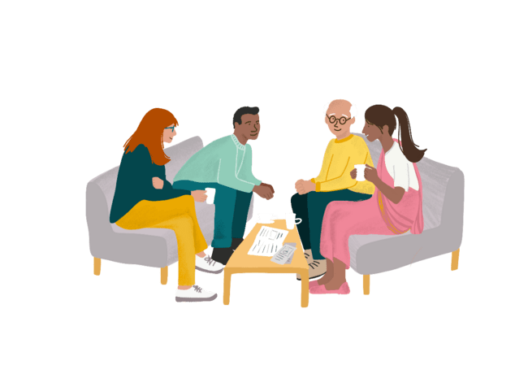
By having a better understanding of yourself you are more likely, and able, to put measures in place to support yourself. These can be simple practical actions and they can develop or change over a period. By having these discussions with fellow Peer Supporters or colleagues we build a better understanding of how we can best support each other. If it helps keep the image and the description that you have just created handy, you could even share with colleagues if you want to. It is a reminder to yourself of building in some of that support for you.

Peer Support in Action: The Anchor
Activity: Peer Support in Action: The Anchor
Purpose: Provides different examples of how a service/organisation can support their Peer Supporters.
Time: 15 minutes.
Share The Anchor example (next page) with the group. Reflect on their approach to supporting peer supporters and identify key themes.

Discussion prompts
- What are the different ways The Anchor provide support to their peer volunteers?
- Do you use a similar approach?
- How does this differ from what you do?
- Is there anything that you could try?

The Anchor
The Anchor is a suicide prevention charity that promotes good mental health and wellbeing through peer support. It has groups and one-to-one peer groups and supports. When asked how they support each other and their volunteers. Gary McGibbons - Wellbeing Worker said:
“We always check in with the two volunteers after facilitating a group. We check to see how they are and whether there were any concerns or worries that they had after the group. We have a culture here where everybody supports each other, and we are encouraged to go and speak to any of our colleagues to talk through anything that we are struggling with.
We also have weekly team meetings where we discuss any issues as a group. We have reflective time once a month whereby we meet with a colleague to discuss the groups or individuals that we have been working with. It is a chance to think, share and bounce off ideas around any of the things we may be finding difficult. It is also a time to look at whether we are taking on too much. It is not a problem to do less. This is unlike the corporate world where I worked before where it was about numbers and meetings like this would be to tell you to do more. There is a culture of wanting to help.”

Support: self, team and organisation
We know as Peer Supporters we are going to discuss and feel emotionally challenged in our roles. Knowing this allows us to factor into our days things that will help us to manage this more easily. It also helps us to identify how we can build a supportive team and how the group or organisation can enable that support. That is not to say that you can totally protect yourself, it is about giving you and your wellbeing the best possible chance.
Activity: Support three ways – self, team and organisation.
Purpose: Identify ways to support self, to build a supportive team and how the organisation (where relevant) can enable support.
Time: 30 minutes.
Split the group into three smaller groups. Put the following headings on three pieces of flipchart paper (one heading on each):
- How can I support myself / manage my own wellbeing?
- How can we support each other?
- How can the organisation support us in our peer role?
Ask each small group to spend five minutes on each heading and to record what support they feel is / would be needed. After fifteen minutes bring the whole group back together to review what has been recorded.
Discussion prompts
- What sort of things can you do as a Peer Supporter to manage your wellbeing and support yourself?
- What sort of things can we do to support each other as colleagues / as a team?
- How can the group / organisation support us in our peer role?

Facilitator notes
Having a conversation about the different types of support needed is important and is very much the essence of peer support. When exploring how Peer Supporters can manage their own wellbeing look for actions such as taking time out, asking for help when needed, identifying and being honest about what is helpful and being clear on what is shared and why in the peer relationship.
When exploring how Peer Supporters support each other look for actions such as providing a listening ear, letting each other know if struggling, take time to share and discuss and engage in co-reflection. You may also want to explore how peer supporters can role model and mentor others and how they can challenge practice supportively.
When exploring how the group or organisation can support Peer Supporters look for actions such as regular supervision (both individual and group), reflective practice sessions or opportunities, training and learning opportunities and access to wider peer communities or networks.

Creating a plan
Activity: Creating a plan
Purpose: To create an outline plan setting out how Peer Supporters will be supported.
Time: 25 minutes.
This activity builds from the previous one. Split into small groups of two or three for about five minutes. Ask the groups to look at the ideas for support – self, team and organisation – and identify the two they feel are most important in each of the categories. Note them down.
Back in the whole group share these support priorities and use them to create an outline plan that Peer Supporters can go on to use and develop as part of their role.
Discussion prompts
- What supports will make the most difference to you?
- What support can you offer yourself and the team?
- How can the group or organisation enable you to feel supported?

Summary and reflection
Activity: Summarise to the whole group the key points of learning allowing space for other suggestions from the group to be added.
Purpose: Pulling together and summarising the key points of learning.
Time: 15 minutes.
Examples:
- Looking after yourself and the environment you work in is absolutely necessary for you to be effective as a peer supporter
- Build support into your day, whatever that may look like
- Recognise when you need support for yourself and ask for help if you need to
- Other peer supporters can be your own network, look for opportunities in your area or nationally for peer supporters to meet online

Creating Hope with Peer Support Workshop – Half Day Example
Estimated time: 3 hours 30 minutes
Time | Activity | Detail
15 mins | Welcome and introductions | Welcome  Session overview  Connecting up – have a discussion topic to help people make introductions.
5 mins | Group Agreement | Agree with group participants what they feel is important to feel comfortable having open and honest discussions.
15mins | What is peer support? | Watch animation – what makes peer support unique?  Whole group discussion – How does what you have seen compare to how you see yourselves providing peer support? Explore understanding of the key elements in peer support relationships.
10 mins | Introduce the Peer Support Pathway | Facilitate a discussion on how the Pathway resonates with participants’ experiences.
35 mins | Connect: Time, Space, Compassion | Appreciate the value of connection as part of peer support approach. Explore the impact of how Time, Space, Compassion are key to establishing a strong connection and building a peer relationship.
15 mins | Introduce Explore & Iceberg analogy | Use the Iceberg Analogy Activity to introduce the Explore stage of the pathway.
15 mins | Break
25 mins | Curious Conversations | Explore different approaches and methods used to encourage others to talk.
10 mins | Introducing Hope | Understanding the methods for and impacts of developing hope within the peer relationship.
20 mins | Hopeful conversations | Practice a peer approach to having a hopeful conversation.
15 mins | Boundaries | Ensuring empowering and safe conversations – role of boundaries.
20 mins | Support: self, team and organisation | Identify ways to support self, to build a supportive team and how the organisation (where relevant) can enable support
10 mins | Review | Opportunity to reflect check in with everyone on how they feel the workshop went.

Creating Hope with Peer Support Workshop – Full Day Example
Estimated time: 6 hours
Time | Activity | Detail
15 mins | Welcome and introductions | Welcome  Session overview  Connecting up – have a discussion topic to help people make introductions.
15 mins | Group Agreement | Agree with group participants what they feel is important to feel comfortable having open and honest discussions.
30 mins | What is peer support? | Watch animation – what makes peer support unique?  Whole group discussion – How does what you have seen compare to how you see yourselves providing peer support? Explore understanding of the key elements in peer support relationships.
25 mins | Introduce the Peer Support Pathway | Facilitate a discussion on how the Pathway resonates with participants’ experiences.
15 mins | Break
20 mins | Connect: Time, Space, Compassion | Appreciate the value of connection as part of peer support approach. Explore the impact of how Time, Space, Compassion are key to establishing a strong connection and building a peer relationship.
15 mins | Connection and language | Explore the importance of language and communication in peer support.
5 mins | Summary of Connect | Review and reflect what participants have discussed.
20 mins | Introduce Explore & Iceberg analogy | Use the Iceberg Analogy Activity to introduce the Explore stage of the pathway.
10 mins | Curious Conversations | Explore different approaches and methods used to encourage others to talk.
5 mins | Summary of Explore | Review and reflect what participants have discussed.
35 mins | Lunch
15 mins | Exploring Hope | Understanding the methods for and impacts of developing hope within the peer relationship.
15 mins | Peer Support in Action: Neil’s Hugs Foundation | Explore the value of sharing experiences and how this gives encouragement and hope.
15 mins | Hopeful Conversations | Practice a peer approach to having a hopeful conversation.
5 mins | Summary of Hope | Review and reflect what participants have discussed.
25 mins | Boundaries | Ensuring empowering and safe conversations – role of boundaries.
10 mins | Summary of Pathway | Summarise what’s been covered and what will come after the break.
10 mins | Break
10 mins | Introduction to Support & This is Me | To develop understanding of supporting yourself and others in the Peer Supporter role.
20 mins | Peer Support in Action: The Anchor | Provides different examples of how a service/organisation can support their Peer Supporters.
5 mins | Summary of Support | Review and reflect what participants have discussed.
15 mins | Review | Opportunity to reflect check in with everyone on how they feel the workshop went.


Sharing learning
We would love to hear how you got on with this resource and how you used it! We want this resource to be constantly evolving and growing with shared learning from the people who are using it – sharing what’s worked well and the different ways it can be put into action.
We have two online forms that can be used to share your own experiences and the thoughts and learning of people who participated in the sessions.
Facilitator form
Participant form
When permission is given on the form we can share the feedback from your participants to help you demonstrate your impact and plan for the future.

Peer Support in Action
We’re pulling out all the stops to showcase different types of peer support making a positive impact on mental health recovery in Scotland! Be part of Peer Support in Action! as we work together to develop the peer landscape in Scotland and show the world what peer support can do! For more information on sharing your example of Peer Support in Action get in touch (page 7).

